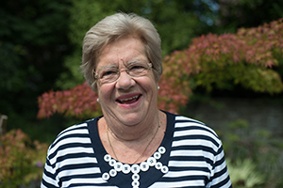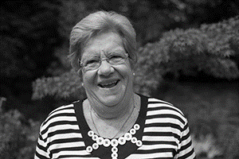

Photo: ‘2017-7 Pat Cherrett’
Colour photos folder here
Grayscale photos folder here

Saying It With Flowers

“A good display is a sermon in flowers.”
Pat Cherrett’s flower arranging team was awarded a Gold Medal at this May’s Chelsea Flower show.
“We started planning two years ago, when the National Association of Flower Arranging Societies asked me to organise a team from Dorset and Guernsey to represent it at the 2017 show. For the final year, we worked on the 20 foot square display in a barn. Nearly all my team of arrangers do the flowers for their own church.
“A Gold Medal is a very high accolade. The judging at Chelsea is very tough. Every leaf and petal must be perfect.
“Our theme was A Walk Through Time, celebrating Dorset’s Jurassic Coast. We used ferns and anemones to depict the prehistoric, as well as showing farming, fishing, and even the local oil industry.
“I was introduced to arranging at a young mums’ event at Lady St Mary’s in Wareham fifty years ago. Someone said I had an eye for it, so I went to evening classes and on from there.
“In 1986, my husband Clive became verger at Lady St Mary’s, and said we should do a flower festival. Thirty years later it’s still going strong.
“Arranging gets you out and meeting people, and teaches you to appreciate the wonder of God’s creation.
“I was baptised Catholic, but when I met Clive we decided to go to one church, so I was confirmed an Anglican. Lady St Mary’s is a big part of our life and I’m in my second spell as churchwarden.”

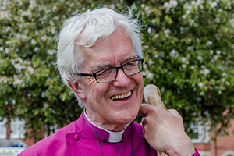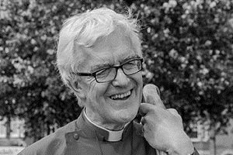

Photo: ‘2017-7 Bishop Ed’
Colour photos folder here
Grayscale photos folder here

Monthly Letter
The Rt Revd Dr Edward Condry
Bishop of Ramsbury

We use our whole bodies in worship.
We stand. We sit. We kneel.
But perhaps it is our hands which we use most of all.
Worship is not simply an internal experience, a product of mind. We are totally engaged.
We place hands together in prayer. We may lift them in praise. We shake hands at the Peace. We place our hands together to receive communion.
Placing communion bread in someone’s outstretched hands is a unique privilege.
In most churches people kneel.
But whether standing or kneeling it is the hands we concentrate on, taking the bread.
Unlike any other social situation we rarely look each other in the eye.
In this rare instance it is not eyes which communicate but palms held upwards.
The communion is with God and not the minister giving communion.
Every Sunday as I move along the communion rail I see cupped hands which: have spent Saturday gardening; are crippled with arthritis; the small hands of a child; fingers with rings; or fingernails brightly painted (one red nail even had a stencil of a bicycle that went down well).
We hold our hands up in supplication. Our hands are held out before us in a simple gesture to remind us of our dependence on God.
This is a moment in which we touch holy things.
In worship we present our selves before God.
Our bodies are an essential part of that trinity: body, mind and spirit.
So, “May the hands which have taken holy things be refreshed with the fullness of your life.”

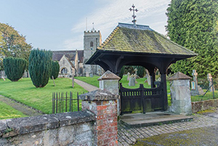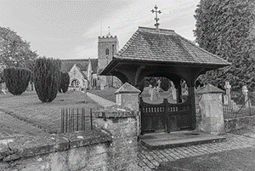

Photo: ‘2017-7 Okeford Fitzpaine’
Colour photos folder here
Grayscale photos folder here

Boost for Rural Excellence

The Diocese is to receive a £1.27M, 4½ year, grant from the Church of England to help it be a beacon for rural ministry.
The Renewing Hope through Rural Ministry and Mission programme will seek to grow local leaders, support parishes in innovation and mission, and encourage more ordinands and mid-career clergy alike to consider rural ministry.
Bishop Nicholas said, “40% of C of E worshippers do so in a rural setting. There is a different dynamic to suburban and urban contexts. Small groups of regular worshippers keep the heartbeat of prayer and worship alive for the whole community.
“We are delighted to be developing as a centre of excellence in which rural ministry and mission is developed and encouraged with imagination and flair.”

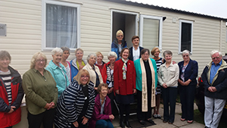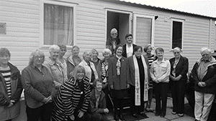

Photo: ‘2017-7 Rockley Park June 30’
Colour photos folder here
Grayscale photos folder here

An Answer To Prayer

A new mobile holiday home for needy families was an answer to prayer for Diocesan Mothers’ Union members.
MU has been providing a six-berth caravan free to those in need at Rockley Holiday Park in Poole for four years. This was showing serious wear and tear.
Diocesan MU President Rosie Stiven said, “Knowing our existing funds wouldn’t stretch to a replacement, we focused our prayers. The Holy Spirit works in wonderful ways, and soon the Musgrave and Tindall Trusts funded a brand new six-berth holiday home.
“We blessed and opened the new home in late June. If you know of families who would benefit from time spent there, please contact murockleyholidayhome@gmail.com, or 07981 743 627.”

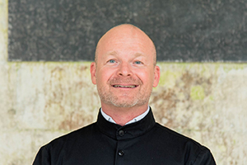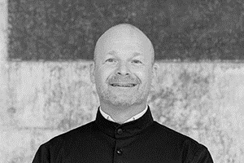

Photo: ‘2017-7 Stephane Javelle’
Colour photos folder here
Grayscale photos folder here

The French Connection

“I felt called to be a father to people and take care of them.”
Ordained in June, Stéphane Javelle is the new curate assistant in the Salisbury Plain Benefice. He came all the way from Marseilles, where he had been events manager for the city council.
Stéphane, who is based in Shrewton, says, “We weren’t a religious family, and French schools are very secular, but I went to midweek catechism classes as a boy. I started feeling a call to priesthood and as a young adult spent four years training as a priest.
“One of my grandmothers was British and an Anglican – I still have her Book of Common Prayer. At the end of those years of training, having studied theology and philosophy in depth, I knew I was an Anglican too!
“I started to attend All Saints’, the Anglican church in Marseilles. Like most churches in the Diocese of Europe, it doesn’t just serve British expats but people from around the world. There are many French Anglicans nowadays.
“I felt at home in a warm congregation with a great sense of family. I became steadily more involved and was licensed as a lay minister 12 years ago. I preached, took services and prepared people for marriage, confirmation and baptism. With my spiritual director, I began to sense a fresh call to priesthood.
“As there are very few paid posts in the Diocese of Europe, normally one has to be ‘adopted’ by an English Diocese.
“During the period I was discerning my vocation, I spent two weeks on placement in Dorchester. Then last summer, I spent a month on placement in Salisbury Plain with the Rector, the Revd Eleanor Rance. When, by chance, a training place came up in the Diocese of Salisbury, I jumped at it.
“I already love working in this rural area of open spaces and strong communities. It certainly gives me a chance to see something different after 20 years in a metropolis of nearly two million.”

