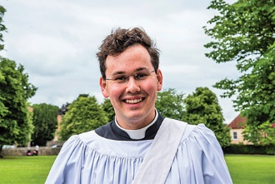
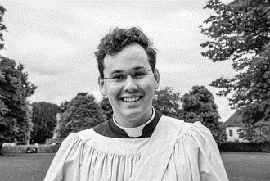
Photo: ‘2017-2 Ben Rundell-Evans’
Colour photos folder here
Grayscale photos folder here

Living God’s Call

“It is a joy to live a life which feels right and fitting with God’s calling to me.”
At 22, Ben Rundell-Evans, Curate at St John’s, Devizes, is the youngest Rev in the Church of England. He needed a special faculty from Archbishop Justin to be made a deacon last June.
“I didn’t grow up in a Christian home, but assemblies at my church primary school made a pattern of worship normal to me. We tend to undervalue assemblies; they can have a long lasting influence. That’s why I really enjoy doing assemblies and Open the Book.
“I started bell ringing and singing in my home church, St Peter’s in Petersfield. The Anglican choral tradition gave me a language of theology, and is still where my spirituality is rooted. It’s the tradition of St John’s too.
“By the time I was sixteen, I was part of the young vocations group in the Diocese of Portsmouth. After A-Levels, I did a gap year in a range of parishes, rural and urban, from Anglo-Catholic to Evangelical. I then went to my selection panel and straight into training for ministry at Cuddesdon.
“St John’s is a diverse church with many young singers, including boy and girl trebles, yet our oldest parishioner is over a hundred. As a town centre church, it can’t avoid the real world and has a breadth of community.
“God calls people to all sorts of ministries at all stages of their life. If you think God is calling you to ordination, don’t tell him you’re too young. Speak to people who know you and your vicar.”

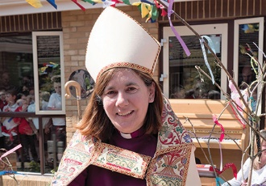
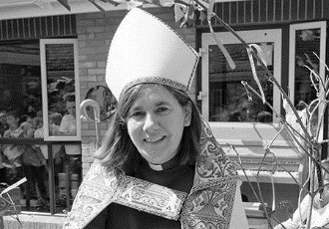
Photo: ‘2017-2 Bishop Karen’
Colour photos folder here
Grayscale photos folder here

Monthly Letter
The Rt Revd Karen Gorham
Bishop of Sherborne

Who is my neighbour? An important question as we seek to address Brexit and observe life the other side of the Atlantic Ocean.
It was a question asked of Jesus and answered by the story of the Good Samaritan. It is illustrated in the children’s hymn ‘And the creed and the colour and the name won’t matter, were you there?’
Such a question takes us out of our comfort zones to look with broader eyes as to who is around us and how we treat them. It rightly causes us to question our prejudices and confront our ‘unconscious bias’.
Yet, if we are not careful we can lose sight of the basic answer to that question. In looking out at the wider world, we can forget those literally living next door to us, our most obvious neighbours.
Recent reports have highlighted the plight of elderly isolation. Half of those aged 75 or over live alone and, as a diocese with a high proportion of older residents, chances are that we have someone living alone down our street. Two fifths of older people say the television is their main companion and in some of our coastal areas I have observed more carers now coming out of blocks of flats than residents, highlighting the problem.
‘Praying Together’, our Lent resource, gives us an opportunity to reach out to a neighbour. In a way it provides both comfort and company during Lent as well as a connection to the parish and diocese.
What a difference we could make if we all reached out to one elderly neighbour living alone, and what joy we could bring if we, not only visited at the beginning of Lent, but arrived with an Easter gift at the end.

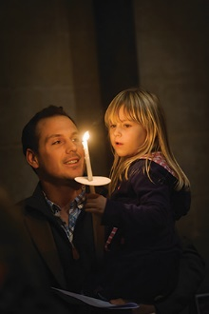
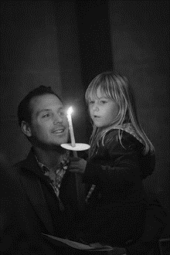

Photo: ‘2017-2 Praying Together’
Colour photos folder here
Grayscale photos folder here

Let’s Pray Together

The Diocese has launched an app, booklet, and daily e-mail to help people pray together during Lent.
Praying Together provides a very short bible reading, reflection, prayer and suggested action for each day in Lent.
Bishop Nicholas has urged people to join him and churchpeople across Dorset and Wilts in prayer, saying, “Prayer is one of the priorities of our Diocesan vision, Renewing Hope: Pray, Serve, Grow. There can be no renewal without prayer.”
Over 23,000 copies of the booklet have been distributed to parishes. Details on how to get the app and daily e-mail are at www.bit.ly/prayingtogether.
The app and e-mail will also, from now, provide prayer points from the existing Diocesan Cycle of Prayer every day.

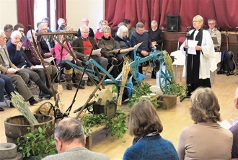
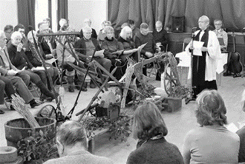
Photo: ‘2017-2 ELM Plough Sunday’
Colour photos folder here
Grayscale photos folder here

Renewing Rural Church

A West Dorset benefice saw a large congregation attend its first ever Plough Service, helped by the Diocese’s Energising Local Ministry (ELM) project aimed at releasing energy and gifts in rural multi-parish benefices.
115 of the 1,700 people in Askerswell, Loders, Powerstock and Symondsbury attended, at least half of whom are not regulars. The Revd Jan Delaney, Rector, said the idea of living out their rural character in worship came via engaging with ELM.
Jan said, “People now share skills and interests across all eight churches in this benefice of small villages and isolated farms, to achieve things none can alone.”
Read this story in more detail and learn how your benefice could benefit from ELM via www.bit.ly/sarumelm.

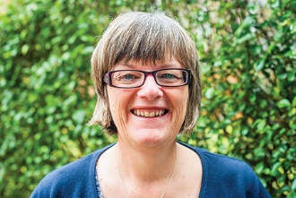
Photo: ‘2017-2 Debbie Orriss’
Colour photos folder here
Grayscale photos folder here

A Passion for Sharing Faith

“My passion is to help people grow into becoming what God made them to be and to share their faith with others.”
Debbie Orriss has been the Diocese’s Discipleship Co-ordinator for five months. She co-ordinates training for lay ministries, and seeks to help all church people deepen their discipleship.
When she was a young woman, Debbie’s deep faith was tested by tragedy.
“I grew up in a loving Christian home and enjoyed going to church and meeting friends. I was confirmed at 13, and felt God’s presence in a very specific way as the Bishop laid hands on me.
“At 16, my secure world was rocked as my father died. I wondered whether to keep following God or ignore Him.
“Through many acts of kindness, my family got through this tragedy, and I recognised we were experiencing God’s love through friends in the Church.
“My faith grew while studying at Bath Spa, where I was involved in the Christian Union. Then I taught in two Sheffield primary schools, but after 6½ years I started to feel unsettled.
“Exploring where God might be calling me led to commissioning as a Church Army evangelist. I did two posts working mainly with unchurched children and youth, including in schools. Then I trained evangelists, before becoming town centre evangelist in High Wycombe in 2009. Part of that was encouraging church people to be more outward looking in their faith.
“Mission on the street was about relationships and showing that I cared because God cares. I offered a listening ear and to pray with people and explore faith issues. It should be natural for all of us to talk about our experience of being a Christian. Sharing faith has to involve both words and actions.
“I am really excited about my role here as I love helping people grow in their relationship with God and be enabled to live out their faith in the world.”

