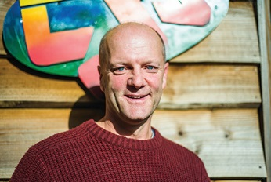
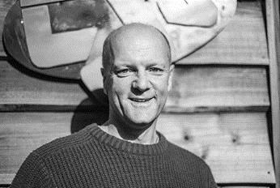
Photo: ‘2016-10 Chris Trent’
Colour photos folder here
Grayscale photos folder here

A Call to Youth Work

“The satisfaction comes from seeing young people’s lives grow and change.”
Deanery youth worker for Poole and North Bournemouth, Chris Trent is passionate about his job, and was recently nominated for a Premier Radio Youth Worker of the Year award.
“I was brought up in a Christian family”, says Chris, “but I was 21 before I picked up a real relationship with Jesus.
“It happened when I was working in forestry, and got a job in Lee Abbey, the retreat centre in Devon. Those were the two best years of my life. I saw Jesus in so many people and so many ways.
“I felt God calling me into youth work. I spent 18 happy years in Oxford, and the award nomination was for work there.
“I came to this area in 2012, for a new challenge. I do youth work on the Turlin Moor estate, am youth minister at Lytchett Minster, and also have a role in supporting and encouraging others. Youth work can be a lonely job.
“It is also rewarding. The job market is tough now, but if God is calling you to Christian youth work, go for it!
“Some of my work is overt evangelism, some is just hanging out with young people, and some of it is about direct support for those who have real and complex problems.
“The key is long-term stickability. The reward is to see young people with their hands in the air, worshipping Jesus. That takes guts in a secular society where there is pressure to reject faith. That is the challenge to all churches, including ourselves.”

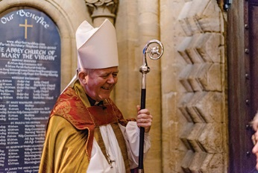
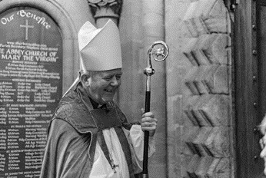

Photo: ‘2016-10 Bishop Nicholas’
Colour photos folder here
Grayscale photos folder here

Monthly Letter
The Rt Revd Nicholas Holtam
Bishop of Salisbury

Politics got nasty this year. How should Christians respond?
When Jesus said “Love your enemies”, and “Do good to those who hate you”, he meant it. In public and private, we should speak charitably to and about one another, even when we strongly disagree. If offensive language is not challenged, an offensive culture develops.
God is the God of truth. Sometimes it is difficult to know the truth, but we Christians are people who are about the truth. We should worry when politicians say we are in an age of ‘post-truth politics’, as if truth no longer matters. Careless talk costs lives.
In the last century, we learned that we either live together in one world, or there will be no world. History tells us that the rise in nationalism ought to worry us.
Nationalism can be good when it teaches us that our country is the particular place in which we learn to love. To love England or the United Kingdom does not mean we cannot love the rest of Europe or the world. Charity begins at home but does not stop there.
The Referendum and American election have made us more aware of serious divisions in our society. Societies where inequality of income is least are the happiest, healthiest and most prosperous. What sort of society do we want?
The average FTSE 100 company pays their highest paid 232 times more than the lowest. A quarter of the children in the UK, 3.5 million, grow up in poverty.
The priciest housing outside London is in this Diocese, at Sandbanks, a short distance from our most deprived parish, Kinson and West Howe.
Advent is a time of judgement in which we pray God will give us grace to cast away the works of darkness and put on the armour of light.

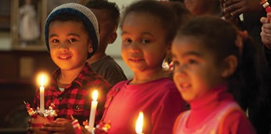
Photo: ‘2016-10 Christingle’
Colour photos folder here
Grayscale photos folder here

Fundraisers Thanked

Children’s Society volunteers were thanked by Bishop Nicholas and Mrs Helen Holtam at a tea party in their home, the South Canonry. 120 supporters from the Diocese attended.
Salisbury has more local groups collecting for The Children’s Society than any other diocese. In the last five years, they have raised over £450,000 for disadvantaged young people.
Helen Holtam said, “The party was held to thank Ann Falconer, who has been collecting for 80 years, starting at age eight! It gave people a chance to support one another, and swap ideas.”
Bishop Nicholas commended the Christingle services, promoted by the charity. “These are a popular way of engaging with children and families in the run up to Christmas”, he said.

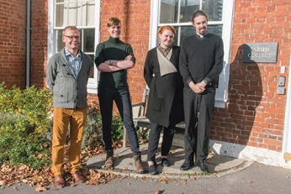
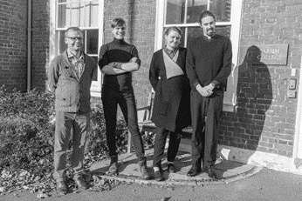

Photo: ‘2016-10 Latvians’
Colour photos folder here
Grayscale photos folder here

From Latvia With Love

Two Anglicans from St Saviour’s in Latvia’s capital, Riga, visited their sister church, Sherborne Abbey, this month as well as Salisbury Cathedral, Sarum College and the Diocesan Synod.
Churchwarden Professor Dr Valdis Tēraudkalns, an academic church historian, and church administrator Nikita Andrejevs, explored spirituality and church life in the Diocese.
They stayed with Sherborne Abbey Curate, the Revd Guntars Reboks and his wife Enija, who are Latvian.
“The face of continental Anglicanism is changing”, says Valdis, “It is no longer only for expats, in some congregations a majority are local people.”
“What strikes me”, added Nikita, “is how the Church of England is interwoven into the fabric of society.”

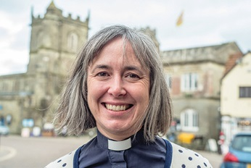
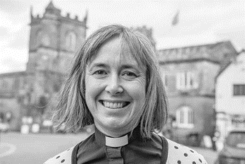

Photo: ‘2016-10 Helen Dawes’
Colour photos folder here
Grayscale photos folder here

A Varied Ministry

“Never think you are too young; you can gain work and life experience as a priest as well as in secular employment.”
The Revd Helen Dawes, Rector of Shaftesbury, didn’t go straight into ministry from university. She worked for three years as a business consultant, after studying physics and the history of science at Cambridge.
“By the time I graduated I thought I would likely be ordained”, she says, “but I tried to avoid it for as long as possible!”
“I was brought up in a church family, and was confirmed in Great Durnford in this Diocese. I just kept at church through school and university, and was Chapel Warden at Trinity College Cambridge as an undergraduate.”
Helen entered holy orders 14 years ago and, after parish roles in Cambridge and rural Herts, took on a unique role.
“I was a social and public affairs advisor to two successive Archbishops of Canterbury; four years for Rowan and two years for Justin. My job was to help them engage with social, political and cultural issues. I worked on some really high profile things – the 2012 Olympics, prisons, credit unions.
“I organised a lot of visits, enabling me to see fantastic charity and schools work. It can be a great help to projects to have an Archbishop visit.
“I came to Shaftesbury a year ago. It is lovely to be in grassroots ministry again. After a period of variety, it is good to have a job where I have continuity in relationships with schools and the community. The church is at the heart of town and village communities here, and people value our presence as Christians.
“I have recently been asked by Bishop Nicholas to be the Diocese’s Dean of Women’s Ministry. I hope someday this role will become unnecessary.
“I would encourage anyone, female or male, sensing a niggling call to ordained ministry to speak to people they trust and not be too scared.”

