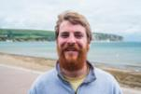

A Gift Born of Struggle

“I hope my music helps people relate to God in dark and challenging times.”
After three years as Youth Minister for Swanage Anglican Team, Matt Hurley is stepping out in faith as a full-time musician from the end of June.
“I’ve loved being a youth worker”, he says, “When I came to Swanage, there were only 15 young people connected with any church in the town. Now, we have a thriving Tuesday club with 30 people attached and other ministries in schools and secular youth groups.”
A Vicar’s son, Matt’s lukewarm teenage faith was tested when visiting his Dad at a bible college in Tanzania. “Armed robbers attacked a restaurant as we ate”, he says, “and shot a security guard dead.
“I believed in God, but didn’t know if he cared. I dropped out of school and was drinking heavily. Then, literally in the middle of the night, I met Jesus again, and started getting my life on track.
“Last year, a close friend died suddenly. I tried to accept God’s will, but it hit me hard. I suffered depression, needed medication, took time off. Somehow the pain gave me a voice for music, and I started writing songs for the first time.
“My songs aren’t typical for worship bands. They’re full of laments and hard questions to God. Coming from a Christian tradition that values certainty, that has been liberating.
“I’ve found people like my music, and I get more gigs in secular venues like pubs and Legions than in churches.
“My first EP, Raising Questions, will be launched on 29 June.”

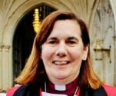

Monthly Letter
The Rt Revd Karen Gorham
Bishop of Sherborne

We have probably heard the joke that the definition of a Synod is a committee waiting to go home. It’s a sad reflection that for many, gatherings of Christians are defined by their tedium and lack of interesting debate or conversation.
I recently attended the triennial Synod of our sister church, the Latvian Lutheran Church. It was interesting to observe procedure and content. As with our own General Synod the importance lay with the voting. With the raising of a hand, or in London or York, with the press of the electronic voting pad, significant change can be enacted.
The richness of any gathering, however, is in the contributions of those who gather, each coming from a particular context, with a particular view. Well managed, those views contribute to collective decision making. Thus, the significance of a Synod comes through a corporate discernment process towards a common mind.
Sadly, in Riga this was seriously lacking. The decision of Synod to amend its constitution to reflect current practice of ordaining only men to the priesthood was made without female voice or theological debate. It is not surprising when decisions made this way get caught up in suspicious legal challenges over correct protocol.
That’s why our July General Synod needs your prayers. The conversations over human sexuality will be held away from the cameras, in the hope that each member can contribute honestly from their own experience and context.
We need to pray for openness and integrity, as well as what proceeds from these conversations; that a common mind may emerge as members speak and listen to one another and corporately hear what the Holy Spirit is saying to our Church, both through Biblical interpretation and the collective experience of what it means to be fully human.

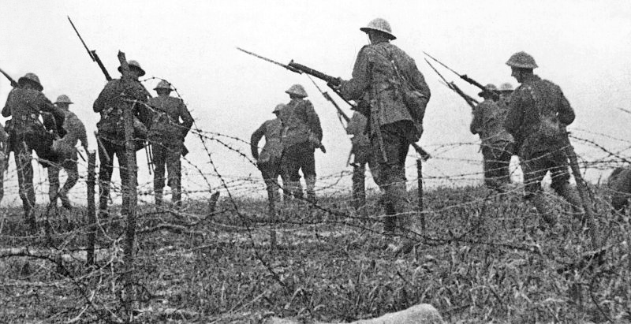

Remembering the Somme

Bishop Nicholas will lead a moving service to mark the 100th anniversary of the Battle of the Somme.
This service is part of the Chalke Valley History Festival, and organisers have built a replica World War One trench.
All are welcome to attend on Friday 1 July at 7.15 a.m. at Manor Farm, Ebbesbourne Wake, SP5 5JH.
Ven Stephen Robbins, former Chaplain General to the forces, is advising on the service. “This was the bloodiest day in British military history”, he says, “with 20,000 dead among 60,000 casualties. Every part of these islands lost people.
“It is important to remember the sacrifice of the soldiers and their families and that war, despite the heroics of those caught up in it, is the biggest failure of human beings.”

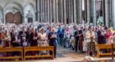

Churchwardens Thanked

Hundreds of churchwardens gathered in Salisbury Cathedral to be thanked, challenged, and inspired by the Bishop.
Normally, annual Archdeacons’ Visitation services take place separately across the Diocese. This year, Bishop Nicholas wished to gather churchwardens together in one place to be thanked, inspired – and challenged.
“I wanted to thank churchwardens for their extraordinary hard work, especially in helping with the Renewing Hope: Pray, Serve, Grow agenda.
“To underline how important prayer is, every parish has been given a specially commissioned candleholder inspired by the Cathedral font.
“I also wanted to highlight the need for robust procedures, on administration and on safeguarding vulnerable people.”

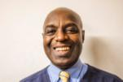

God in the Darkest Times

“In the darkest times, we see God in the way the church rallies round.”
Growing up in rural Uganda, Herbert Nabaasa was, like his father, a devout Anglican and good singer. His musical gifts won him scholarships to a local church school and then to university in what was still called Leningrad.
“I hadn’t the same rigorous childhood musical training as the local students and was told I could never catch up”, says Herbert, “I changed to journalism, but the USSR wasn’t an easy place to write about religion, which was my interest. Or to be Black!” He eventually came to England in 1990.
“I met my wife in London, but ironically she is from the same Diocese as me! I worked as a bus driver, and we eventually settled in Greenwich with our two sons, Edwin and Kenneth.
“In 2009, coming home from church, Edwin was stabbed many times by a gang outside our front door. It was only 6 pm and still twilight. We still don’t even know who called the ambulance.
“As he fought for his life in hospital, I prayed, ‘we need to get out of London’. Church friends prayed for Edwin, for our future, and gave practical support. Prayer is a powerful weapon in my life.
“My sister-in-law lives in Malmesbury and encouraged us to consider this area.
“I thought it would be difficult when I asked Stagecoach for a transfer, but they said they had a shortage of drivers in Wiltshire and I could move as soon as possible. Then we got a house swap with someone in Calne within a week!
“Next, we looked for a church in the town. St Mary’s was the first hit on Google. We knew it was for us the first time we worshipped there, as people were so kind and welcoming.
“After regaining his confidence, Edwin is doing well, studying engineering at Southampton. Kenneth is doing A-Levels in Chippenham, races in sprints, and rings bells at St Mary’s.”

