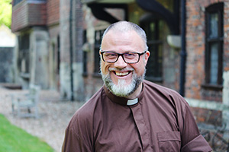
Building Bridges

“Many deaf people need healing inside. There is anger as we face so much discrimination.”
Neil Robinson, Curate at Bemerton, was made deacon in June. He was born profoundly deaf in a hearing family, none of whom were Christians.
“There were Christian staff at school, some lovely people”, he explains, “But I really started exploring faith as an adult, through friends’ influence. Coming to Christ was a slow process.
“I came to faith in a Charismatic church, but later came to value the liturgy and breadth of Anglicanism. But first and foremost, we are all followers of Jesus.
“Having explored priesthood in the past, in 2011 I had a definite vision of Jesus calling me to try again. Deaf people were positive about the idea, as many had never met a deaf priest.
“I hope to be a bridge between deaf and hearing people. I would love to see more deaf people become Christians.
“In my first year, I’ll work 25% with deaf people, 75% in hearing contexts in the parish. That can be a challenge, working through interpreters, as it was when I trained at Trinity Bristol. My colleagues and parishioners are amazing, though, and so inclusive.
“I’m involved in a Bible translation project into British Sign Language, currently working on Mark’s Gospel. Some deaf people find reading English difficult, and for nearly all of us BSL is our ‘heart’ language.
“My wife, Helen, is also deaf, and Secretary of Deaf Anglicans Together.”

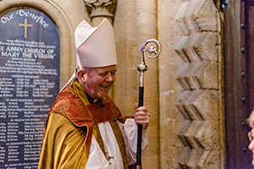

Monthly Letter
The Rt Revd Nicholas Holtam
Bishop of Salisbury

There’s a strong nationalism at the Olympics, particularly when looking at the medal table. Team GB has done us proud.
A healthy nationalism knows that to belong everywhere you have to belong somewhere. The instinct is that by loving our own country we are better able to relate to the wider world. The Olympic movement is international.
It was good in Rio to have a few competitors for the first time who are refugees and have no country to represent. Half are South Sudanese living in refugee camps in Kenya. They, too, are part of the Olympic ideal.
The way we tell our history and describe our present circumstances makes a very big difference to the way we live in a world of threats and opportunities.
When we go abroad we see things differently. We’ve been in Germany. After the Second World War 14 million German speaking people were moved into Germany as defined by the Allied powers.
No wonder Mrs Merkel has encouraged modern Germany to receive 1 million from the present migrant crisis. It’s in their history to do so.
In Munich there is a Victory Gate, the Siegestor, that looks much like the Arc de Triomphe in Paris or the Wellington Arch in London. Built in the nineteenth century to celebrate Bavarian valour it was badly damaged in the Second World War.
Its restoration has incorporated on one side the destructive marks of battle and the inscription now reads: ‘Dedicated to Victory; Destroyed by War; Urging Peace’. It turns a disaster into a hope.
This is a Biblical pattern. In seeking Christ in today’s world we face reality and ask where and how hope is reborn. Christ is in our history and is a very present reality that transforms the future.

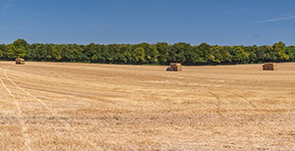

Give Thanks For Creation

The C of E has commended liturgical resources to encourage churches to celebrate Creationtide.
Creationtide, from 1 September until 4 October, is originally an Eastern Orthodox initiative, but has spread ecumenically, uniting Christians in prayer and work for the environment that sustains everyone.
Bishop Nicholas said, “The consequences of teaching over recent centuries that humanity has been given domination over creation are clear in the complex environmental crisis we now face. It is important that Christians rediscover older traditions of a godly relationship of humanity to the wider created order.”
The resources are available at www.bit.ly/creationresources.

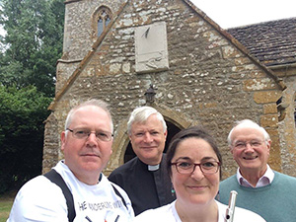

A World Tour of Dorset

A musical duo has performed a ‘world tour of Dorset’ to raise money for historic churches.
Flautist Katy Ashman and bassoonist Miles Nipper, both from Beer Hackett, played in 17 venues along a 50-mile route over 10 hours, from Holnest to Bradford Abbas.
Katy says, “It’s not just about keeping the roof on these buildings. Very often they remain the only real community building in rural villages where people can come together, when the school, post office or pub has been sold.
“Musicians sometimes see churches as just venues, but they mean more to us.”
The £1,600 raised was split between Three Valleys Benefice and the Dorset Historic Churches Trust.

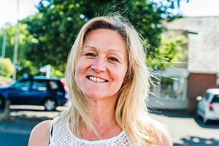

Fit for the Lord

“I was crippled physically and terrified emotionally. Perfect love casts out fear.”
Helen Yates has been on a rollercoaster journey since coming to Christ in 2009.
“My Mum became a Christian later in life and started praying a lot. During a rocky spell, I prayed, ‘Jesus, if you’re real, show me’. A few nights later in bed, I found myself filled with love and joy. I saw Jesus standing there. I just knew!
“People who knew me for years saw a real change. I was a very enthusiastic convert! I came to worship at The Lantern in Merley. I love the lively worship and supportive friends there.
“At the time, I was doing a course as a fitness instructor and started running Zumba classes with my mother and my daughter.
“The demand astonished us. 125 people turned up at our first night. It became a full-time job, with 16 classes a week across East Dorset. I was open about my faith, and people would talk to me or my Mum after class. We ran home groups for them. Over four years, more than 30 people became Christians.
“In late 2014, I started getting hip pain, then slipped a disc. The pain got worse and eventually I couldn’t even walk. I had to give up my fitness business which meant losing my ministry. Then my husband broke his leg and lost his job as a result. We had no income. It was so frightening and I got depressed.
“I had to learn to let others pray for and minister to me.
“I found a job where I could sit all day at a reception desk in Bournemouth Hospital. Instead of being up front, I was in a big, anonymous, organisation, wearing a uniform. I prayed for the people I met with serious conditions.
“My back has now healed, and I’m working in the Motor Neurone Disease unit in Bournemouth, and am starting a Christian counselling course. I feel the Lord in people’s spiritual and physical wellness.”

