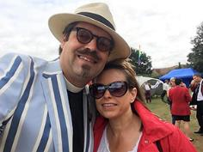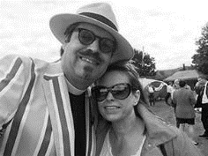
Photo: ‘Nov 2018- Richard Hancock’
Colour photos folder here
Grayscale photos folder here

Getting Out of the Boat

“When St Peter first stepped out of the boat, he started to sink, but Jesus reached out to him.
“The rural church needs to be prepared to step out of the boat, and if we sink occasionally, at least we have had a go.”
This ambition to get our rural church communities to “have a go” is at the heart of the work of the Revd Canon Richard Hancock, one of the Diocese’s four new Rural Field Officers.
“It’s great to find a Diocese that takes rural ministry so seriously.
“But our church buildings are actually like up turned boats, you know. And to keep the analogy going, we are loath to step out of our boat unless it is sinking.”
Richard, who is also the Priest in Charge of Sixpenny Handley, Gussage St Andrew and Pentridge, wants churches to step out of the boat to make sure they grow; and he believes for parishes to succeed, they need to be collaborative in all they do.
“I think of it as a pilgrimage, as a journey, meeting others along the way, it’s all about sharing learning as we pray serve and grow.”
With more than a passing nod to the Two Ronnies, Richard has come up with his “Four Candles of Mission.”
“We need to be intentional, that’s the getting out of the boat bit.
“We need to be collaborative, that is clergy and laity working together using all their gifts fully.
“But we also need to be relational and keep those relationships with your communities going seven days a week.
“And we need to be holistic, we must make sure everything we do relates together.”

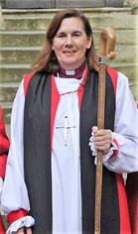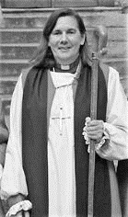
Photo: ‘Nov 2018- Bishop Karen’
Colour photos folder here
Grayscale photos folder here

Monthly Letter
The Rt Revd Karen Gorham
Bishop of Sherborne

I was recently given the details of four women from Dorset who lost their lives in the First World War.
Dorothy Stacey died aged 25 while serving with the Queen Alexandra’s Imperial Military Nursing Service.
Mildred David, whose father was Rector of Hazelbury Bryan, died while serving as an ambulance driver with the French Red Cross.
Annie Neish, aged 32, died in Reading after nursing a soldier with septic pneumonia.
Dorothy White, aged 20, died whilst serving with the Women’s Royal Naval Service.
Stories I would never have known had someone not researched them.
Stories shape our remembrance and it is encouraging to see, over the last few years, how local communities have worked hard to remember individuals who have died in war.
In the First World War, 20 million people died. That could so easily remain a shocking statistic, if it were not for names on our memorials and our year by year acts of remembrance.
Stories shape who we are and the sharing of them is important to new generations.
As we recall those names and those who gave their lives in the past so that we may enjoy freedom now; as we think of each poppy as a person; and try to come to terms with such unimaginable loss, let us pray that our story too may help shape a different world.
“Lord, make me a channel of your peace, where there is hatred let me bring your love, where there is injury, your pardon Lord and where there’s doubt, true faith in you.”

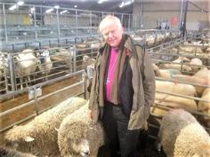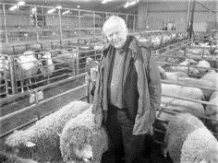
Photo: ‘Nov 2018- Bishop Nicholas Market’
Colour photos folder here
Grayscale photos folder here

The Church Goes to Market

“Welcome to my church” was the greeting Bishop Nicholas received from the Revd Richard Kirlew, when he visited Salisbury Livestock Market.
The Lead Chaplain at Salisbury Livestock Market, Richard, who is also the Rural Officer for Dorset had invited the Bishop to join him on the Chaplain’s “rounds”.
The Bishop took the opportunity to meet farmers as they unloaded sheep, pigs and cattle, engaging in some interesting conversations.
He was even light heartedly heckled by Simon Whalley, the CEO and Senior Auctioneer who, as he auctioned a large pen of sheep, shouted “Bishop, which ones of these are yours?”
To which the Bishop replied, “All of them!”
Bishop Nicholas said, “Salisbury Livestock Market is an important part of the local economy, a gathering point for the rural community.
“The sheep auctioneer asked which sheep were mine. I said all of them but we all knew I might have a particular interest in any one who had got lost.”
Farmers and others come to the Livestock Market for various reasons, but as the chaplain told the Bishop, it is in the café that the real work of chaplaincy is done;
“Someone once called this ‘fried breakfast ministry’!”
“Farmers, some of whom may be suffering as a result of isolation, stress, financial and marital issues, just want to talk. The chaplains sit and listen.
“To have a farmer completely unload their problems to you, sometimes in tears is a massive privilege - humbling indeed.”
Reflecting on his visit, Bishop Nicholas said; “It was striking that the chaplain was known by so many.
“The Livestock Market was interesting, it was enjoyable, but above all it was obvious that the Church was there and involved, caring and effective.”

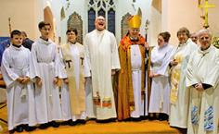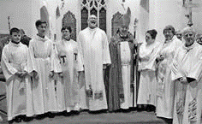
Photo: ‘Nov 2018- St John's People’
Colour photos folder here
Grayscale photos folder here

An Urban “Stick of Rock”

“We will be the urban church we are required to be, and then we can hand it over to the next generation for whom our prayers are said today.”
This was how the new Vicar of Studley St John’s, the Revd Alastair Wood describes the vision of his Trowbridge church and its congregation.
“I was attracted to this community because St John’s knew it needed to find a new incumbent who would lead in prayer, serve in love, and grow disciples in maturity.”
And Alastair, who grew up in a village south of Manchester, certainly had the background for the task, having been in various forms of ministry for over 30 years.
“I worked for 15 years as a Scripture Union Schools Worker and Team Leader. My job was to nurture and grow church teams to work in schools, discipling young adults to be leaders in their own churches.
“I am actually like a stick of Blackpool rock, through the middle are the words Pray - Serve - Grow!”
Now six months into his ministry at St Johns, Alastair says; “We are asking questions. Why do we do what we do? Why do we do it this way? And all in the framework of Renewing Hope.
“We are a large urban parish with an inherited chunk from a previously closed church, that has a different identity and that is an issue.
“Prayer is taking on a new challenge - especially as we plan to extend and rebuild our hall and community facilities.
“We are serving and broadening our scope, while our 4 schools and our college present even more specialised opportunities to serve.
“And doing all this, while growing our people, enabling and commissioning them into their ministries once identified.
“I was trained as a pioneer minister, but one who realises that parish ministry is what society today will actually benefit from more than ever.”

