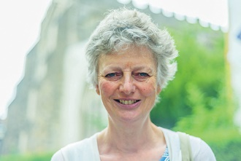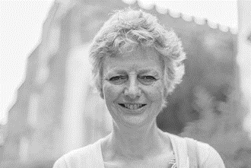

Photo: ‘2018-7 Elizabeth Waterman’
Colour photos folder here
Grayscale photos folder here

Using Gifts to Help Others

“It’s a chance to use the gifts God gave me to help others.”
Elizabeth Waterman had a varied career as an occupational therapist, including running her own business. The worshipper at St Lawrence’s, Stratford-sub-Castle now gives much time in retirement as a charity trustee.
“Kidasha is a UK-based charity, but most of our staff are Nepalese based in Nepal, where money goes much further.
“We focus on children in urban poverty. Few tourists see Nepal’s urban slums, which have grown enormously since the 2015 earthquake as people fled destroyed villages for the cities.
“The children we help are those who fall through the cracks of other support. We seek to find them an education and safe place to live. Many street children have addiction problems or involvement in crime. They may have been sold by their own families as domestic slave labour or even as sex workers.
“To raise funds, I do everything from running a ‘pop-up restaurant’ in my home to sponsored treks and organising events. For a small charity, connections with church and community are huge assets. So is the large Nepalese community in South Wilts.
“My father was churchwarden in the Gloucestershire village we grew up in. Church was central to our lives and the village’s. It’s still like that in Stratford.
“Family and professional commitments have meant that through life I’ve often spent different weekends in different places and so attended different churches. But faith has been a constant.”

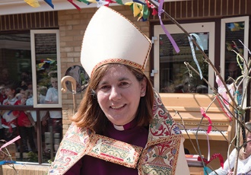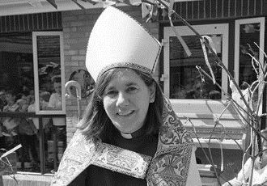

Photo: ‘2018-7 Bishop Karen’
Colour photos folder here
Grayscale photos folder here

Monthly Letter
The Rt Revd Karen Gorham
Bishop of Sherborne

For the last few years Neil Larkey has done an excellent job of raising the profile of Confirmation across the diocese, and our numbers have increased as a result. Thank you Neil.
It is one of the highlights of my role as Bishop to confirm individuals at the Cathedral or more frequently in local parish churches. In its simplest description, Confirmation is all about saying ‘yes’ to God, and many from teenagers to those in their eighties have done just that.
During the service, that ‘yes’ to God and following Christ is publicly confirmed by the laying on of hands, the anointing of oil, and prayer that God’s Holy Spirit will be with all those making promises to the end of their life.
For many it marks the beginning of a chosen faith journey, for others it is the culmination of years of seeking and searching.
Everyone who comes to our churches, our chapels, our middle or secondary schools, deserves the opportunity to respond to that simple invitation – ‘Would you like to say ‘yes’ to God?’ We do people a disservice if we do not offer it.
Each person prayed for has a unique story to tell and stories told during Confirmation services can be moving and encouraging, speaking of what God has done, how Christ has become real, how helpful the preparation has been and the belonging become. And each service gives testimony to God moving in the lives of those who find themselves working, living or studying in our diocese.
Confirmation is no meaningless rite of passage, as some have thought, but a joyful celebration of God at work in the lives of those who choose to say ‘yes’ to God.
Don’t let it pass you by.

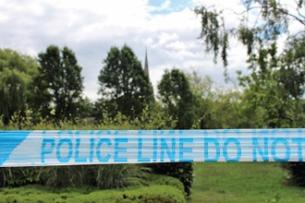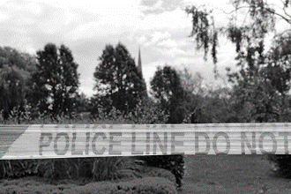

Photo: ‘2018-7 Police tape at Elizabeth Gardens’
Colour photos folder here
Grayscale photos folder here

Response to Second Attack

After two further people in South Wiltshire fell ill from the effects of exposure to the nerve agent Novichok, one of whom died, Bishop Nicholas said, “The poisoning of Charlie Rowley and Dawn Sturgess is very troubling. They are being prayed for in the cathedral and the local churches.
“Thank God for the emergency services and the experienced care of the Salisbury District Hospital. As with the earlier incident with the Skripals, it is going to take time to discover what exactly has happened.
The Revd Philip Bromiley, who conducted Dawn’s funeral, said, “Dawn had a heart for people, especially for people living on the streets. She was often incredibly generous and gave time and energy for them.”

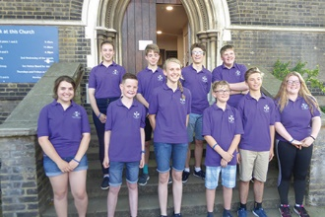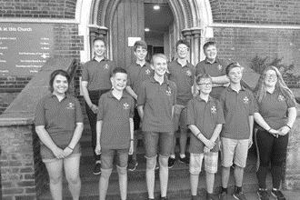

Photo: ‘2018-7 Young Ringers Go Bellistic’
Colour photos folder here
Grayscale photos folder here

Young Ringers Go Bellistic

Ten young ringers from the Salisbury Diocesan Guild of Ringers travelled to a sweltering London to take part in the Ringing World National Youth Contest (RWNYC) with 21 other teams.
Their team name was ‘Go Bellistic’.
This is the first time the Salisbury Guild has been able to enter a team since the competition started in 2011
The team rang after just fifteen minutes to practise, adjust ropes and test. A ‘C’ grade was creditable on its first outing, as one of the youngest teams in the competition with an average age of 14.
The team didn’t get through to the final in the afternoon, so members were able to carry on running around visiting towers around the capital until evening.

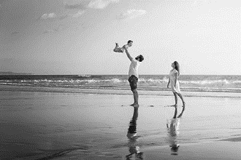

Photo: ‘2018-7 shutterstock_394881511’
Colour photos folder here
Grayscale photos folder here
NB: If you use the photo, please credit ‘Photo Shutterstock ID 394881511’

Making A New Family

“Faith gives us the extra strength to go through the adoption rollercoaster.”
Joe and Mary (not their real names) are a churchgoing couple in East Dorset who have recently adopted a son through a Christian agency.
“We both grew up in churchgoing families”, says Joe, “but lapsed as young adults. As we thought about marriage, we started going to Mary’s home church. The people were welcoming and friendly, and the vicar did our very rewarding marriage preparation.
“It has become a valued part of life. It’s great to be part of a new community.”
“We had considered adopting”, explains Mary, “even before learning we weren’t able to have birth children.
“We explored different agencies but we found Families for Children’s Christian ethos and depth of support to be special.
“The process is rightly in-depth. It does give a rare opportunity to reflect on your life and what has shaped you. It takes about six months to be approved.”
“The challenging bit is learning about possible children to adopt”, adds Joe. “There are so many children who need a loving home, usually after a traumatic early childhood. It is so hard to say no.
“Some had very specific needs that we couldn’t meet but other adopters could.
“It was magic when we met the boy who was to become our son. We had planned for a year, but it came together quickly in the end and it was a panic to get his bedroom finished in time!”
“A year on”, says Mary, “we have a son who is full of energy, loves the outdoors, helps in the garden. We had him christened in the church we were married in. It was very important to us.
“It has been a steep learning curve as new parents, but Families for Children provide us with great support and can do for the rest of our lives, if we need it.
“Adoption is hard, but it’s so worth it. When he smiles, we’re a family.”

