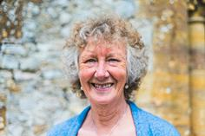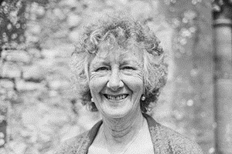

Photo: ‘2018-5 Jean Ransford’
Colour photos folder here
Grayscale photos folder here

A Devon-ly Village Church

“Being a troubleshooter is a part of the job. You never know what will turn up.”
Jean Ransford has just started her third spell as churchwarden in St John the Baptist in Hawkchurch – the only Diocese of Salisbury parish in Devon.
“I grew up in Lyme Regis in different times. When my parents divorced, my mother was ostracised by many and expelled from the Mothers’ Union.
“I didn’t suffer as we were brought up by my Mum and my grandad together. He was a rock! He was a devoted church person and I picked that up from him.
“My mother always told me I needed to spend time in London, so I trained as a domestic science teacher there, where I met my husband Neil. We travelled round the country with work, and were both very church oriented.
“We moved back to this area in the ‘80s as Neil had elderly parents here, and naturally got involved in St John the Baptist. He was a Licensed Lay Minister, and did a tremendous amount around the team.
“Perhaps my most memorable job was dealing with the aftermath of the north roof blowing off in the 1987 hurricane!
“Neil died last July. We did so much together, including our church work, and I miss him awfully.
“This year, my partner warden is quite newly confirmed so I’m getting a chance to use my teaching skills!
“I like how practical the job is and I try to be at every service. I do often worry about how congregations have declined over my thirty years here, though.”

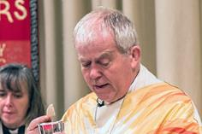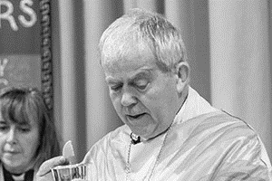

Photo: ‘2018-5 The Rt Revd Nicholas Holtam’
Colour photos folder here
Grayscale photos folder here

Monthly Letter
The Rt Revd Nicholas Holtam’
Bishop of Salisbury

We are made for goodness, although the state of the world can make us feel otherwise.
It was a long, grey, wet winter with a hot and cold but wet Spring.
Maybe I am just getting older but the weather was breaking records for one extreme after another. The summer sunshine and long days are very welcome.
Salisbury has had its problems recently. The impact of the nerve gas attack on the Skripals continues as the city seeks to recover its place as a destination for shoppers and tourists who want to enjoy a peaceful day out.
What took place here is being used internationally in ways that do not leave me feeling comforted.
What I want, and pray for, is peace between all people. The beautiful exhibition of origami doves in the cathedral expresses that and the city has responded positively.
Many shops have doves in their windows. The story we want to tell from Salisbury is of our overcoming terror and violence and making peace.
The international news of late has been grim – the opening of the US embassy in Jerusalem; the appalling violence in Gaza; the suicide bombing in Indonesia by families, including children; the continuing violence in Syria, Yemen, and Iraq… and so on and on and on.
It makes the way we live our daily lives all the more important as a response to the world.
We are made for goodness. Seek to build on it in whatever ways you can.
The Royal Wedding is helping to cheer the whole country up. In some ways that is pretty superficial but if it causes us to think about whom we love, to value relationships, and commit more deeply that is a very good thing.
The world gets changed by millions of small actions for good. Let’s do it.

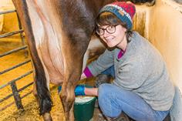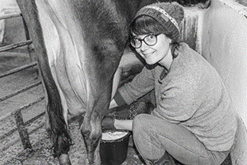

Photo: ‘2018-5 Pilsdon’
Colour photos folder here
Grayscale photos folder here

Happy Sixtieth For Pilsdon

A West Dorset community providing a Christian place of transformation and refuge in the heart of the countryside is celebrating its 60th anniversary.
Since 1958, the Pilsdon Community has been offering a refuge to people in crisis, welcoming those from all backgrounds and walks of life. As part of its anniversary celebrations, it is seeking to record experiences from anyone who has come into contact with it, as members, volunteers, or guests.
Mary Davies, who is co-ordinating the project says, “We’d like to help people mark their experiences without it being a chore. People can e-mail me at mdavies@pilsdon.org.uk to find out how or visit our stories website at
www.stories.pilsdon.org.uk.”

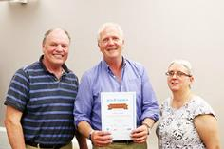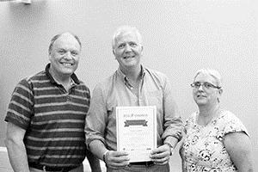

Photo: ‘2018-5 Eco Church Award Longfleet’
Colour photos folder here
Grayscale photos folder here

More Eco Church Awards

More parishes are celebrating Eco Church awards, including St Mary Longfleet in Poole, St Mary’s, Beaminster (both bronze) and Holy Trinity, Bradford on Avon (silver).
The Eco Church awards scheme allows parishes to audit what they are doing and could do to care for God’s creation.
Jane Jones, who led the project for Holy Trinity, Bradford on Avon, said, “This gave us a chance to look at how we could incorporate one of the Five Marks of Mission into the life of the Church. It brings to the fore how important it is to care for and teach about God’s creation.
“It has also has helped us save some money!”
More info at ecochurch.arocha.org.uk or through david.morgan@arocha.org.

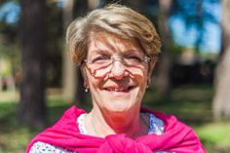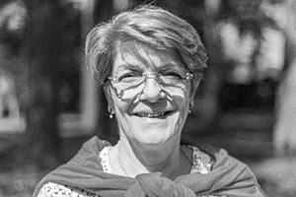

Photo: ‘2018-5 Jane Hazell’
Colour photos folder here
Grayscale photos folder here

Keeping People Safe

“Safeguarding isn’t a tickbox exercise. It’s important to keep people safe.”
Jane Hazell is a safeguarding representative for Canford Magna, one of the largest parishes in the diocese with three well-attended churches.
“My journey to this point started as a girl, when I went to church with my father in London. I don’t know why, but we just stopped when I was twelve.
“When my son was a baby, I asked the local parish church about baptism. The curate asked me why, and I said I wanted him in God’s family. From then on I got quite involved in church.
“We moved to Merley in 1990 and started going to Canford Magna Parish Church. I’d say this is where I really got to know the Lord, at an Alpha weekend.
“I was a secondary teacher with training in special needs and inclusion. I was employed as a safeguarding lead for a Bournemouth high school in the 2000s.
“When I retired, I was asked to take over the parish safeguarding role. At first I thought it would be a short-term thing, but I’ve been doing it since 2012.
“The parish has lots of young people’s activities – Sunday groups and weekday mother and toddler groups in all three churches. We also have groups for older people who may be vulnerable.
“People go to church for many reasons. Most because they’re Christians, some because they’re lonely. Realistically, a few come with an ulterior motive.
“We need to have good systems in place to protect people from harm. We are all challenged in different ways. Safeguarding involves not putting people in a position where their vulnerabilities will cause problems.
“It can be hard work but also rewarding, for example, when people confide in you as they trust you and know you care. When I run safeguarding training, some people arrive unenthusiastic. By the time it’s finished, they are much more positive about how important it is to have the right processes in place.”

