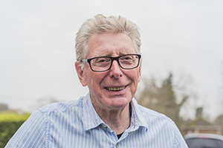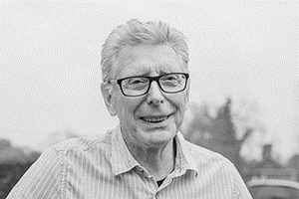

Photo: ‘2018-1 Roger Hayward’
Colour photos folder here
Grayscale photos folder here

A Bit of a Resurrection

“I’ve experienced a bit of a resurrection.”
Roger Hayward worships in All Saints’, Netheravon, the church where he sang as a boy after a tough start to life.
“My mother abandoned my three siblings and me when I was a toddler. After six years in a rough orphanage in London, my father managed to get us back to the village to raise us. All that made me a very strong character!
“When Peter Powne, a gentle man I’d have done anything for, was vicar, he got me to become churchwarden. I went on for eighteen years under four vicars.
“Coming towards retirement in 2005 after a career in the brewing business, I thought it was time for new blood. Now my wife, Suzy sings in the music group and I play guitar. The church supported me through all life’s problems.
“I then had a second career. I was always keen on bikes, and just at the right time, Wiltshire Council were looking for someone to run their cycle training scheme for schools and instructors.
“Two years ago, I was diagnosed with a type of stomach cancer so rare I was finally sent to London for treatment.
“I’d done Ride+Stride, cycling to raise money for historic churches every year since 1984, but in 2016 I was too ill.
“So many people prayed for me, not just here but across the UK thanks to the Methodist hospital chaplain. Between that and the medics’ skill, I went into remission and got back on the bike for Ride+Stride last September.
“My attitude to life has changed. Every day, I wake up and say, ‘This is great!’”

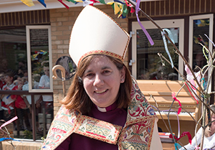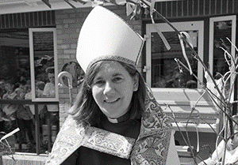

Photo: ‘2018-1 Bishop Karen’
Colour photos folder here
Grayscale photos folder here

Monthly Letter
The Rt Revd Karen Gorham
Bishop of Sherborne

One of the responsibilities I hold around the diocese is supporting our many chaplains.
We have chaplains in schools, colleges, our university, the police, prisons, the armed forces, hospitals, hospices, our law courts and in our residential homes and shopping centres. In fact chaplaincy is becoming an increasingly vital ministry. As Christian ministers they form an important bridge between the world of the Church and the life of everyday people.
To many of us who inhabit parish life, much of this significant ministry remains hidden, but to those who interact with our chaplains, particularly at critical times in their lives, that role of being ‘God’s person’ in a place can literally be life giving and life changing.
I am delighted therefore that a number of our chaplains have contributed to our Praying Together 2018 Lent booklet, so we can learn from them, and reflect on some of the contexts in which they minister.
We shall be distributing over 30,000 copies of the book through churches, chaplaincies and schools. In it, we shall follow the Gospel of Mark from Ash Wednesday to Easter Sunday. We shall travel together the journey of Jesus, as he interacts with the everyday people of his day, and we shall be challenged in our own service with those we meet.
I hope Praying Together 2018 will be a resource you will enjoy and share, as well as a way of learning from those whose ministries we sometimes forget.
May God bless you as we travel through Lent together.
Copies should be in every church in the Diocese on the Sundays before Lent starts on 15 February. Further copies can be requested from 01722 411922 or enquiries@salisbury.anglican.org.
The daily reflections can also be received via e-mail or the PrayerMate app. People can sign up for both at www.bit.ly/prayingtogether.

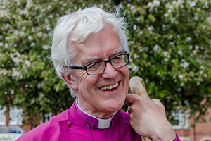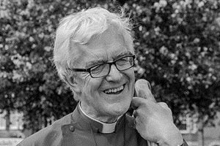

Photo: ‘2018-1 Bishop Ed’
Colour photos folder here
Grayscale photos folder here

Bishop Ed Retires

The Bishop of Ramsbury, the Rt Revd Dr Edward Condry, will be retiring at the end of April when he will reach the age of sixty-five. His farewell service will be Evensong at St John’s Devizes on Sunday 15 April at 6 pm.
Bishop Edward said, “Sarah and I move on with some sadness but with much thanksgiving. We have loved living in the beautiful county of Wiltshire.
“I have been constantly astonished at the generous and loving work of those who worship here, quietly serving Christ through their service to neighbours and communities.”
Bishop Nicholas said, “Bishop Ed has been the encourager he said he wanted to be when he became a bishop. There is much to give thanks for and he and Sarah will be greatly missed.”

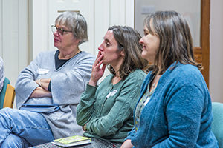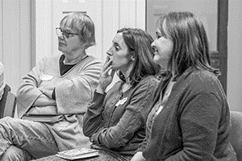

Photo: ‘2018-1 Sharing for Growth’
Colour photos folder here
Grayscale photos folder here

Sharing for Growth

Rural clergy are gathering to share ideas on reducing administrative burdens, helping congregations deepen in prayer, better serve their communities, and grow in numbers.
The rural residentials are part of Rural Hope, a 4½ year programme supported by the national church to help rural congregations in our Diocese grow, and be a model for the Church of England.
For example, the Revd Simon Weeden, Team Rector of Whitton, Marlborough, explained how they moved from five PCCs to one Team Council. Instead of needing 80 lay people to fill legal posts, they only need 19 now. Clergy need attend fewer than 20 meetings a year instead of 61, freeing time for growing the church and caring for people.

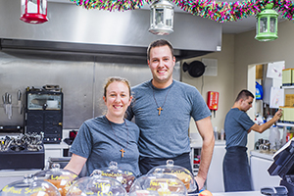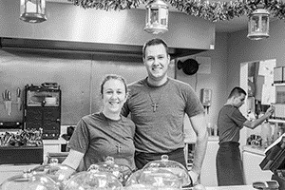

Photo: ‘2018-1 Simon and Hayley Hill’
Colour photos folder here
Grayscale photos folder here

A Year in God’s Time

“It was a big financial risk, but we’ve seen so much provision from God.”
Simon and Hayley Hills moved to a smaller house to fund their cafe on Poole’s Canford Heath. The St Mary’s, Longfleet, worshippers are taking ‘a year in God’s time’ with the Lambeth Palace-based Community of St Anselm.
Hayley said, “I grew up in Emmannuel Church in Weymouth. I started going to St Mary’s when I came to university in Bournemouth. Simon came here ten years ago to work for the Environment Agency and we met through church.
“I did a second degree in youth ministry and got a job at Canford Heath Baptist. In that time, we got a real sense from nowhere to run a community cafe.”
Simon continued, “Canford Heath was built between the ‘70s and ‘90s and has 13,500 people. Surrounded by dual carriageways, it’s a distinct community. The only meeting places were two pubs and we saw a need to build community.
“We opened the cafe four years ago. It has been a privilege to walk with people and build community. We also try to give back with a gardening group to look after public spaces on the estate.
“Just over a year ago, we found we were so busy keeping it all going that we needed to regain a rhythm of prayer.”
Hayley concluded, “We kept seeing the Community of St Anselm mentioned by friends and on Facebook. We worried it might be another thing in a busy life. But God confirmed the call.
“As non-residential members, we go up to London every Monday night and one Saturday a month for a year. Members are aged 20-35, from around the world, and traditions from Orthodox to Free Church. It is a safe space, focused on Jesus, to learn to live with difference.
“We live a rule of life based on Francis, Ignatius and Benedict, committed to prayer, unity, and daily Bible reading. It has helped us learn just to be.
“It has been amazing. We’d recommend it to any young Christian sensing a call.”

