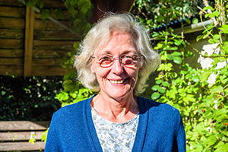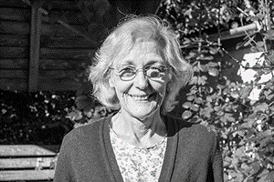

Photo: ‘2017-8 Anne Mantle’
Colour photos folder here
Grayscale photos folder here

Led to A New Ministry

“If you sense a call to lay ministry, explore it with people you trust.”
A teacher of maths to adults, Anne Mantle’s faith journey reaches a new phase on 30 September when she will become a Licensed Lay Minister (LLM).
“My parents were intermittent church goers, but sent me to Sunday School every week so they could have a break!
“I was confirmed as a teenager but it didn’t mean much to me. At university in Salford, though, my mind was more open. Through meeting some lovely Christians, I came to a real faith.
“My husband’s faith is also strong, so church was always part of our lives. We worshipped in different denominations as we moved a lot when first married. We came to Wiltshire 25 years ago. I felt I should be part of the community, so we got involved in St John the Baptist, Pewsey, as our local church.
“After years of involvement, including starting a prayer ministry and seven years as churchwarden, I felt called to more. I was asked by a local priest if I had thought about becoming an LLM.
“As a teacher, the teaching and preaching element of Licensed Lay Ministry appealed, giving me a chance to use my skills in a new way.
“Training involves time commitment but has been rewarding. Learning is at a high standard alongside ordinands at Sarum College. There is a good balance of academic theological work with formational and practical. It’s a great preparation for a new role in leading prayer, preaching, and pastoral work.”

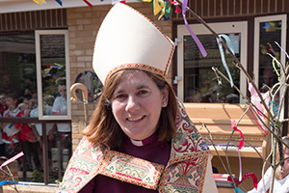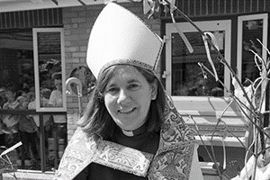

Photo: ‘2017-8 Bishop Karen’
Colour photos folder here
Grayscale photos folder here

Monthly Letter
The Rt Revd Karen Gorham
Bishop of Sherborne

This summer I went on retreat to Glendalough in Ireland. It is a much visited place where St Kevin set up his monastery amongst the Wicklow Mountains around 1,500 years ago. It was a major centre of the conversion of Ireland to Christianity.
These saints of old had good sense. The scenery is fantastic, while the monastery and his hermitage were over a mile apart within a beautiful valley, providing the essential balance between work and prayer.
There is a legend around St Kevin, reflected in a poem by Seamus Heaney, that he prayed with his hands open for long enough that a blackbird came and made its nest there. A challenge for any retreatant!
Another story is that a friendly otter would visit daily to bring a salmon to feed Kevin and his fellow monks.
Christ in the Gospels demonstrates God’s provision both for our daily bread and for abundance. That means coming before God day by day faithfully in prayer, and asking for miracles.
As this autumn term unfolds there is much happening, which calls for both daily bread and miracles.
Our expectations can be simple yet extravagant.
In some ways I am daunted as we launch out on our diocesan project to grow the rural church. So much of that ministry is about daily bread.
However, knowing what is already happening and the great team of lay and ordained leaders we have in our parishes, and believing in a God of abundance, I trust that amazing things can and will happen. We should trust in God’s gifts, not just our own strength.
‘Now to him who by the power at work within us is able to accomplish abundantly far more than all we can ask or imagine to him be glory in the church and in Christ Jesus to all generations’. Ephesians 3: 20,21

Photo: ‘2017-8 Homeless 2’
Colour photos folder here
Grayscale photos folder here

Rector Challenges Council

A Rector has called on Poole Borough Council to be compassionate in enforcing new Public Space Protection Orders in the town centre and Quay.
The Revd Lucy Holt, Rector of St James’, says the orders, which could see anyone begging or drinking on the street fined, could stop vulnerable people accessing support.
“People find themselves homeless for a huge variety of reasons”, she said, “Mental health and addiction often play a part, along with domestic violence.
“These plans could jeopardise the work of Poole’s churches over many years to serve homeless people’s immediate needs and give them routes to more stable lives.”
The plans are on the council’s website. A consultation runs until 16 October.

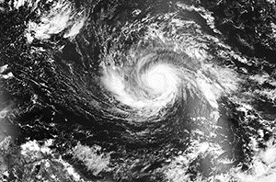

Photo: ‘2017-8 Hurricane Irma’
Colour photos folder here
Grayscale photos folder here

Pray and Care for Creation

Bishop Nicholas has joined world church leaders in commending the Season of Creationtide, which runs until 4 October, St Francis’ Day.
“Creationtide”, said Bishop Nicholas, “is a time for Christians throughout the world to pray, reflect, and act on issues related to the care of all of Creation, the environment and our world.”
A record-breaking hurricane season has again made clear that many countries suffering most from climate change are those contributing least to the problem. Many of those suffering are our Christian brothers and sisters.
Creation can be a theme at harvest services and in prayer groups. Prayer is the heartbeat and the root of all transformative Christian social action.

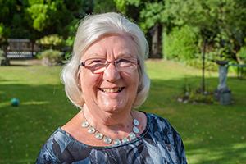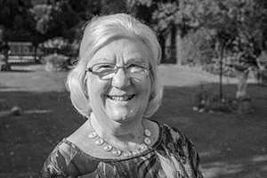

Photo: ‘2017-8 Gillian Clarke’
Colour photos folder here
Grayscale photos folder here

A Pilgrimage to Lead

“Pray, Serve, Grow has inspired us; giving us a focus but also freedom to do things as it suits our own parishes best.”
Gillian Clarke says she is surprised to find herself Chair of the House of Laity of Diocesan Synod. The worshipper at St Mary’s, West Moors, has, however, always had a strong and active faith.
“I grew up in a mining village near Barnsley where we went to a very high church three times on a Sunday. My grandparents met at church and my father was a churchwarden and Reader.
“My faith was really brought to life by a new vicar who arrived when I was in my early teens. He preached, taught the faith, led us on processions of witness at Pentecost, and made it all real.
“Studying English at Durham, Mass at St Chad’s followed by bacon butties was the mainstay of Sunday. While staying on to do a PGCE, I met Alex, now my husband and also a strong Christian.
“As teaching careers took us around the country, we always went to our own parish church, so we’ve worshipped in very different traditions. Our family life was rooted in church.
“We came to Dorset 27 years ago, and a few years later, I became churchwarden. Gradually I became more involved in Wimborne Deanery affairs, becoming Deanery Lay Chair nine years ago.
“I’ve really enjoyed this work. We have a real action plan in Wimborne, making projects happen on the ground like our Coach in the Community mobile youth centre serving local communities.
“I’ve enjoyed my first months as Diocesan Lay Chair. People can use me as a channel to make their views known. I can see how work at parish, deanery and diocesan level joins up and together furthers the cause of the Gospel.
“This is an exciting time in the Diocese. Pray, Serve, Grow provides such a simple but powerful framework. The Strategic Development Funding means we’ll aim to be a beacon for how to grow rural parishes for the whole C of E.”

