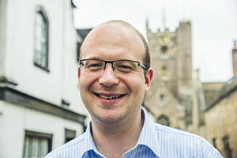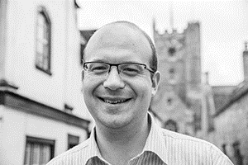
Photo: ‘2017-6 Chris Totney’
Colour photos folder here
Grayscale photos folder here

Making A Merry Noise

“There is a place for all worship styles.”
Chris Totney is Director of Music at St John’s, Devizes. Of the 40 members of the traditional Anglican choir there, 23 are aged 18 or under.
“In January, they sang Evensong at St Paul’s Cathedral. I’m proud of them.
“I love choral music and giving young people a chance to take part in it. When you have young people in a choir, their friends often come along to hear them. Their siblings join the Sunday school. It helps the whole church grow.
“When I was a boy, my piano teacher was organist at a local church. He asked me to join the choir: one of the most rewarding things I’ve ever done.
“When my voice changed, it seemed logical to try the organ. That led to a degree in music at Durham, and two years as organ scholar at the Cathedral
“While there, I met my wife, Jennifer, who is now a Team Vicar in Pewsey. I teach at St Mary’s School in Calne.
“Music is a hugely uplifting part of the Christian faith. It expresses more than words, as Scripture tells us God hears us pray in more than words (Romans 8).
“I’m also part of the Pipe Up! scheme, where the Diocese subsidises organ lessons for under 18s, with teachers based across Wiltshire and Dorset.
“A choral tradition can be restarted if it has dwindled or gone. In recent years, Rowde and Bromham started a youth choir. Now its choristers are gaining awards. It can be built up quite quickly once there are a few youngsters.”

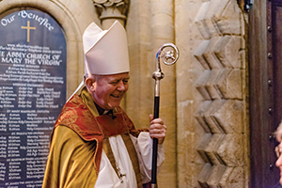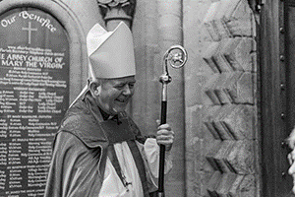
Photo: ‘2017-6 The Rt Revd Nicholas Holtam’
Colour photos folder here
Grayscale photos folder here

Monthly Letter
The Rt Revd Nicholas Holtam
Bishop of Salisbury

Faith in an Age of Uncertainty is the theme of the clergy conference from 3-6 July. The title was chosen long ago but it certainly fits the moment. Recent acts of terrorism in Manchester and London; the Grenfell Tower fire; the USA reneging on the international agreement made in Paris in response to climate change; as well as all the political uncertainties after the election to do with Brexit, a faltering economy, commitment to austerity, and an unwillingness to fund public sector services; do indeed make for very uncertain and difficult times.
Politicians and journalists tell us we don’t like uncertainty. That was why the Prime Minister wanted to give us strong and stable leadership. For ourselves, we try to make smart choices to manage the uncertainties of life as best we can. We try to live healthy lives, get a good education and smooth out the ups and downs through financial planning for ourselves and families as well as for our communities, but there is always uncertainty.
Religious faith helps us navigate the changes and chances of this life, to be creative, good and loving amidst whatever the difficulties. Just think about the way people responded to the terrorism in Manchester and London, or the fire in Kensington. We are made for goodness and goodness is stronger than evil, love is stronger than hate. In the end, the way of truth and love wins every time.
Christianity has always been one generation from extinction but that is a good reason for us to be confident. It is an enduring faith. Indeed, perhaps having to work hard for what matters is what draws out the best from us.
What Jesus teaches is that if we only seek to look after ourselves we will be sunk. Of this I am certain: walk the way of the Cross, love one another, give generously, be thankful, seek the way of truth and peace and we will have life in all its fullness.

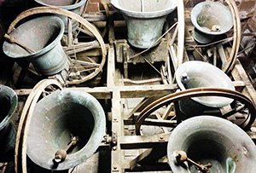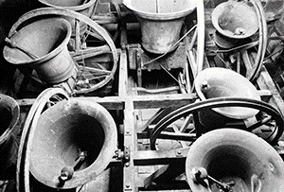
Photo: ‘2017-6 Bells’
Colour photos folder here
Grayscale photos folder here

Strike Back Against Cancer

Dorset bellringers rang quarter peals last month to help the national Strike Back Against Blood Cancer campaign.
The campaign is led by bellringer and cancer sufferer Julie McDonnell to raise awareness of the 137 blood cancers.
It has raised more than £7 million through bell ringing events worldwide.
Over a weekend, bells rang out in Beaminster, Yetminster, Milton Abbey, Sherborne Abbey, Iwerne Minster, Sturminster Newton, Sturminster Marshall, Lytchett Minster, Charminster and Wimborne Minster.
Andrew Smith and Joanna Wenborne of the Dorset County Association of Bellringers led the effort. “We were delighted that Julie herself joined us in ringing the notoriously tricky method named in her honour”, said Andrew.

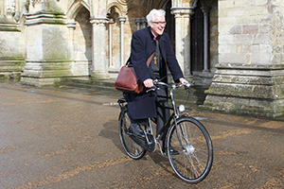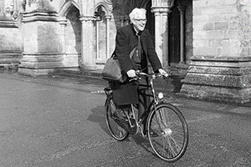
Photo: ‘2017-6 Bishop Ed Bike’
Colour photos folder here
Grayscale photos folder here

Bishop Goes to Rome

The Rt Revd Edward Condry, Bishop of Ramsbury, is going to Rome. Not in a theological sense, but by bicycle.
The famously keen pedaller will ride a whopping 1,200 miles from Canterbury to the ‘Eternal City’ in aid of the Friends of Erlestoke Prison. He will follow the ancient pilgrimage route, the Via Francigena, first recorded by Sigeric, Archbishop of Canterbury, in AD 990.
“Erlestoke Prison is near where I live. The Friends support the prisoners, their health, well-being and rehabilitation, as well as their families. They fund courses and training, and have donated to the Chapel. My pilgrimage will take 14 days of cycling.”
Bishop Edward can be sponsored online at bit.ly/BishopEdward.

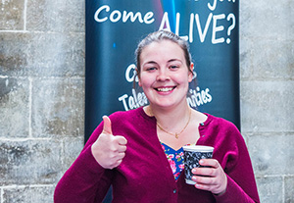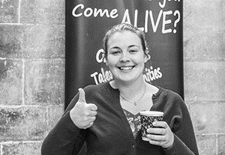
Photo: ‘2017-6 Leila Mather’
Colour photos folder here
Grayscale photos folder here

Following God’s Call

“Knowing God’s presence while doing completely new things is incredible.”
26 year-old Leila Mather wanted to be an opera singer at first. Then a mystical experience changed her life’s direction.
“I was home from college for Holy Week, at the Maundy Thursday Vigil in St John the Baptist, Tisbury.
“Suddenly, I felt the walls closing in around me and saying ‘watch and pray and serve me’. It became apparent soon that I was being called by God to explore a vocation to priesthood.
“My parents are atheists, but I went to the Christian Union at school because they gave me free chocolate biscuits.
“Through that, I went to a Christian summer camp, but found it a bit like brainwashing! Yet when I came home, I started reading Isaiah. Lo and behold, there was Jesus. I became a Christian through Isaiah and the Psalms.
“At university in Bristol, I got heavily involved in Christian Union, teaching the faith and practical service. Then I went to music college in Cardiff. That’s when I had my Holy Week experience.
“My first job was as mistress at a Roman Catholic boarding school. It was really fun, and I loved the brothers. While there, the Diocese supported me to go to a ‘BAP’ - a selection panel for ordinands. At that, I was told to get some more experience of the Church.
“I’ve spent the last year in a Diocesan scheme living with other young adults in a house in Poole, exploring where God is calling us. I’ve done a parish placement at Holy Angels, Lilliput, doing pastoral visits to homes and hospitals, leading worship preaching. I’ve also made friends for life.
“I went back to BAP in April, and was recommended to start training this year at Westcott House, Cambridge.”
Did you know? There is a 14% increase in those to start training for priesthood in the Church of England this year. A quarter of those are aged under 32.

