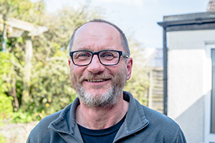
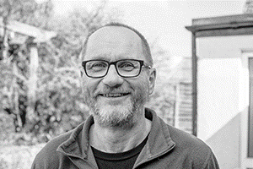
Photo: ‘2017-4 Simon Dawson’
Colour photos folder here
Grayscale photos folder here

A Mentoring Ministry

“As well as preaching, I really value the mentoring part of my ministry.”
Brought up in a churchgoing family, Simon Dawson drifted from faith during a busy career in the Royal Navy and as a sports coach.
“I began exploring faith again in my 30s, including Hinduism and Buddhism. As I’m gay, I had negative views on the Church, yet I found myself pulled steadily into Christianity.”
“Studying theology and realising the space for differing views broke my resistance down. I was also drawn in by the warmth of welcome for my partner, David, and I when we attended St James’, Piccadilly, in London.
“I first thought about Licensed Lay Ministry there after leading discussion groups and occasionally preaching.
“Then we moved to Wiltshire, worshipping at St Michael’s, Winterbourne Earls. The call to lay ministry developed further, and I was licensed in 2015.
“I now work across the Bourne Valley Team. I value how people of varying traditions and views worship together in rural churches. One week, I’ll develop a praise service for a more Evangelical church; the next I’ll take BCP Matins. The variety keeps me fresh and engaged.
“I also love using my sports coaching experience to mentor people, walking alongside them as they develop in faith.
“I try to live with a Benedictine balance of work, prayer and study. We keep sheep and chickens and grow veg on our land. Working outdoors connects me to the seasons and the Church year.”

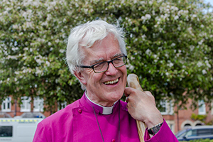
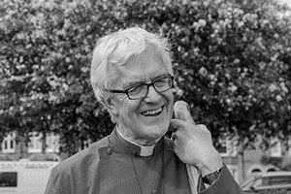
Photo: ‘2017-4 Bishop Ed’
Colour photos folder here
Grayscale photos folder here

Monthly Letter
The Rt Revd Edward Condry
Bishop of Sherborne

St John’s telling of the Resurrection is my favourite for Easter Day.
Mary Magdalene finds Jesus alive when she expected death.
I do find it easier to preach on Good Friday than on Easter Day.
The crucifixion is so much more apparent than the resurrection. The pain of the world: in Sudan, in Syria, as well as in our own lives is so all pervasive.
The forsakenness of Christ on the cross is close to experience. “My God, My God why have you forsaken me” is a cry of all humanity.
Yet there is that magical moment when Mary Magdalene goes grieving to the tomb, just as many visit graves in Easter churchyards in our time.
She goes with her memories and her grief. There she finds the Risen Lord, and hope is restored.
I have heard the resurrection compared to many things: to the Morning Star in the still dark sky; to the Rising Sun; to Spring itself; to the Lark Ascending; as well as to wings ascending. (I’ll leave aside eggs and bunnies).
Then one day I read someone say that the resurrection is a single event which gives meaning to all things.
It is experienced day by day.
At first this perplexed me further. What was I missing?
I think I was always looking for something grand and dramatic.
God’s work is so much more often quietly gentle.
Rupert Shortt in his recent book God is No Thing (highly recommended) says, “Christianity – at its centre, the story of love’s mending of wounded hearts – forms a potent resource for making sense of our existence”.
That’ll do for me. That is resurrection.
Mary Magdalene comes with her grief and sorrow and finds love and life again.
Christ is Risen. Alleluia!

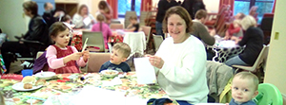
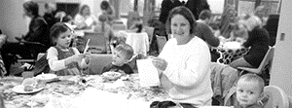
Photo: ‘2017-4 Breakfast@9’
Colour photos folder here
Grayscale photos folder here

Worship and Breakfast

The Diocese is to launch a new ‘hub’ in Canford Magna supporting churches with ‘Breakfast Church’ congregations.
In the Breakfast Church model, people sit café style around tables during the service, with breakfast provided. It is often attractive to young families.
Canon Chris Tebbutt, Rector of Canford Magna, will co-ordinate the hub. He set up a breakfast service just over five years ago, which ran successfully ever since.
“We use connections developed through infant baptism to introduce people to the service”, says Chris, “It’s inclusive of all sorts of people. One thing it is especially effective at is attracting the whole family – Dads as well as Mums.”
Breakfast churches have been effective in churches of different traditions, and some regularly celebrate the Eucharist.

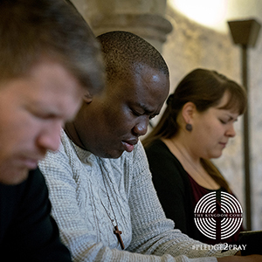
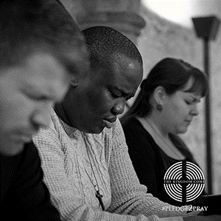
Photo: ‘2017-4 Praying’
Colour photos folder here
Grayscale photos folder here

Praying for Renewal

The Archbishops of Canterbury and York have invited all Christians to join a global wave of prayer later this Spring.
From Ascension to Pentecost, Thy Kingdom Come will bring Christians of all traditions together to pray for the renewal and revival of the Church, and for Christ to be made known.
Gerry Lynch, Diocesan Thy Kingdom Come Co-ordinator said, “Taking part doesn’t necessarily mean having a big, fancy, event. Why not encourage people at your church to commit to saying the Lord’s Prayer at home every morning, or have regular home groups focus meetings around the Lord’s Prayer during the period?
“There are lots of other ideas and resources for ideas big and small online at www.thykingdomcome.global.”

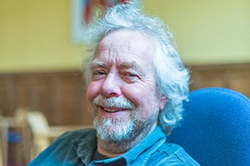
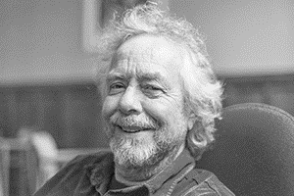
Photo: ‘2017-4 Julian Richards’
Colour photos folder here
Grayscale photos folder here

Digging Around for Others

“I have a passion for engaging people with the heritage of their area.”
Julian Richards worships at St James’ in Shaftesbury and is known for being the presenter of Meet the Ancestors on BBC TV and Mapping the Town for Radio 4 for seven years around the millennium.
“I grew up in a traditional churchgoing family in Nottingham, but as a teenager found it too comfortable and rejected it.
“It was much later that a dormant faith reawoke, after university and several years working as an archaeologist. Sue, now my wife, and I wanted to get married, and we finally felt settled in a place when we moved to Shaftesbury.
“Both the suburb and church of St James’ are strong communities, which appealed to us, and our clergy have been good at helping people feel part of that.
“Most archaeologists work as part of the planning process, so I’m lucky to make a living as a freelance lecturer and teacher. While I no longer do TV, I make non-broadcast films for museums and such.
“Stonehenge has been a big part of my life. I spent a decade working in the field there, which is like winning the lottery for an archaeologist. I wrote English Heritage’s current guidebook to the site.
“I’m fascinated not only by Stonehenge’s past, but its present as a global icon!
“I was churchwarden for a while but my career didn’t allow the time it deserved.
“My main church role now is running our annual recycling and vintage sale for the Sudan Medical Link. This started after we thought about how to recycle more as part of being an Eco Church.
“Most of us have too much ‘stuff’ and need to declutter. We thought by helping people sell what they don’t need, we could help people who have too little.
“Older people are often surprised how ‘in’ kitsch from past decades is today. I seem to have a real eye for that!
“Leafleting the parish looking for jumble raises our church profile, and we raise a few grand to help others too!”

