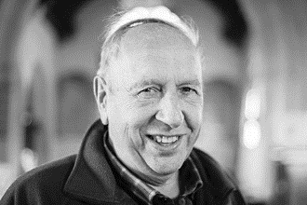
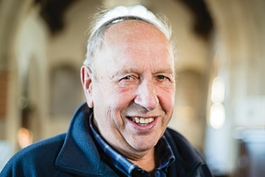
Photo: ‘2017-1 Derek Old’
Colour photos folder here
Grayscale photos folder here

Serving the Village

“I’m Dorset through and through!”
Derek Old has been churchwarden at St Eustace in Ibberton for 42 years. At the New Year, he got a special reward for services to his village - he was awarded the British Empire Medal.
“They say it’s not ideal, but with only a hundred people in Ibberton and a Methodist Chapel, it doesn’t leave many people to volunteer.
“I was born in West Stafford, then lived in Buckland Newton, where I started serving at the altar at Holy Rood aged nine. I went to school at Foster’s in Sherborne and was confirmed at the Abbey. My wife is from Ibberton, so I was married here at St Eustace in 1960 and we came to live here in 1963.
“We’ve farmed all our lives. The carol service here was always after Christmas because so many people were in poultry.
“I usually made an agreement with my fellow wardens over the years that I would do the manual side of the job if they did the ‘religious’ side.
“Our churchyard is all steep slopes on top of a hill, so it takes some looking after!
“Over the years, I had the bells rehung as a stationary chime after one was cracked, and the clock electrified.
“We’ve lost a few older people recently, including our organist of fifty years. Those are sad and hard blows.
“I was chairman of the parish council for 38 years and village hall chairman. One of the things I’m proudest of was getting the cricket club going.”

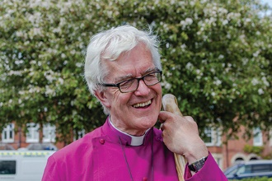
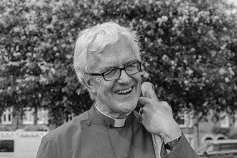

Photo: ‘2017-1 Bishop Ed’
Colour photos folder here
Grayscale photos folder here

Monthly Letter
The Rt Revd Dr Edward Condry
Bishop of Salisbury

I drove to Sunday morning church recently in a thick winter mist. I had to scrape the ice off the windscreen just to leave the house.
The familiar route was changed. The trees hung in the light. Two deer ran ahead of me on the road.
There are, it has always seemed to me, two ways of experiencing being a Christian.
There are those, who are perhaps very fortunate, who seem to sense God’s presence, and the inspiration of His Spirit very easily and naturally.
There are others, and I am one, who find that we simply cannot summon up God, like Aladdin rubbing his lamp and the genie appears.
This is absolutely not the same as saying that I don’t believe. It’s just that I don’t experience God at all times in all places. So I am one of those for whom faith is a search.
This is not the same as doubt, although for some people it may well be. I’m not talking theory here. I’m talking about experience: what it feels like to be a regular Christian. Someone who goes to church pretty regularly.
It can feel like driving through the mist.
The point for me is nevertheless to expect God.
The aim is to put myself, if you like, in His way. That’s what I am doing when I pray.
I don’t necessarily experience God every time I close my eyes and put my hands together. But I do hope. I do expect.
It’s a continual, persistent, and all-important question.
It’s like the Orcadian poet Edwin Muir’s meditation on Good Friday:
Did a God
Indeed in dying cross my life that day
By chance, he on his road and I on mine?

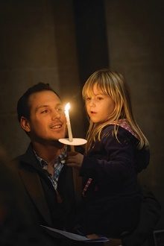
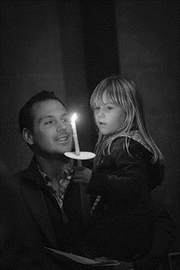

Photo: ‘2017-1 Candle Dad Daughter’
Colour photos folder here
Grayscale photos folder here

Praying Together in Lent

Bishop Nicholas is asking people to join him in prayer this Lent using Praying Together, a framework for shared daily prayer for the season.
Bishop Nicholas said, “This is a simple pattern which can be followed in a time as short five or ten minutes to as much as half an hour. It can be used by individuals or in groups.
“For each day in Lent, there is a very short bible reading, a reflection, prayer and suggested action.
“Prayer changes us, especially when we pray together with others. There can be no renewal without prayer. Jesus said we should pray for what we want. It is the heartbeat of the Christian and the Christian Community.”
Full details will be in next month’s edition of Grapevine.

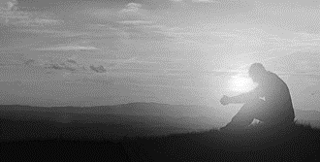
Photo: ‘2017-1 Sunrise Man’
Colour photos folder here
Grayscale photos folder here

Exploring Prayer

Four events across the Diocese in February will help people and parishes alike strengthen their prayer life.
The events, Exploring Prayer, will be led by Brother Sam SSF from Hilfield Friary and Bishop Michael Perham.
Set within the context of a day of worship, those attending will be led in an exploration of how we pray, both individually and together and there will be opportunities to explore different styles of prayer.
The Diocese’s Director of Learning for Discipleship and Ministry, Canon Jane Charman, said, “Prayer is at the centre of our Diocesan vision of Renewing Hope: Pray, Serve, Grow. We are often asked for resources to strengthen prayer life.
“Information on booking is available at www.bit.ly/exploringprayer.”

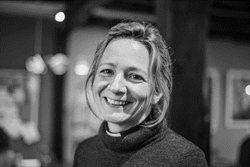
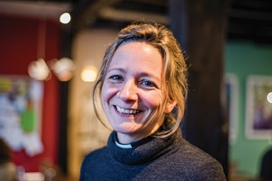

Photo: ‘2017-1 Becky Roberts’
Colour photos folder here
Grayscale photos folder here

Learning for Leadership

“Real leadership is about getting alongside people and helping them achieve things themselves.”
The Revd Becky Roberts grew up in a church family in the Diocese, at St Mary’s, West Moors. She is now the vicar of Harnham in Salisbury.
“I was an altar server from the age of 11. Before the service began, we had to spend 20 minutes in silent prayer. That’s where I learned to listen for God.
“I knew by the time I was 17 I wanted to be a priest, but in those days it was still impossible for women to be ordained.
“At university in Pontypridd, I attended a very charismatic Baptist Church. It was spiritually very important to me, but I couldn’t sign up to all of it. I wouldn’t be baptised twice or accept male headship!
“I trained as a teacher, and worked in East London and then in Tanzania with CMS. On coming back to London, the call to ordination resurfaced quickly.
“Since ordination, I’ve worked both in parish ministry and as a teacher.
“I came to Harnham four years ago. There is a great sense of community and school links. The people are prayerful and faithful to the Church.
“Because I’m a teacher, I have a passion for learning and helping other people learn. When I came to Harnham, I had been out of theological learning for over a decade and I missed it.
“With Sarum College on my doorstep, I decided to study for their MA in Christian Leadership. To me, leadership is finding your authentic voice, whilst listening and responding to the voice of the community and God.
“One thing I value about the course is that it gives me the chance to study younger women leaders, in a world where leadership is felt to be something done by older men.
“Ordination can be seen that way too. But I’d encourage anyone at any stage sensing a call to ordination to explore it with their vicar and the Diocese.”

