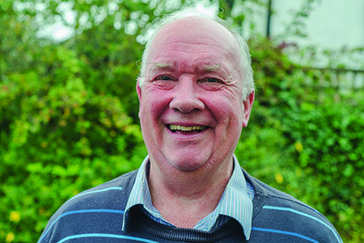
Photo: ‘2016-9 Tim Collins’
Colour photos folder here
Grayscale photos folder here

Life Change Ringing

“The sound of bells always makes people think about the Church.”
Tim Collins has been ringing since his early teens. Bells have even changed the Bradford Peverell man’s life.
“I met my wife at a ringing practice at the world’s heaviest peal of eight bells, Sherborne Abbey.
“As a boy, I was roped into the church choir in Charminster where I grew up”, he says, “When my voice broke, I needed a new hobby, so I took up ringing. Once I became old enough, I travelled all over to ring, making great friends and taking on big challenges.
“In the late 1960s, I once rang 153 full peals in a year, a world record then, though it has since been broken. That’s three hours, three times every week!
“Bells were first put into churches to call people to worship. Over time, ringing became more elaborate. You’ll hear bells around the world, but change ringing developed uniquely in England.
“Bells are also used to celebrate good news and to commemorate tragedy. They speak to people’s souls. A half- muffled peal somehow shakes the head and makes people think.
“Once, I was ringing at a church in Somerset where the bells hadn’t been used regularly for many years. They were difficult bells to ring too!
“Later, we found two women in the porch. One was blind and very old and had asked her neighbour to walk her across a road to thank us. Hearing the church bells had made her day, and the memory still brings tears to my eyes.”

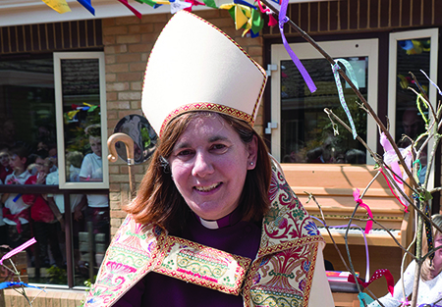
Photo: ‘2016-9 Bishop Karen’
Colour photos folder here
Grayscale photos folder here

Monthly Letter
The Rt Revd Karen Gorham
Bishop of Sherborne

I recently received a thank you letter from a 78 year-old lady from Bridport who was recently confirmed. She goes on to explain how she hopes to set an example to her family, and feels her calling at her stage in life to pray for peace.
The service of confirmation brings together seekers of all ages, wanting to step out and make a commitment to follow Jesus in their lives.
Earlier in September four teenagers were confirmed in Maiden Newton, ready to step out into university life, wanting to share their faith with new friends.
It is encouraging to see God at work in individual lives.
We all have a story to share, and it is often easier to share it when our faith is awakened afresh and we feel energised to tell others of our experience.
Four enthusiastic young people have just launched out on a year’s adventure in Poole testing a calling to ordination and I am sure their faith and eagerness will be infectious!
For many of us, however, faith has been kindled over the years and has become so much a part of us we tend to take it for granted.
We hope it rubs off on those we meet by our attitudes, values and priorities, as we aim to grow deeper ourselves by the weekly rhythm of worship.
That’s all good, but those being confirmed remind me of the calling on all of us to share our faith and the joy we have found in the fellowship of the church because many are seeking meaning for their lives.
As we approach the season of Remembrance, maybe it’s time to draw someone else in.
As the well known hymn says, ‘How shall they call if they have never heard the gracious invitation of our Lord?’

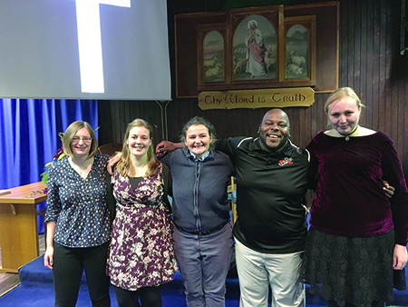
Photo: ‘2016-9 CEMES’
Colour photos folder here
Grayscale photos folder here

Discipleship and Vocation

Projects aimed at encouraging vocation and deepening discipleship in the Diocese have launched in recent weeks.
Church Army evangelist Debbie Orriss is the Diocese’s new Discipleship Co-ordinator. “My passion is to enable people to grow in their faith, and find ways of living it out in the church and the world”, says Debbie.
Debbie will co-ordinate training for lay ministries, and help individuals and communities deepen their discipleship.
Meanwhile, four young adults have started a year living in community in Poole as they explore a possible vocation to ordination.
Placed in local parishes, Augustine, Becky, Leila and Abby will further their Christian education, pray together daily and develop a rule of community life.

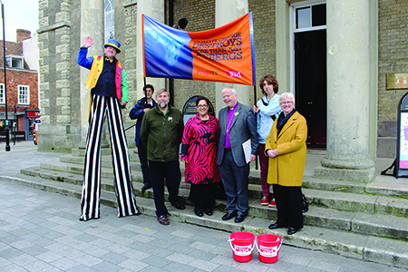
Photo: ‘2016-9 Speak Up’
Colour photos folder here
Grayscale photos folder here

Climate Change Call

Christians and others jointly called for climate change action in Salisbury.
Bishop Nicholas and Christian Aid CEO Loretta Minghella led the march from St Thomas’ Church to the Guidhall as part of the ‘Speak Up’ week of action on climate change. More than 200 events took place across the UK and Ireland.
“Every person who will take an action this week is making a difference”, said Loretta Minghella, “letting politicians know what is really important.”
Arturo Tahup, a Filipino Christian Aid partner and environmental leader, told a story of an entire family swimming for their lives and said, “For us Filipinos, climate change is real. It has been happening here and now and it has really devastated our communities.”

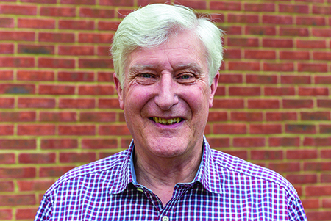
Photo: ‘2016-9 Allen Edwards’
Colour photos folder here
Grayscale photos folder here

God, Beauty and Science

“I don’t understand why people see a conflict between faith and science.”
Recently retired as a nuclear engineer, the Revd Dr Allen Edwards is now a Visiting Professor in the field at Cardiff University, and Associate Priest at Christ Church, Warminster.
“I was brought up in church, and was an altar server right through school, but drifted away at university in Cardiff.
“After studying mechanical and aeronautical engineering, my PhD was in hypersonic aerodynamics. That meant studying whether space shuttles could be steered in the atmosphere!
“Then I was commissioned as an officer to teach at the Royal Naval Engineering College. My faith was reignited there, after our son Paul was stillborn. I suppose that may have pushed others away from God, but it brought my wife Jean and me closer to Him. We started attending chapel where I worked.
“I moved to the UK Atomic Energy Agency, which brought me to Dorset. We went to St John’s, Weymouth, where we both taught at the Sunday School. I was PCC Treasurer, and soon discerned a vocation to lay ministry.
“Just after I finished training, I had another job transfer to Oxfordshire. While worshipping at an Anglican-Baptist Ecumenical Partnership there, I trained as a priest. On retirement, we came to Warminster. Prayer surrounded all our moving decisions.
“To me, the structure and order of creation show the hand of a creator. Science can explain how the world works, but not why the autumn colours are beautiful. Beauty is something where I really see God in creation.
“Aeroplane designers say that an aircraft that looks beautiful when being designed will probably fly. Mathematicians always prefer the most elegant solution to a problem.
“One of the key things about faith is exploring God’s creation, and how wonderfully he put it together.”

