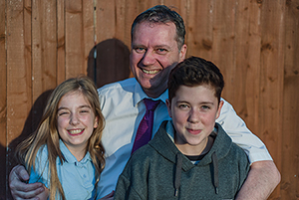

A Family Matter

“It was a magical moment.”
Mike Rothery had a special sponsor at his recent confirmation in Salisbury Cathedral – his 13 year-old daughter, Amber.
“I went to a church primary”, says Amber, who attends Gillingham Top School, “A priest from St Mary’s came every Thursday to take collective worship. My family went to church at Christmas, Easter, and for the fun club.
“I decided to be confirmed in Year 7. Classes were held at our pioneer priest, Eve Pegler’s, house. There was only one other young person. That was OK, as I find older people easier to talk to.
“Everyone was friendly, there was a chance to discuss your thoughts and feelings, and always lots of cake!”
Mike sat in at the end of classes while waiting to pick Amber up. “I had gone to Sunday School as a child”, he says, “and believed in God but drifted away from church. Recently, I started doing some work as a pall-bearer. I thought it would be depressing, but it was a lovely last thing to do for someone. It also got me thinking about the ultimate questions.
“Once, Bishop Nicholas came to Amber’s class. I asked him to prove there was a God. He thought about that, then asked me to prove there wasn’t.
“He said he wasn’t any closer to God than anyone else and Christians were allowed to have questions. That was a turning point. I decided to attend the next confirmation class in Gillingham.”
Amber’s step-sister, 10 year old Olivia, has started confirmation classes too.

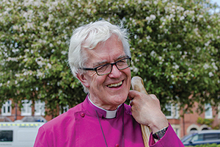

Monthly Letter
The Rt Revd Dr Edward Condry
Bishop of Ramsbury

It is predicted that 25% of care homes for the elderly will close in the next three years. They will not survive the financial pressures they face.
It is sadly significant that one of the reasons is the introduction of the living wage. We know that care workers are amongst the most poorly paid. Simply raising their wages to a realistic minimum will cause homes to close.
It is all made more difficult by population pressures as the number of people in older age brackets increases.
This is not a criticism of local or central government, but an indictment of all of us.
On the face of it, churches should be one place where this trend is countered since the average age of the church member that of the general population.
Churches are good at community, and have their own networks of care. In this diocese the Lay Pastoral Assistants do a lot of quiet good work.
The excellent Wiltshire Community Foundation identified isolation as the main social problem we face. I am sure it is the same in Dorset. Churches do many things to counter this.
Yet there is much church talk which implicitly colludes with society’s views on the elderly. We fail to value the significant contribution older members of our communities play in running churches and voluntary associations.
Too often, I hear churches with older members described as ‘dying’. The worst was someone who said that their church ‘did not do old people’ as ‘there was no future in them’.
If we are a church which believes in the resurrection of Jesus Christ, and if we believe in heaven and eternal life then we should see it as a privilege to serve the elderly who are probably nearer the most significant event which any of us will ever face: the end of this life.

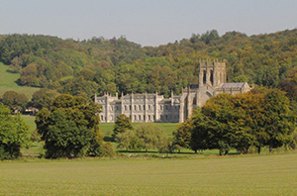

See The Great Stare

Milton Abbey will celebrate 300 years since the birth of Capability Brown, the great landscape designer, with a major exhibition in the Summer.
The Abbey is set in a glorious 500 acre landscape designed by Brown, known as ‘The Great Stare’. The Abbey sits at the convergence of three valleys surrounded by 16 miles of trails.
As well as providing a chance to see the landscape, the exhibition will feature art, photography and embroidery. It is open from 10 July to 21 August.
The organisers are seeking volunteers to help with stewarding for half days. Contact Michael McAvoy on mmcavoy@tiscali.co.uk or 01258 880333, if you would like to help.
Learn more at www.capabilitybrownatmiltonabbey.org.

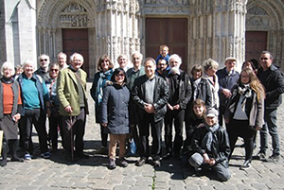

Une Entente Cordiale

“Joyful, enlightening, generous, fantastic, marvellous, accommodating, development, gastronomic!”
That’s how a group from Whitton Benefice, near Marlborough, summed up its visit to Notre Dame des Bois Parish in the Roman Catholic Diocese of Évreux in Normandy. This returned a visit to England by Notre Dame in 2014. Our Diocese has been twinned with Évreux for 29 years.
Both Whitton and Notre Dame cover a number of small villages. They share similar issues of rurality and maintaining Christian witness in deeply secular societies.
Many ideas on lay ministry and youth outreach were shared, as well as worship and good Norman food and drink!

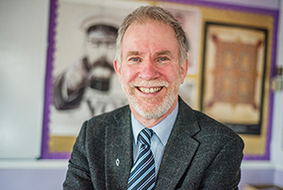

Called To Teach

“My calling is to teach in state schools.”
Martyn Whittock has been preaching since the age of 17, but when asked if he would consider ordination, he is clear about his true vocation. “I still love teaching after 35 years, all of them in comprehensives”, he says.
Like his father he is a Methodist Local Preacher, and is now a Licensed Lay Minister at St Thomas’, Trowbridge.
Martyn teaches history at Kingdown in Warminster, a large school with 1,500 pupils and no religious foundation.
“I try to be a good witness in the classroom”, he continues, “so faith must make a difference seen by others.
“At school, my job is not to preach, but I am here to be me, and being a Christian is part of me. Pupils know this and sometimes ask me about it.
“I became an Anglican during my first job, at Queen Elizabeth’s in Wimborne. We started attending Canford Magna Parish Church, and I got confirmed as a mark of solidarity with Anglicanism!
“We’ve been worshipping at St Thomas’, since 1992. It’s a great church, serving all ages, including families, and working well with other churches.
“The ministry of Licensed Lay Ministers is varied, but for me it’s primarily about preaching and teaching.”
Martyn recently co-authored a book with his daughter, Esther, called Christ: The First 2000 Years. She is a recent Cambridge Theology graduate, teaching at a Birmingham comprehensive with a mainly Muslim intake.
“We geared the book to general readers and undergraduates. We hope Christians will find it worthwhile. It should also interest people of any faith or none wanting to learn about what Christians believe and why.
“It was great fun writing the book with Esther. We have a very relaxed relationship, and we’ve always been a very chatty family!”

