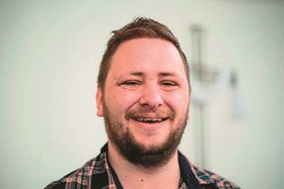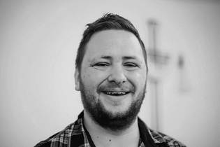

Growing Through God

“God has grown me so much through the past three years.”
Poole born and bred, Nigel Williams is a churchwarden at Christ Church, Creekmoor. At 26, he’s still one of the youngest around after three years.
“We went to St George’s, Oakdale, as a family. I moved to Christ Church in my early teens, after my sister got involved in the youth programme. I went to church through habit and for friends. I didn’t have a real faith.
“Outside church, I lived a wild lifestyle! At 18 I was given the choice of leaving school or being expelled. My dreams of being an accountant were in tatters.
“I prayed, ‘God, if you’re real, sort my life out’. Soon after, I met an old school friend at Soul Survivor. When I told him my story, he asked had I ever thought of doing a degree in theology.
“The next day Janice Audibert, our vicar, asked me exactly the same thing! I said to myself, ‘Lord, you are my God!’
“God had to do a big job to transform me! I enjoyed studying theology at Moorlands Bible College. I returned to Christ Church as Mission and Outreach Worker. When the funding for that ran out, I volunteered to be churchwarden.
“It has been challenging and more fun than I thought. It has helped me see how the church’s work fits together.
“It can be frustrating too! I’m in charge of maintenance which means fielding phone calls at odd hours when something breaks. But I’d still recommend being a churchwarden. It’s a lot of hard work but very rewarding!”

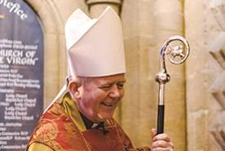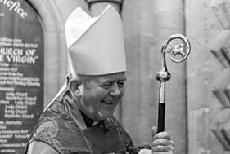

Monthly Letter
The Rt Revd Nicholas Holtam
Bishop of Salisbury

I hope churches will find ways of praying and talking about the Referendum to help people engage and make prayerful, thoughtful, decisions. It is one of the most important political decisions of our lifetime. There are Christians on both sides. Here are a few of the things Christians might want to make sure are considered.
Christianity in Europe: Christianity has vitally influenced European self-understanding, politics and culture. In some ways, Europe is a Christian construct. Our society now is more secular and pluralist. Although there is a risk of growing hostility and enmity, European society is enlightened and tolerant. How do Christian faith and values strengthen our identity and help us to get the best from our diversity?
Love your neighbour as yourself: We live in an inter-connected world. Unless we are good neighbours, our lives on this fragile earth are threatened. I find myself praying about what it means to be English, British, European and Global. Stay or Leave, what is the vision of how we belong together?
Blessed are the Peacemakers: The European Union was created following two World Wars. It has made a huge contribution to peace and prosperity. Given the challenges we face, with instability in the Middle East and the biggest refugee movements for decades, how can we best be peace makers?
Care for God's creation: There is a consensus about the scale of the environmental challenge facing us. We cannot continue defining success by consumption. We need to move quickly to a sustainable and renewable use of resources. Nature knows no national boundaries, so we must work together. What political institutions will best support caring for God’s creation?
Jesus said ,”Where two or three are gathered in my name, I am there among them.” Let’s do it.

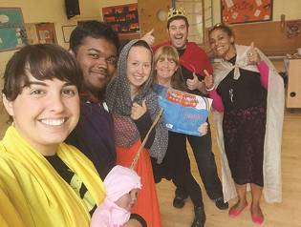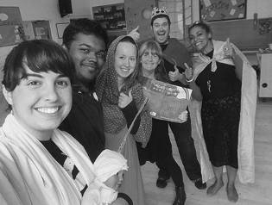

Giving the Gift of the Bible

Open the Book, run by the Bible Society, aims to give every primary school child a chance to hear the Bible’s story.
Volunteers from churches go into schools and tell stories in 10-15 minutes, in an accessible, fun, style.
Pippa Rossiter, who helps organise the Open the Book programme in Blandford Forum, says, “It’s brilliant at bringing the generations together and great fun for everyone. It helps schools fulfil their statutory requirements.
“I love storytelling, so it’s rewarding to see the children responding to and getting involved in the Bible stories.”
The Open the Book trainer and co-ordinator in this Diocese is Barbara Meardon, who can be contacted on barbara.meardon@salisbury.anglican.org or 01722 746 953.

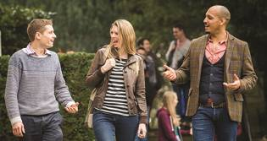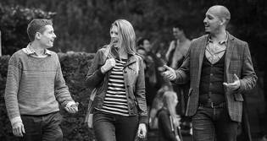

Following God’s Call

Like the rest of the Church of England, the Diocese of Salisbury is giving more support to young people exploring ordination. One example is the Pray Serve Grow gap year scheme, a new opportunity for 18-29 year olds.
Participants will spend a year living in a small community in Poole, with others exploring Christian ministry. They will get ministry experience in a local church and receive theological training with Sarum College and others.
Board is provided free of charge and participants will receive a small allowance, study time and time off.
Learn more about this scheme and other opportunities to explore where God is calling on the new vocations website www.salisburycalling.org.

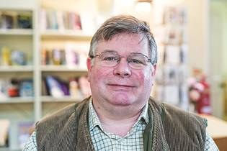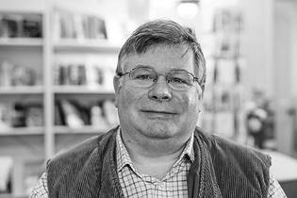

A New Role

“I can’t believe how much joy I get from leading worship.”
Michael Page’s whole 42 year working life was as a Cathedral Verger. He is now adapting to “moving from a backstage to a front-of-house role”. He was commissioned on Passion Sunday at St Bartholomew’s in Royal Wootton Bassett as a Licensed Lay Minister.
“I was born in Germany as my father was in the Army, and we emigrated to Australia when I was ten. My first job was at St George’s Cathedral in Perth. On moving to the UK, I worked at Chelmsford Cathedral and St John’s College, Cambridge, finishing up as Dean’s Virger at St Paul’s Cathedral.
“My wife, Honor, and I retired to Royal Wootton Bassett in 2009. It is a friendly, caring, town with an active sense of community. That is very attractive after living in London.
“We found St Bart’s to be a wonderful church and got involved quite quickly. I resisted getting involved in worship at first, so Honor and I could sit together in Church for the first time ever!
“Through part-time study, I took a Foundation Degree in Ministry run by the Diocese. It was not only fascinating but great value.
“This is the same course that was taken by Licensed Lay Ministers, and it soon became clear that I had a call to that role.
“A Licensed Lay Minister can lead worship and preach, but doesn’t preside at Holy Communion.
“My training was excellent. I was taught how to preach, how to take a funeral and how to care for people pastorally. A real eye opener was a placement with the chaplaincy team at Bath Hospital.
“The incoming Mayor of Royal Wootton Bassett, Mary Champion, has chosen me as her Chaplain for 2016-17. As well as being a great honour, as this role is usually filled by clergy, I hope it will lift the profile of lay ministry.”

