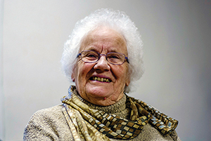

Faith For A Lifetime

“God is there through thick and thin!”
Jean Downham, a parishioner of St Mary’s in Calne, has a deep faith in God and gratitude for her life in the Church.
“My faith kept me going in some very dark moments”, she says, “and the friendship and support from fellow churchpeople has blessed my life.
“I was sent to church by my parents growing up, getting involved in youth clubs, and learning to ring bells. I rang at St Mary’s for 50 years. I can’t manage steps now, so only ring in some nearby villages like Compton Bassett.
“I met my husband, Ray, through a church ‘20s club’. He was very involved too, a General Synod member for many years. He died 12 years ago.
“He was also Mayor of Calne three times, which explains our connection with St Edmund of Abingdon. Driving back from our twin town in Burgundy, we stopped at St Edmund’s resting place at Pontigny, which was nearby.
“St Edmund was Vicar of Calne in the 13th Century, and later Archbishop of Canterbury. He was a caring priest who gave most of his money to the poor. He wasn’t afraid to challenge powerful people – even the Pope – on corruption.
“We helped organise the ecumenical pilgrimage for the 750th anniversary for his canonisation in 1996 with other organisations connected with him. Then I helped organise a parish pilgrimage to Pontigny three years ago.
“We have a special celebration of St Edmund on Pentecost Sunday this year at St Mary’s, with visitors from abroad.”

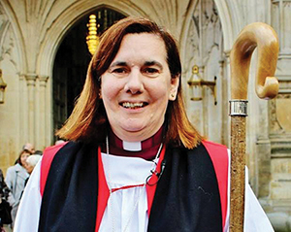

Monthly Letter
The Rt Revd Karen Gorham
Bishop of Sherborne

Not long ago, I knelt in Westminster Abbey with oil literally pouring down my face. It was an amazing moment, which few people saw. We had been warned that the Archbishop liked to use a lot of oil, but nothing prepared me for sensing so physically God’s abundance from my head to my chin!
Fortunately a towel, produced fairly quickly, stopped the oil getting totally out of control, but the smell stayed with me for the rest of the day. It was a reminder that living the Christian life of service embraces all of who we are: our sight, our mind, our actions, but also our hearing, touch, taste and smell too.
Holy Week and Easter are times when we are all invited, by God and God’s Church, to participate fully and walk with Christ, engaging our senses, in the most significant event in history.
So we join in the cries of Palm Sunday and Good Friday, aware of the times we rejoice, but also collude. We taste the Passover meal, celebrating with bread and wine, mindful too of God’s grace in our temptations to betray, or deny or blame. We come before the Cross on Good Friday in penitence for our pride, and sorrow for our sins, silent and moved, sometimes to tears, by the passion of Christ.
We then wait expectantly in anticipation, filling our churches with sweet smelling flowers, and colour once again, ready for Easter Sunday, when with fire, party poppers, the water of baptism and eggs we greet the risen Lord.
An extravagant offering may sometimes be embarrassing in our more reserved culture.
Easter, however, demonstrates that we serve Christ who gave everything and whose love, summed up in that famous hymn of Isaac Watts, ‘demands our soul, our life, our all.’



Breaking Debt’s Chains

Christians Against Poverty aims to release people who are held hostage by the chains of debt and poverty.
Charlotte Bell, manages the Salisbury Debt Centre which opened in 2014, and explained CAP’s work:
“We put together plans to help people pay off their own debts, and mentor them in managing their money better.
“We don’t pay off debts, but negotiate with creditors to reschedule payments. We support people until they’re debt free. This can take up to five years.
“Many of the people we work with are not just poor, but very isolated and lonely. So we also invite people to events and reconnect them socially.
“I would encourage churches thinking of setting up a debt centre in their area to contact CAP headquarters on 01274 760720 or www.capuk.org.”

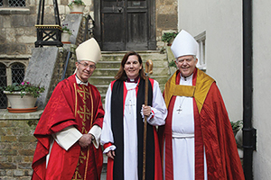

Welcome Bishop Karen

The Rt Revd Karen Gorham was consecrated the 36th Bishop of Sherborne at a stunning service in Westminster Abbey on 26 February She was welcomed to Dorset 10 days later at a special Choral Evensong at Sherborne Abbey.
Speaking after the service, Bishop Karen said, “A key role for me is to encourage and equip Christians to share God’s story of love. I am looking forward to this adventure with a mixture of excitement and trepidation.”
Bishop Nicholas added, “My vision for the Diocese is one of Renewing Hope, and I have confidence in Karen’s ability to lead the churches and people of Dorset into a renewed hope, rooted in prayer and service of others, that will lead to growth in all sorts of ways.”

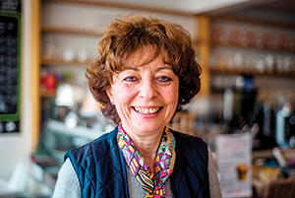

Passionate Lay Ministry

“I feel privileged to be called to be a ‘window’ for the light of God to the people around me.”
Judy Anderson is passionate about her role as a Licensed Lay Minister (LLM). The retired music teacher worships at St John the Baptist, Tisbury, and is the Diocese’s Vice Warden of LLMs.
“I was baptised a Presbyterian”, she says, “My parents didn’t go to church but sent me to Sunday School because the minister asked them to at my christening.
“As a student at the Royal Academy of Music in London, I worshipped at All Souls’, Langham Place, but drifted away from church after graduating.
“During my second teaching job, my Head of Department invited me to Sunday lunch – and church beforehand! She attended a lively, very charismatic, Anglican Church, which suited me. I got really involved there, and was confirmed as an Anglican, to me a sign of recommitment to faith.
“While taking a theology course, I felt a call to Reader ministry, and was admitted and licensed in St Albans Diocese in 1992. Lay ministry is vital. Our churches are full of gifted people, not called to priesthood, but with much to give in other ministries.
“My last job was as a housemistress in a boarding school. I was the only Christian many of the girls knew well, at a really important stage in their lives. I was exactly where God needed me.
“George Herbert’s poem, The Windows, means a lot. It reminds us that God can take our best efforts, inadequate though they may seem, and speak to people’s hearts through our words.
“The Church celebrates 150 years of formal licensed lay ministry this year. Every church in the Diocese is asked to join in on the Sunday after Ascension, and all are welcome to our Diocesan celebration in the Cathedral at 11 am on Saturday 1 October.”

