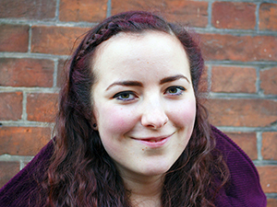

Youth and Responsibility

“At the opening service in Westminster Abbey with the Queen, I realised the responsibility I’ve been entrusted with.”
Fenella Cannings-Jurd is an altar server and sub-deacon at St Peter’s, Parkstone, in Poole. Aged 20, she’s also General Synod’s second youngest member.
“Christianity was always part of life for my Mum and me”, she says, “We moved around a lot so went to different types of churches. We came to St Peter’s three years ago as I wanted to be confirmed and they offered good preparation.
“We stayed and got involved as it was a genuine and welcoming community.
“I study history at St John’s, Durham, which is amazing. Daily worship in a residential community has expanded my horizons and, as I’m High Church, so has worshipping in an Evangelical context. As the college trains clergy, I live with lots of young couples and children, which aren’t normally part of undergraduate life.
“The women bishops’ vote in 2012 confused me, so I decided to understand General Synod. I did a special project on General Synod, women bishops, and equal marriage in my final school year.
“I thought people would laugh when I mentioned I would like to run for Synod last year. Instead, I was really encouraged, especially by a chaplain at university. I was surprised to be elected!
“My first meeting in November was fascinating, learning the ropes. The press often emphasises the Church’s divisions, but it really did feel like we were all on the same side.”

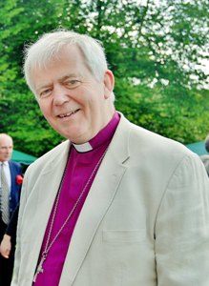

Monthly Letter
The Rt Revd Nicholas Holtam
Bishop of Salisbury

The latest statistics from the Church of England show average weekly attendance has fallen below a million. I liked the press release with this, that said this exceeds the combined membership of all UK political parties. Christmas attendance was 2.4 million and the C of E still does 3,000 funerals well over 2,000 weddings and 1,000 baptisms every week. In the Diocese of Salisbury, we have the third highest proportion of the population attending Church, typical of rural areas where churches are small but strongest.
Across the country there are 15,712 open Church of England parish churches. Church life is sustained by a wide range of volunteers, including 25,000 churchwardens, 6,600 Licensed Lay Ministers and a host of others. There are just over 8,200 full time, paid, Anglican clergy in dioceses and a further 1,500 chaplains in fields like the NHS, prisons, the military and education. This number is supplemented by 3,100 licensed unpaid clergy. Around 5,700 active retired clergy also have permission to officiate.
The Church of England provides activities outside church worship for 500,000 children and young people. More than 80,000 volunteers run children’s or youth activity groups sponsored by the Church.
There are nearly 4,500 C of E Primary schools, a quarter of all primary schools, over 200 Church secondaries, and 500 independent schools of Anglican foundation between them educating 1.3 million children.
Over 400 Church schools have become academies. Dioceses recruit, train and support around 22,500 governors.
So, yes there has been a long period of decline but there is also a lot of life. Why would we be surprised? Church is an enduring institution. Our hope is renewed constantly by the risen life of Jesus Christ.



Primates Meeting Outcome

Given the public disagreements within the Anglican Communion it was a small miracle the Primates agreed to continue to journey together.
For the Episcopal Church of the USA there are consequences for going ahead with same-sex marriage. For 3 years they cannot represent the Communion or take part in internal discussions about doctrine or church organisation. Scotland and Canada are considering the same issues this year. There is growing movement for change within the C of E. The Archbishop apologised to those who are LGBTI for past and present pain caused by the Church.
With enormous social and cultural change, it is no surprise that Christians disagree. We must ask how we walk together and how change happens. In the process we should also take better care of one another in Christ’s name.

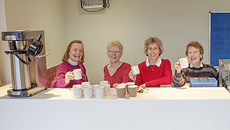

A Place of Comfort in Court

Mothers’ Union has opened a café in Salisbury Law Courts. The previous café was losing money and closed in 2014.
“This was a huge loss”, says Andrew Wells, court chaplain, “Courts place great stress on defendants, victims, staff, families, and many others. There was nowhere for people to relax or for the team to take people, sometimes in real distress, for a chat and a cuppa.
Diocesan Mothers’ Union President Rosie Stiven adds, “We agreed to run the café, which is staffed by volunteers, to help fulfil our vision of supporting families. The Bishop of Salisbury funded the equipment for the project. We need some more volunteers of any age or gender. If you can help, please contact Joanna Woodd on 01722 333 402 or joanna.woodd054@gmail.com.”

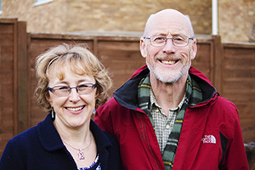

Christ For All Nations

“Much of my ministry has involved working with people of different cultures. I’m glad it will continue to.”
Recently retired to Trowbridge, the Revd Andy Yorke was born the vicar’s son in Ogbourne St Andrew in Wilts. They later moved to Sussex, where his father died when Andy was just 10. After a brief flirtation with farming, Andy followed in his father’s footsteps.
“My multi-cultural ministry began as a curate in Christ Church, Spitalfields. In the ‘70s, before the bankers arrived, this was a very diverse part of the East End, with people of many different faiths.
“I was wondering what God had planned next when I was told they needed clergy in Canada’s Diocese of the Arctic. For ten years I was vicar of an Inuit town of 1,000 on the Arctic Ocean coast, called Tuktoyaktuk, with a second church on Banks Island, 300 miles further north.
“I met Rachel in England at this time. She had a growing interest in mission, and had helped support the Diocese of the Arctic. Later we married and she joined me in Canada. We spent three years in a Gwich’in Indian community inland at Fort McPherson. Afterwards, we spent 23 years on the Isle of Wight where we raised our three daughters.
“We remain in touch with our Arctic friends and sometimes visit. This is a beautiful area with lovely people, rich cultures and wonderful crafts.
“Arctic ministry can be challenging, with high levels of unemployment, alcoholism and suicide. Climate change is causing real problems as the tundra and ice thaw. I’d still tell a young priest or youth worker considering doing something different to give it a go!
“Retirement is starting to get active! Trowbridge has become very ethnically diverse, so the vicar of St James’ has asked me to run an international housegroup. Rachel is training to teach English as a foreign language, and we host overseas schoolchildren learning English for immersion visits to Britain.”

