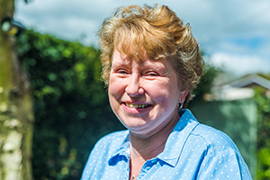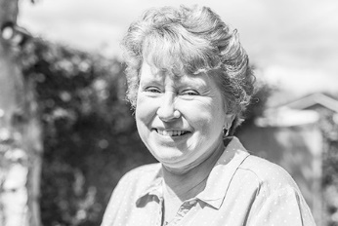

Photo: ‘2017-5 Lyndy Bishop
Colour photos folder here
Grayscale photos folder here

A Voyage to Lead Worship

“I was a peripatetic music teacher – now I’m a peripatetic worship leader!”
Lyndy Bishop’s upbringing wasn’t pro-church, but things started to change when she fell in love with Kerry, a fellow musician and devoted church organist.
“My journey of faith started on the altar step when we were married. I made my vows, consciously and sincerely, to God.
“I was still detached from the Church, but over the years odd events happened.
“I reluctantly agreed to teach violin to a murderer in Erlestoke Prison who had passed Grade 4, thinking someone willing to work so hard deserved a new chance. The only audience we ever had was after the chapel Sunday service. At first, the other inmates jeered, but over the weeks they began to listen intently.
“Years later, Kerry started teaching at Warminster School. We befriended the overseas boarders who rarely saw family or friends from home. Just then, the vicar asked me if I’d been baptised. Aged 45, I still hadn’t. I decided to have my baptism in the school chapel, with the children we befriended as my sponsors.
“I still only went to the Saturday Eucharist. Fr Anthony, an older priest who has since died, became my spiritual director, helping me deepen my faith.
“I started to pray with people often, for healing especially, but sensed God wanted more. On talking to clergy and praying, a call as a Lay Worship Leader emerged, and I really loved the training.
“I see myself as a reserve, helping out our clergy by leading services in churches and nursing homes as I’m needed.”

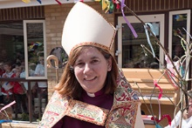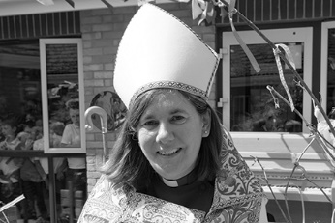

Photo: ‘2017-5 Bishop Karen’
Colour photos folder here
Grayscale photos folder here

Monthly Letter
The Rt Revd Karen Gorham
Bishop of Sherborne

‘Jesus was praying in a certain place, and after he had finished, one of his disciples said to him, “Lord, teach us to pray.”’
I don’t know about you, but for me prayer has never been easy. That’s why the Praying Together booklet for Lent proved so helpful. We can struggle with the words, the time, the posture, the routine and then end up feeling guilty because we believe there is an invisible bar which indicates how we ‘ought’ to measure up and how far short we fall.
Jesus’ reply to those questioning disciples, and his own example, can help us look at this more simply. Time for prayer is essential, yet can be anywhere; words can be important, yet Jesus presents his followers with a template which is simple and profound, and most of us know it!
The Lord’s Prayer, said with a heart wanting to connect with a God who loves us and longs to listen, helps us verbalise thanksgiving, confession and supplication. It brings us in touch with God’s priorities and challenges our own generosity and forgiveness. Said with meaning and sincerity, it connects us with God’s ways and God’s will, as we pray regularly, ‘Thy kingdom come.’
Between Ascension and Pentecost, Christians across the world are invited to join the Archbishop of Canterbury in saying those words in a global act of prayer. Events will be held in the Diocese, and worldwide, encouraging us to pray together. We are like those early disciples gathered to pray following Jesus’ ascension, for power from on high to become the people God wanted them to be. Christians are being invited as families and as individuals to pray ‘Thy Kingdom Come’.
In the Lord’s Prayer, we have been given a rich resource not only to sustain us on our own journey but to pray for others on the Way, particularly those who do not know the love of Christ. At this important time in the life of our world – let us pray.

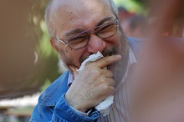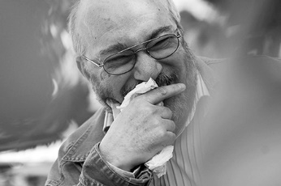
Photo: ‘2017-5 Dementia Friendly Services’
Colour photos folder here
Grayscale photos folder here

God and Dementia

Blandford Forum Parish Church has launched a dementia-friendly service once a quarter called Just As I Am.
The service is organised by Anita Rhodes, a dementia nurse who worships at the Church and represents it on the town’s Dementia Action Alliance.
“Just As I Am is part of our drive to be a dementia-friendly church”, says Anita, “It lasts about 20 minutes, with hymns, a short reading and a short address tailored to older people with memory problems. Around a dozen people attend, so it is very intimate.
“The coffee time afterwards gives sufferers and carers alike vital support.
“Why not get your church involved in your local Dementia Action Alliance, which can help you organise a service?”

Photo: ‘2017-5 Praying With Scripture’
Colour photos folder here
Grayscale photos folder here

Praying With Scripture

The Diocese’s Discipleship Co-ordinator, Debbie Orriss, has set up a collection of resources helping people build reading the Bible into their prayer lives.
“People were enthusiastic about our Praying Together resources for Lent”, said Debbie, “with many finding it helpful to have a portion of the Bible every day to think about, pray through, and respond to.
“I have made a list of Bible reading resources from various publishers. These are written to help children, young people and adults meet with God and grow in faith. Each day there is a small section of the Bible, some reflection, and a prayer or thought to apply to daily life.
“You can see the list at bit.ly/bibleres and there is also a display of resources in Church House.”

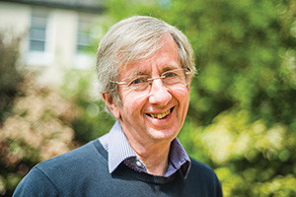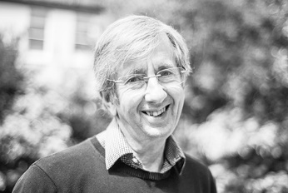
Photo: ‘2017-5 Guy Wilkinson’
Colour photos folder here
Grayscale photos folder here

Bringing People Together

“The underlying theme of my life has been a role bringing people together.”
Canon Guy Wilkinson had a winding path to priesthood. His father’s late vocation saw him ordained when Guy was a teenager, but while at university he turned away from Church for a while.
“As a young man, I tried to change the world through social and political action, first as a development worker in East Africa, then working at the European Commission. During this time my Christian faith deepened, and I felt a persistent call to priesthood that resisted my attempts to push it away.
“With our family growing up, I returned to the UK to work in the dairy industry and finally accepted the call to ordination and parish ministry.
“Some years later, my work with other religions really began in the 1990s as vicar in a majority Muslim benefice in Birmingham. With demographic change, I had to merge three parishes into one, but also ensure a renewed Christian community and Centre in each area.
“That experience led to my appointment as Archdeacon of Bradford and then as Archbishop Rowan’s Inter-Religious Affairs Secretary. This involved dialogue with other religions and work to strengthen parishes in religiously diverse areas. My last stipendiary post was as a vicar in West London.
“Inter-religious work includes receiving people into Christianity from other faiths. In science or politics, people seek to persuade others of their point of view and we should also be ready to speak about the truth of the Gospel. We must remember at the same time that people of other faiths are also loved by God, and can be touched by Him when they pray.
“Bishop Nicholas asked me to be his Inter-Religious Adviser when we retired to Salisbury last year. Inter-religious work is just as important in areas like this where minority faiths are small. Stereotypes arise more easily because people rarely meet those of other faiths.”

