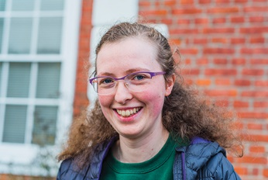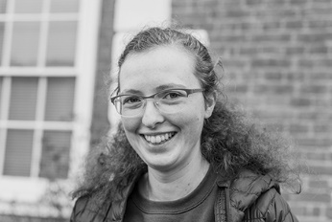

Photo: ‘2017-10 Amy Stevenson’
Colour photos folder here
Grayscale photos folder here

Future Rural Ministry

“I love the community that comes with rural life.”
Amy Stevenson has come from a village on the outskirts of Manchester to Fontmell Magna. She is spending a year in the Diocese’s Pray, Serve, Grow ministry scheme, exploring whether she has a call to ordained ministry.
“I grew up near the Peak District. We went to church at major festivals, then as a teenager I felt drawn to go regularly which meant taking my Mum!
“I joined the church youth club, where the leaders were pretty special. I also got involved in leading children’s worship and altar serving.
“I studied Maths at St Chad’s, Durham, and was asked by the chaplain to be the chapel clerk, effectively the sacristan.
“I started feeling a call towards ministry around the end of of my penultimate year there. At that time, I suffered from PTSD, and I don’t think I would have survived without my faith. That’s when I made it the most important thing in my life.
“I came here after graduating, as only two ministry experience schemes give the option of working in rural parishes, and Salisbury’s is the best.
“As well as time for study, I help with the Mums and Tots, children’s club, pastoral visiting and some office work. I lead the first part of Sunday services and will soon get the chance to preach.
“I’ve gained a better understanding of myself and the Church. I’m hoping to start training for full-time priesthood soon – ideally in the countryside.”

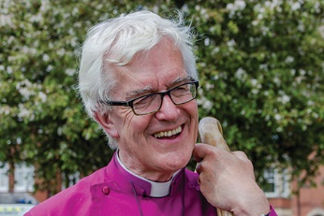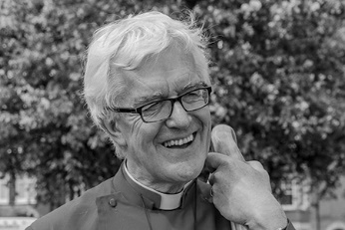

Photo: ‘2017-10 Bishop Ed’
Colour photos folder here
Grayscale photos folder here

Monthly Letter
The Rt Revd Dr Edward Condry
Bishop of Ramsbury

What are the Big Debates as we approach Christmas through Advent? Are they “What do you think of the John Lewis Advert?” and “Shall we have turkey again this year?”
Or perhaps the really big question is this: Do we celebrate streets filled with lights, stars and santas, sleighs, robins and elves; carols in supermarket aisles?
Or do we complain that commercialism has taken over and all is tawdry and cheap, a distraction from the true meaning of Bethlehem?
It is an old debate. I’m on the side of those who celebrate all this.
I love walking down dark streets, looking at white lights in front garden trees.
Bring on the choirs carolling in shopping centres. They all add to the sense of anticipation that some-thing marvellous is about to happen.
There have long been those who objected.
There are some who will have not allowed Christmas Trees in churches.
There have been purists who would not allow carol services before Christmas Day itself.
I see the lights in dark street trees as somehow reminding us of the incarnation of God in our world as the child Jesus.
Carols which sing, “Unto us a son is born” are a prompt, a reminder that beneath all this there is some-thing much greater, much deeper.
The profusion of lights outside the church may remind us all that God sent his Son to all the world, and not just to those in church.
He showed his concern for all: poor and wealthy, grieving and rejoicing.
The lights help me hear the angels sing. The lights lift my heart and give me hope in Advent.
The lights tell of the greater light that shines in the darkness, and that the darkness shall never over-come it.

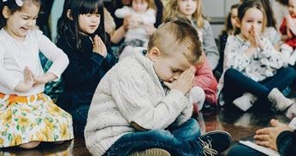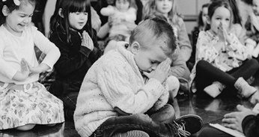

Photo: ‘2017-10 Adoring Kids’
Colour photos folder here
Grayscale photos folder here

The Coming Kingdom

Bishop Karen has joined the Archbishops of Canterbury and York in encouraging people to join an annual global wave of prayer next year.
Thy Kingdom Come runs from Ascension to Pentecost, 10-20 May 2018.
Archbishop Justin writes, “Between Ascension and Pentecost we pray each year for a fresh outpouring of the Holy Spirit, so that we are enabled to proclaim and bear witness to the Good News of Jesus Christ.”
Bishop Karen added, “We are encouraging churches to pray for the renewal of the whole Church at this time. You can join in with your own events, and resources will be nationally available.”
Find out how your church can join in at www.thykingdomcome.global.

[

Photo: ‘2017-10 PGS logo’
Colour photos folder here
Grayscale photos folder here

Good News on Giving

“The Parish Giving Scheme has been nothing short of a positive revolution for us”, says Michael Porter, Treasurer at St James’, Southbroom, in Devizes.
The new Parish Giving Scheme enables people to give to their church by Direct Debit for the first time, and allows the church to receive the Gift Aid automatically, reducing the administrative burden.
Five months after it launched in the diocese, over fifty parishes are now registered with the scheme, large and small, in towns, suburbs and villages. Over 250 people now support their parishes financially through the it.
Donations can also be inflation proofed and changed at any time if circumstances change.
Find out more at www.bit.ly/pgscheme.

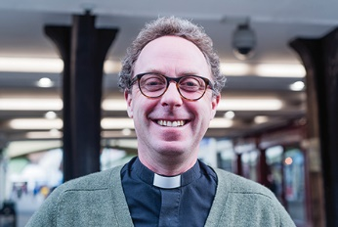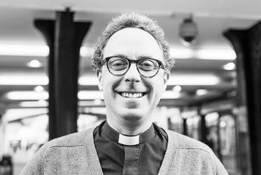

Photo: ‘2017-10 Colin Heber-Percy’
Colour photos folder here
Grayscale photos folder here

Priesthood and Profession

“I’m surprised just how much being a priest has influenced my working life.”
Colin Heber-Percy is a priest in the Vale of Pewsey, but receives no stipend. He’s a self-supporting minister who earns his living as a script writer.
“I’ve always felt most at home in theatre or church. I was brought up with a kind, gentle, Anglican Christianity and was religious at school. Then I went to drama school, and by the time I left I was already writing for the stage.
“Empathy is the heart of theatre and the Gospel alike. Writing means reflecting on how people treat each other less than perfectly; it’s a part of what brought me back to faith, after a period of drifting.
“The death of a close friend’s daughter shook my world to bits. Praying through it changed me. The Christian faith became unavoidable; as messy and disturbing as life. In moments of complete distress, what holds us is Love.
“Writing the BBC Preston Passion in 2012 also deepened my faith. This sets the Holy Week story in Lancashire, present and past. I worked with churches, mosques, and community groups to develop the stories.
“Through that, I realised how universal the story of Christ’s passion is.
“I started training in 2014 and was ordained a priest this year. I know I would be a less effective priest if I gave up my writing. But being a priest has also changed my writing for the better. I’m currently working on a TV series with some challenging church themes.
“Priesthood is a calling, not a job. I can feel stretched managing it all, especially as a father of three. If you feel God is calling you to ministry while continuing your job, trust Him. Don’t be put off by the selection rigmarole or feeling you don’t tick particular boxes.
“I take services most Sundays. I marry, baptise and bury people, and visit the sick and housebound. It’s a privilege, especially amid the broad generosity of the rural Church of England.”

