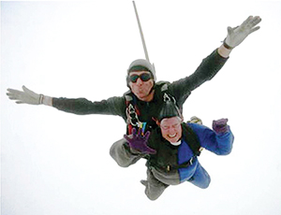

Self-Supporting Clergy!

“It goes so quickly, 5000 feet in less than a minute! It takes your breath away!”
Renée Coulson raises money for charity in unusual ways: sky-diving, trekking in the Himalayas, walking over hot coals. The recently retired priest-in-charge of Seend, Bulkington and Poulshot also had an unusual path to priesthood.
“I felt Jesus and God as part of my life from an early age. The foster family I spent my first years with sent me to the Baptist Church in our Kent village.
“Aged 11, I moved in with my birth mother in Central London, where the Churches were Anglo-Catholic, and I was baptised and confirmed. Because of all that, I’m very broad church.
“I met my late husband in the RAF in Germany, a life where we moved a lot, including two tours in Upavon. We liked this area, so we eventually settled in Potterne. I got involved in St Mary’s, as a sidesman, altar server and LPA.
“One day the vicar asked if I’d thought about priesthood. I asked if he was joking, but he said I’d help keep people’s feet on the ground.
“My husband wasn’t always a fan of the Church, but after a sharp intake of breath, he said he’d support me. God has a great sense of humour – even our then bishop said I ‘wasn’t the brightest candidate’ but still ordained me!”
Renée encourages people to explore any call they think they might have.
“You must talk to people who have the skills to help discern what it is”, she says.

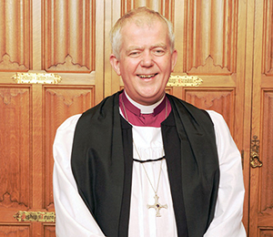

Bishop’s Letter
The Right Revd Nicholas Holtam
Bishop of Salisbury

No one makes community as well as churches. We gather around a simple meal of bread and wine in which we recognise the gift of life is sacred and that in Jesus Christ, God is among us.
Parish socials are a miracle like feeding the 5,000. Somehow people bringing five loaves and two fish produce enough food for everyone.
It’s always so, and there is usually food left over, if not 12 baskets then at least enough to be shared out and taken home or dropped off for the person who couldn’t come because they are housebound.
If I stopped believing in God I might still go to church because there is no other place where all sorts of people meet on an equal basis. No wonder our churches are such an important part of the social capital of our society. This is precious and it runs very deep.
Our parish churches are a presence in every village, town and city neighbourhood in England. Add in the work of other denominations, and the Christian contribution to our communities is even stronger.
This month we are celebrating the 800th anniversary of Magna Carta.
Some of the principles in that document have become part not just of English law but have had an impact worldwide. The more modern tradition of Human Rights has grown from this tradition of dealing with people equally under the law.
Why does Salisbury Cathedral have one of the four original copies from 1215? There is an element of chance that our copy has survived – but it has done so because of the care which our cathedral has taken over the centuries.
The making of community is precious to Christians and we treasure that which helps us belong together under the just rule of law.

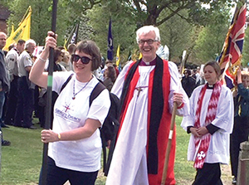

900 Rings for 900 Years

This year’s patronal festival at St George’s in Harnham was extra-special. Young people helped the church celebrate nine centuries in existence.
Year 6 pupils from Harnham Junior School rang the church bell 900 times to celebrate the supercentenary, guided by regular bellringer Pat Davison.
The following Saturday, over 300 scouts, joined by the Bishop of Ramsbury, paraded from the Cathedral to Harnham Cricket Field for a Medieval Fayre.
“We value our community” said the Revd Becky Roberts, Vicar of Harnham, “In our recent residents’ survey, being community was one of the top things local people wanted from their church.
“One of many centenary events is a 900 minute prayer marathon in July.”

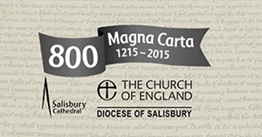

A Fun Family Day Out

Excitement is building ahead of next month’s Diocesan pilgrimage celebrating 800 years of Magna Carta.
On the afternoon of Sunday 14 June, pilgrims will make the 2½mile journey Magna Carta itself made 800 years ago from Old Sarum to the current Cathedral.
“It promises to be a fun family day out, walking through lovely scenery”, said the Ven Alan Jeans, Archdeacon of Sarum, “to finish with a Liber-tea and open air service on the Cathedral Lawn.
“Why not bring a picnic and join us from noon at Old Sarum, or better yet, a minibus load from your Benefice?”
Info on times, transport and parking is at www.salisbury.anglican.org/parishes/magnacarta.

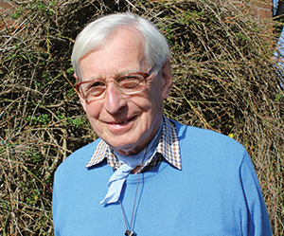

Caring for Our Churches

“I remember the crowds in London were silent. As the train passed through the countryside, people turned to face it. In Oxford, we passed a football match and every player turned to us and bowed.”
Fifty years ago, Barry De Morgan was serving with the Queen’s Royal Irish Hussars, and had the honour of commanding the bearer party that took Winston Churchill’s coffin from Waterloo station by train to its final resting place at Bladon in Oxfordshire.
“I was and remain a great admirer of Churchill’s, so it was a pleasure and privilege to take part at such a unique occasion.”
“After the army, I had a career in the steel and electronics industries. When the electronics company I was working for in Poole was bought out, my then chairman suggested I go into business with him. The company we founded, TDSI, is still trading and employing people in the town.”
Barry worships at Holy Trinity in Stourpaine, and decided to make his business skills available for churches.
“I was asked to get involved in the Dorset Historic Churches Trust about 25 years ago. I’m the Trust’s representative for Milton and Blandford Deanery. I’m there to advise churches on fundraising for repairs. I always say that running a church is a lot like running a business!
“Despite secularisation, there is a lot of interest in church buildings. People who rarely go to services will contribute to their upkeep, and beautiful old churches are often the place where people come to faith for the first time.
“The Trust exists to help with the costs of continued maintenance of churches. Our biggest fundraising event, which supports churches across the country, is Ride+Stride on the second Saturday of September every year. Why not get involved in this fun day out?”

