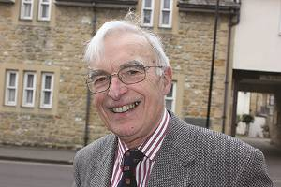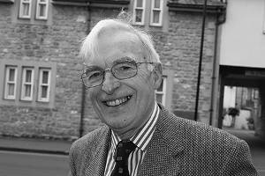

Passion for the Prayer Book

“I like the ‘language contained therein’!”
Ian Woodhead was the long-standing Chairman of the Salisbury Branch of the Prayer Book Society, helping make it the biggest in the country.
“I first went to church when my musical mother enrolled me in the local choir in Sussex. When my voice broke, I became a sacristan. On leaving school, I moved to London to join the police, and drifted away from church until after Ann and I were married. We joined the Society in London in 1982.
“After 30 years with the Met, I moved to Keevil in 1985. I later became the local Branch Vice Chairman on the basis it would be in name only. In 1996, the then Chairman took seriously ill, and I had to fill his boots. It was 2013 before I could hang them up!
“Locally, we have at least four meetings a year with speakers from the church, the arts and politics. We get 50-60 people for our meetings, which include our famously generous teas and lunches!
“I now look after advertising and marketing for the Society, and help organise the Cranmer Awards for young people reading in public.
“We’re not a fundamentalist society. I’m happy if some churchgoers want a different liturgy, but it would be a loss if the Prayer Book faded away.
“But I’m sure it won’t. Young people brought up on modern services are discovering the BCP, and we now have an active branch at Oxford University.”

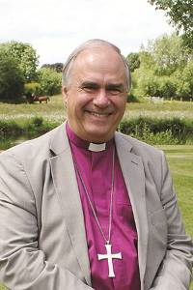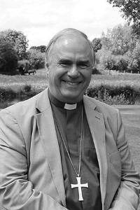

Bishop’s Letter
The Right Revd Dr Graham Kings
Bishop of Sherborne

Alison and I have put down deep roots in this Diocese since 2009 and would value your prayers for us as we move to Bermondsey, London.
The Archbishop of Canterbury, Church Mission Society (CMS) and Durham University have founded a new seven year post, ‘Mission Theologian in the Anglican Communion’.
I will be researching, encouraging, and publishing theology, particularly from Africa, Asia and Latin America.
Henry Venn, the great 19th Century General Secretary of the CMS, talked of ‘self-supporting, self-governing and self-extending churches’ throughout the world. More recently, there has been a ‘fourth self’: ‘self-theologising’. These are voices which must be heard more clearly throughout the Communion.
Working in Lambeth Palace Library, I will visit Durham University as an Honorary Fellow about three days a fortnight, and convene a series of seminars in Africa, Asia and Latin America. I have also been invited to be an Honorary Assistant Bishop in the Diocese of Southwark, helping out with some confirmations and missions.
The Twitter account @MissioTheology and www.MissionTheologyAngCom.org website will have updates on this work.
This is an extraordinary Diocese, full of hope, led with vibrancy by Bishop David and now Bishop Nicholas. We have made profound, treasured, friendships here. I have particularly enjoyed praying with priests in their chancels, meeting with Licensed Lay Ministers, annual parish missions, Alpha courses and visits to the Sudans.
Alison and I thank God for your welcome, prayers and friendship over these six years and look forward to seeing you on Sunday 19 April at 4.30 p.m. in the Cathedral for our farewell service.

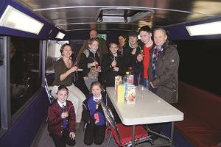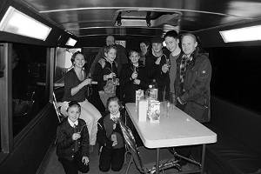

Bus Full of Fun

“It’s great to have somewhere Cranborne youth can hang out together as a village community.” That’s the view of Stan, a 15 year old Queen Elizabeth’s School student about the Coach in the Community.
The Coach, supported by Wimborne Deanery and the Aldhelm Mission Fund, works in East Dorset villages and is fitted out with all the facilities of a youth club, with games consoles, high spec audio-visual equipment, and a tuck shop. It regularly visits Alderholt, Cranborne and Hinton Martell.
With councils cutting funding, the C of E is now the largest provider of youth services in our region.
Jonathan Stephens, a leader at Cranborne’s youth club, says, “The Coach helps us provide a better range of fun activities than we could otherwise.”

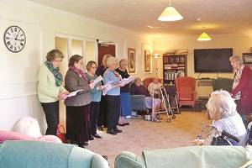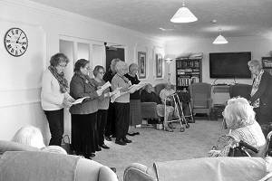

Letting the Bible Speak

Hazelbury Bryan parishioners have written powerful scripts dramatising Bible passages. Over thirty, from Gospel Parables to Old Testament favourites such as David and Goliath, are available or in production.
In 2010, Palm Sunday’s Passion Gospel was dramatised with 18 readers from all six Benefice parishes. The readers were asked for another work at Christmas, and the idea built from there.
The pieces are carefully rehearsed and now performed in local nursing homes as well as churches.
“The power of the living Word affects both readers and listeners powerfully”, said Jean Bennett who organises the readings, “For scripts, contact me on jdbennettmappowder@yahoo.co.uk.”

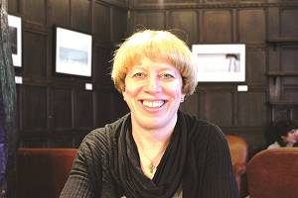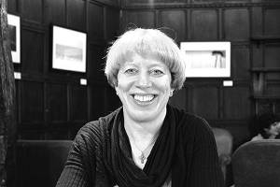

Faith-Based Career Change

“I have a passion for new forms of worship that allow people to explore on their quest for faith.”
A few weeks ago, Sarah Keen was made a Lay Worship Leader at St Mary’s, Beaminster. She couldn’t have imagined it a decade ago, when she was a high-flying City of London banker.
“For many years I worked in front-line small business banking which I really enjoyed. Later I started working on inter-bank financing, which had a very different and more macho culture.
“Then two friends brought me to St Helen’s, Bishopsgate. My Christian faith came alive for the first time. That made me ask if my career was really the best use for the talents God gave me.
“My father was an academic working on international development, which inspired me to explore how to use my banking skills in that field.
“I now work on financial inclusion issues in several countries, especially Uganda and Bangladesh. Our consultancy oversees aid programmes for DfID, the UN, the EU and others. I’m confident money is used well and addresses the problems it is targeted at.
“We provide financial education to the poorest, just entering the cash economy. At a different level, we provide micro-finance and teach business skills so people can move out of subsistence work, and later to grow a stable business that might start employing others.
“I work in London during the week, but my husband and I spend our weekends in Beaminster. We moved here 8 years ago, and now consider it home. It’s such a friendly town with thriving shops.
“Recently, the Beaminster Team held a vocations day. I thought I might have a call to pastoral work, but a gift for leading worship emerged instead. I helped lead my first service on Mothering Sunday - a really rewarding experience!”

