Life has been tough this past year.
Lots of things may have made you sad, and you know what, it’s okay to feel that way.
Jesus felt sad too.
God understands our sadness. The Bible says, 'You keep track of all my sorrows. You have collected all my tears in your bottle.' – Psalm 56:8

Take a tear drop bead and think about something that has made you sad this past year. Drop the ‘tear’ into the big bottle. If you want to, you can write or draw your sad thing onto a big tear drop and stick it onto the cross as a prayer.

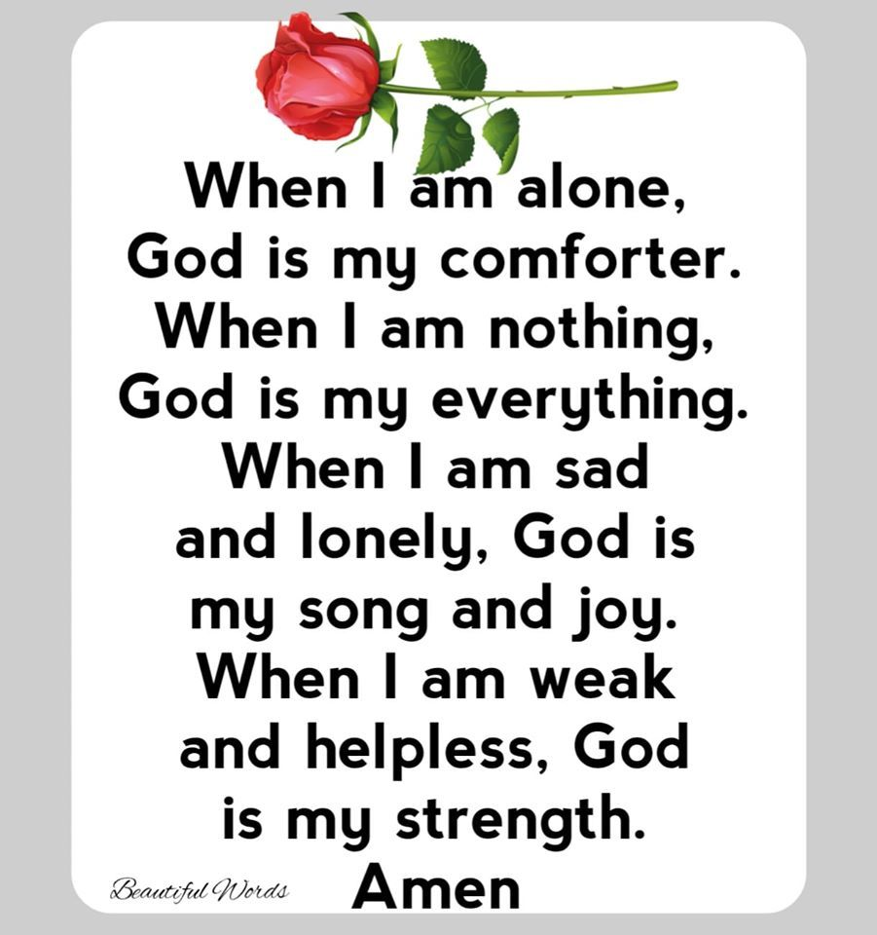

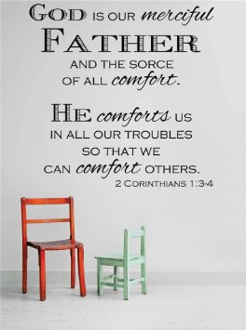

What might you write down about your own feelings of sadness?
You might want to share your sad feelings with God by writing them onto a teardrop.
You could say a prayer and give your sadness to God as you drop a ‘tear’ into the water.

³ Praise be to the God and Father of our Lord Jesus Christ, the Father of compassion and the God of all comfort, 2 Corinthians 1:1-3

New International Version

Shout for joy, you heavens;
rejoice, you earth;
burst into song, you mountains!
For the Lord comforts his people
and will have compassion on his afflicted ones.

Isaiah 49:12-14

New International Version

