Examples of Spirituality activities across the curriculum
Music – listening to high quality music with understanding:
Key Question: What would the creation of the world sound like?
- Introduce key questions and gather initial ideas – write these in red on the key question sheet.

- Listening to Haydn’s Creation Overture No1 based on the Christian Creation story from the Bible (7minutes 42seconds)
Model to pupils how to listen to music and use the oil pastels (if this is needed).
Pupils to listen to the music with oil pastels (sitting at tables around the edge of the room).
Share some of their art at the end – explaining what they heard/thought when they used different colours/shapes etc.
What were you thinking of here?
Tell me about the (red) in your art.
Which emotions did you experience?

- Give pupils images of the Christian Creation Story from Genesis from the King James Bible:
Night and day
Heaven and earth
Earth and seas
Grass and trees
The sun, the moon and the stars
Animals in the seas and sky
Animals of the land
Man (Adam and Eve)

Pupils to choose their section and instruments to create the sounds. In groups, pupils to compose a short piece of music creating the sound of the creation on that day (animals of land and man were created on the same day).
Give pupils time then come back together. Pupils to play their creation. At the end say ‘on the seventh day God rested.’ Give pupils one minute of resting time.

- Discuss key question – gather ideas and add these in green to the key question sheet.

Science – Materials and their properties:
Respect Rocks
Key Question: How do you show respect in your life?
- Ask key question and gather initial ideas – write in red on the sheet.

- Rock meditation (all pupils to sit in a circle):
Choose a rock - allow pupils to choose their rock one at a time from the middle of the table.
Close your eyes.
Take two, long, slow breaths in… and out.
Feel the air move through your nose.
Feel your chest move with each breath.
Feel your rock.
Feel its weight.
How heavy does it feel in your hands?
Is it warm or cool?
Is it smooth, rough, bumpy?
Imagine what your rock could withstand.
Think about the strength of your rock.
Who do you think found it?
Where was it formed? … in the sea? … did it fall from a cliff?
How did it arrive in your hand?
Hold it.
Feel your rock.
Feel your chest move with each breath.
Notice your body, your fingers, your hands, your arms, your back, neck, shoulders.
Notice your breath in your nose.
When you are ready, open your eyes.

- Show pupils some respect rocks – painted on top with respect messages underneath.
Pupils to use the pens/paints to decorate their own respect rock.
Allow peaceful time for this.
Share rocks at the end, as they are placed in the Respect Rocks garden – under the oak tree in the front of the school – do as a group.

- Ask key question again and write ideas in green.

Geography – biomes:
Sometimes teaching helps us to understanding things and appreciate them in a deeper way – think how much deeper this understanding can go if there are opportunities for spiritual reflection.
This video was shared at the end of a unit… there was so much awe and wonder from the pupils.

Which is your favourite biome?
Which biome would you most like to experience and why?
What makes the biomes so important?
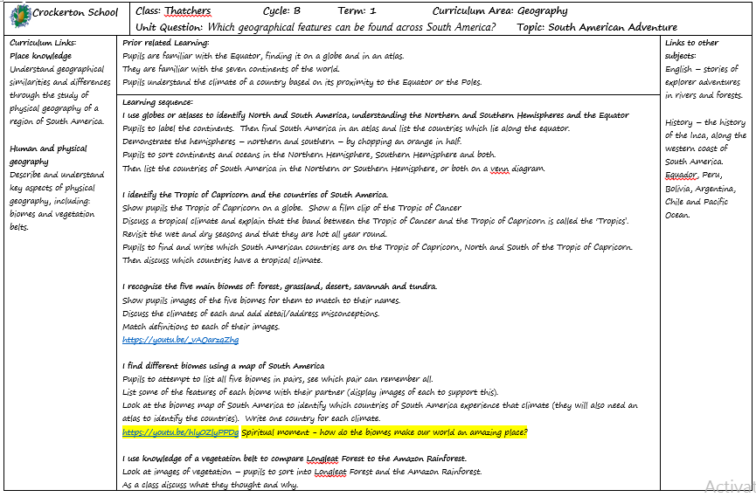

https://youtu.be/hIy0ZlyPPDg 3 mins - Spiritual moment - how do the biomes make our world an amazing place?

DT/Science/PSHE – healthy eating – ingredients – healthy eating plate
A MINDFUL EATING SCRIPT Begin by connecting to your breath and body, feel your feet on the ground and notice your experience in this moment. With your awareness in this moment, notice any thoughts, sensations or emotions you are experiencing. (Pause) Tune into the awareness or sensation that you have in your body of feeling hungry, thirsty or maybe even feeling full. If you were going to eat or drink something right now, what is your body hungry for? What is it thirsty for? Just pay attention and notice with awareness the sensations that give you this information. (Pause)
Now, bring your attention to the item in your hand and imagine that you are seeing it for the first time. Observe with curiosity as you pay attention and notice the colour, shape, texture, and size. Is there anything else that you notice, sense or feel? (Pause) Imagine what it took for this item to get to your hands: sunshine, water, time, processing, and shipping. You may choose to be aware of gratitude for everyone involved in the cultivation and preparation of this item of food. You may choose to bring in your own gratitude or spiritual blessing. (Pause)
Now place the item between your fingers and feel the texture, temperature and ridges. You may notice smoothness or stickiness. Again, notice if you have any thoughts, sensations or emotions at this time. Continue to breathe and be fully present in this moment. (Pause)
Take the piece of food and bring it toward your nose and smell with your full awareness. Notice if you have any memories, sensations or reactions in your body. Even before you eat it, you may notice that you begin to have a digestive response in your body just by noticing and smelling. (Pause)
With full awareness of your hand moving toward your mouth, place the object (fruit or chocolate) into your mouth without chewing or swallowing it. Just allow it to be in your mouth, roll it around to different parts of your mouth and tongue. Notice the flavour and texture. Notice the physical sensations within your body, especially your mouth and your gut. Continue to breathe as you explore the sensation of having this item in your mouth. (Pause)
Next take just one bite and notice the flavour, notice the change of texture. Then very slowly begin to chew this piece of food, and notice the parts of your mouth that are involved in chewing. Notice the sound and movement of chewing, as you continue to notice the sensations and flavor. (Pause)
When you are ready, swallow this item and notice the path that it follows from your mouth and throat into your stomach. Notice the sensation and taste that may linger in your mouth. Connect again to your body and your breath and notice your experience in this moment. (Pause)

RE – Salvation – Easter
Stations with music, an object which can later be linked to the story, a passage from the Bible and an image – high quality, varied and multicultural art. Get outside! Share it with the community.

