7. Statutory Inspection of Anglican and Methodist Schools - SIAMS

A new Vision is where it all began…
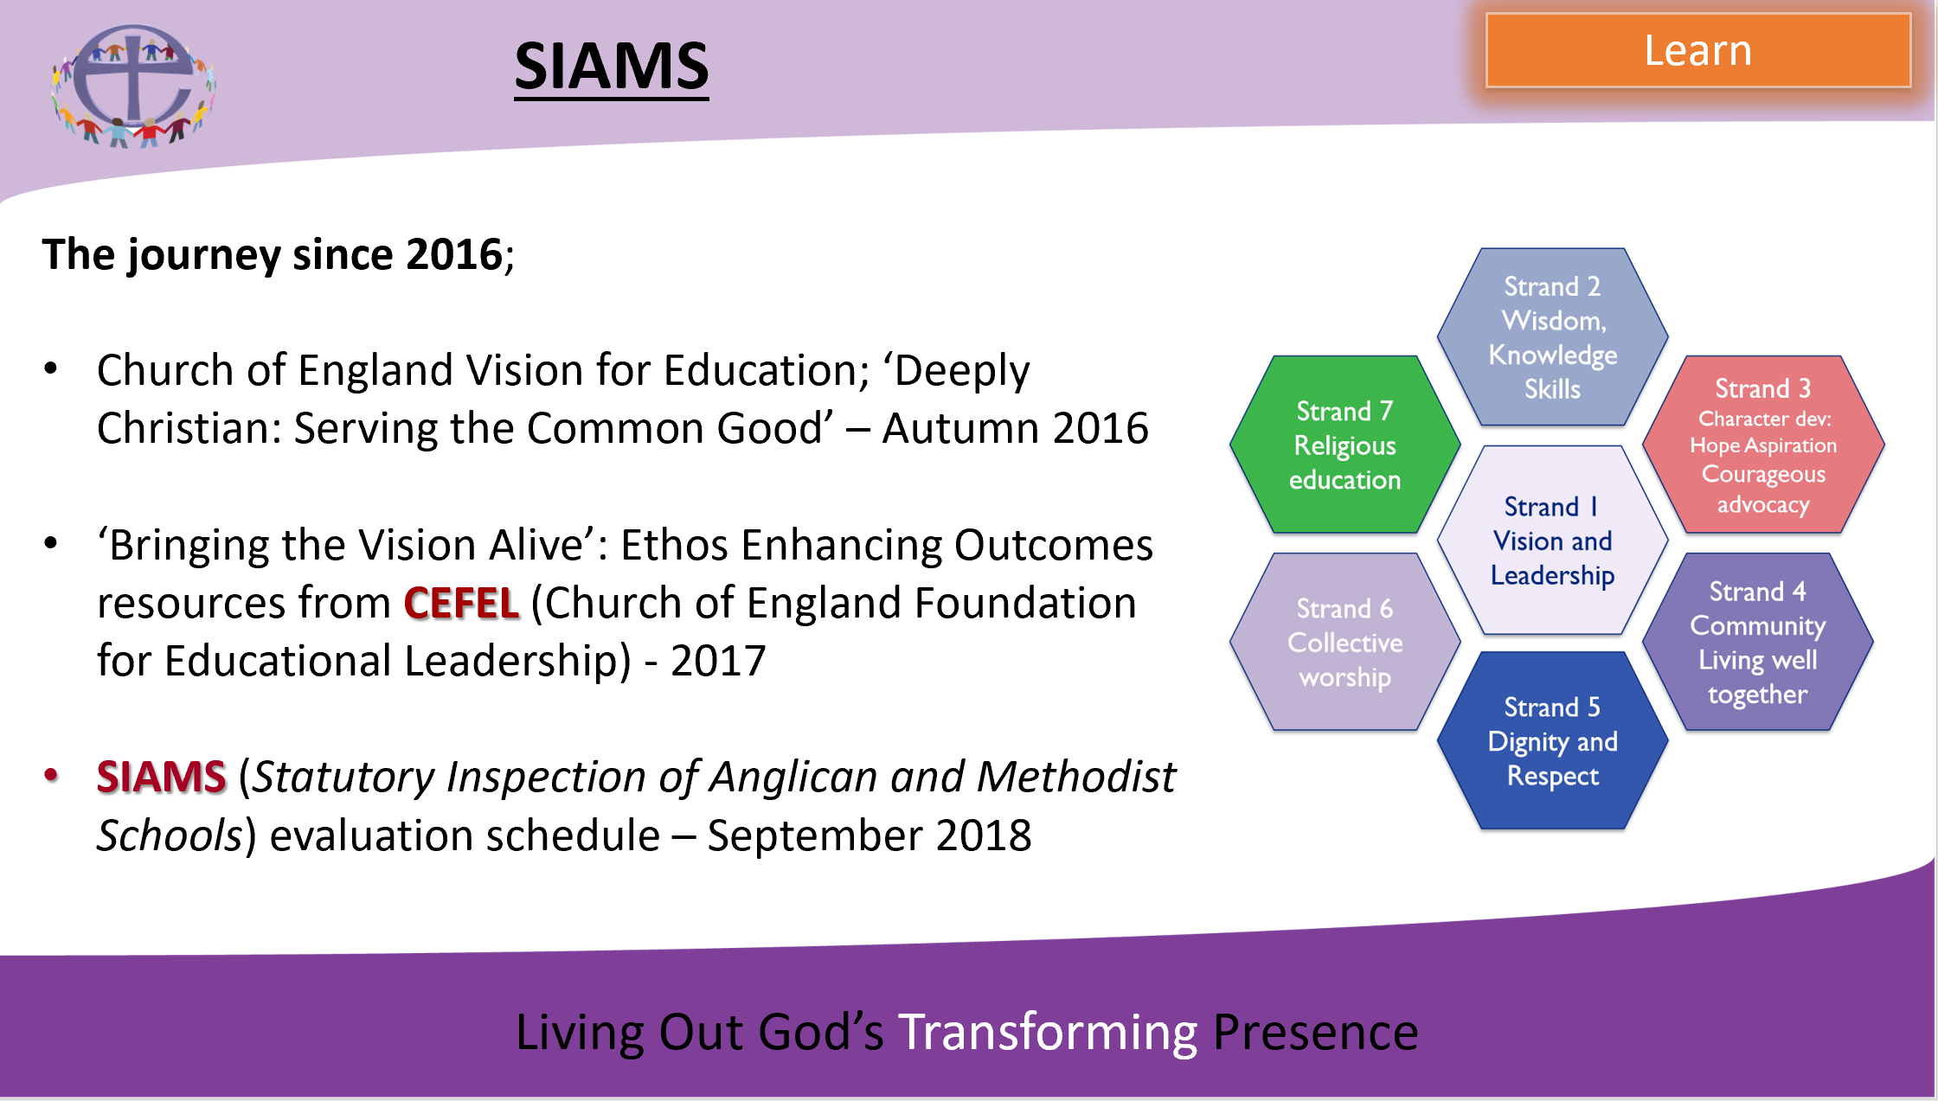

Find the Church of England Vision for Education here.

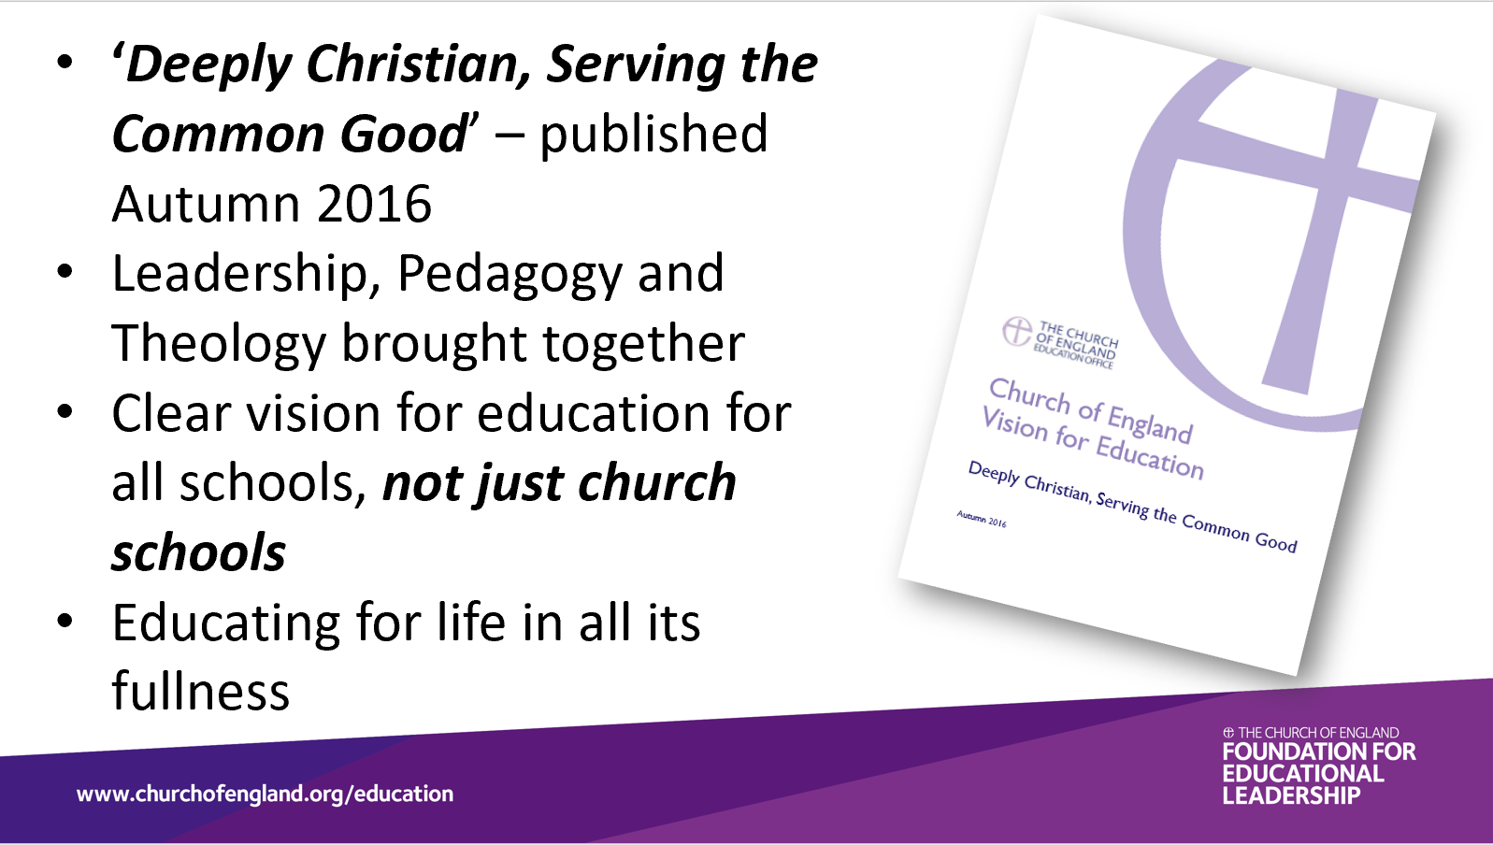
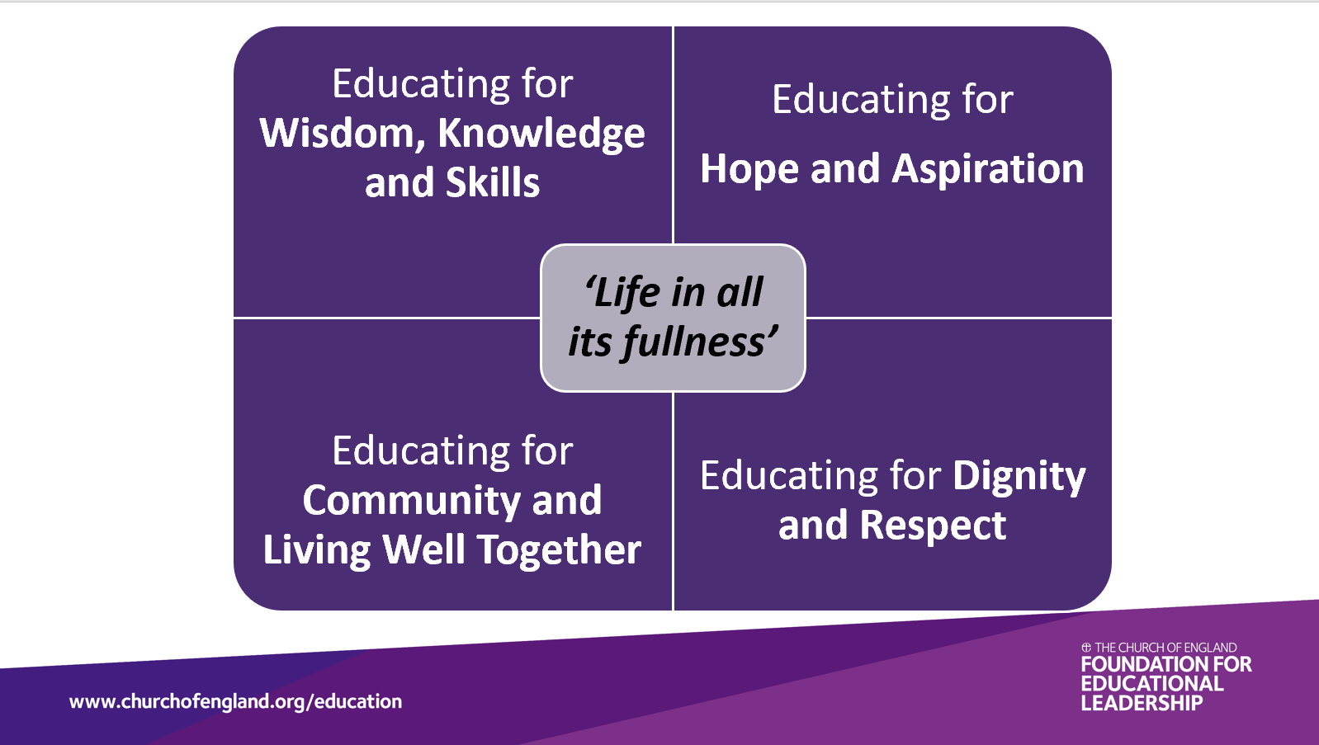
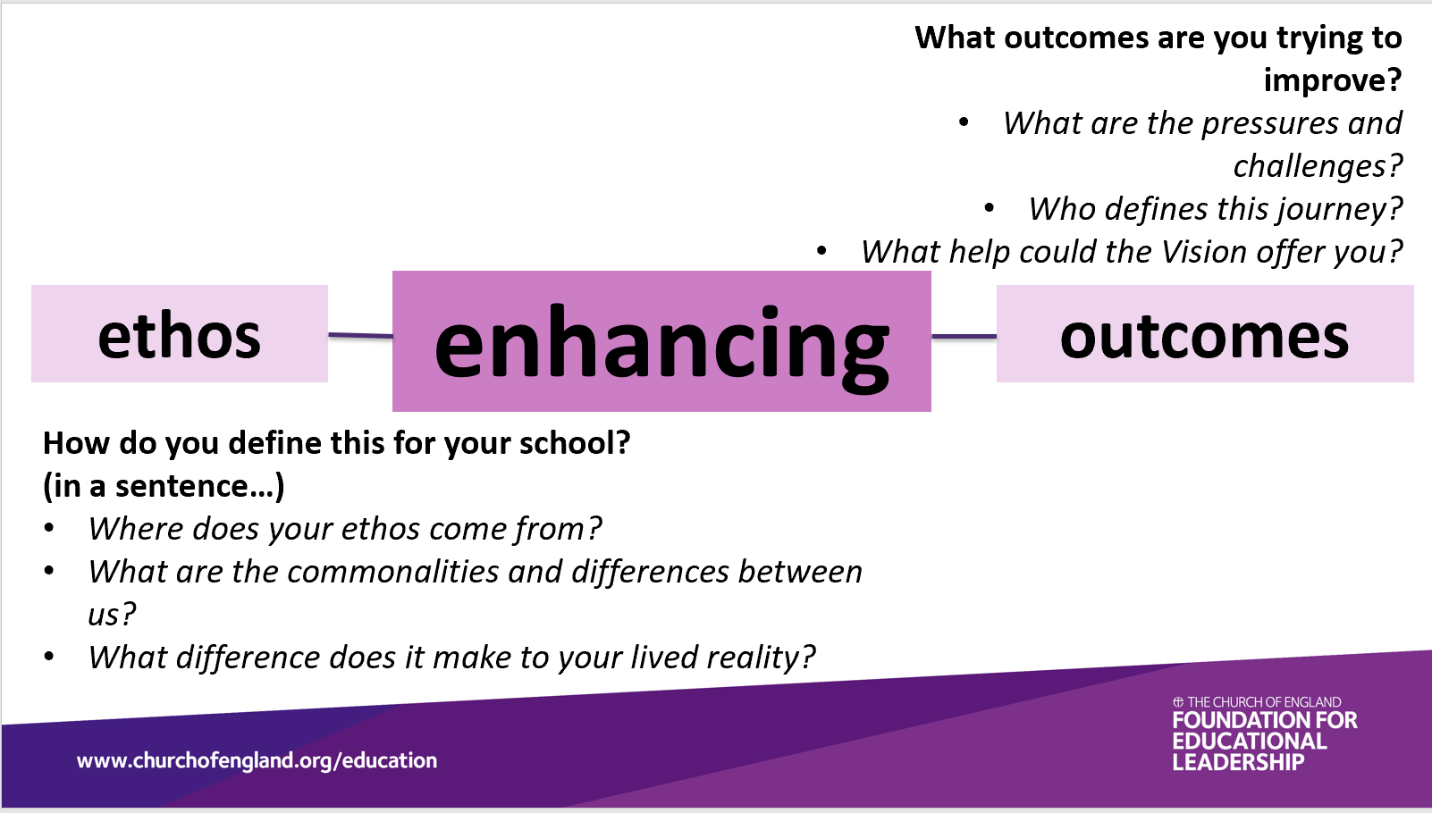
Questions from the resource ‘Bringing the Vision Alive’ produced by The Church of England Foundation for Educational Leadership (CEFEL).
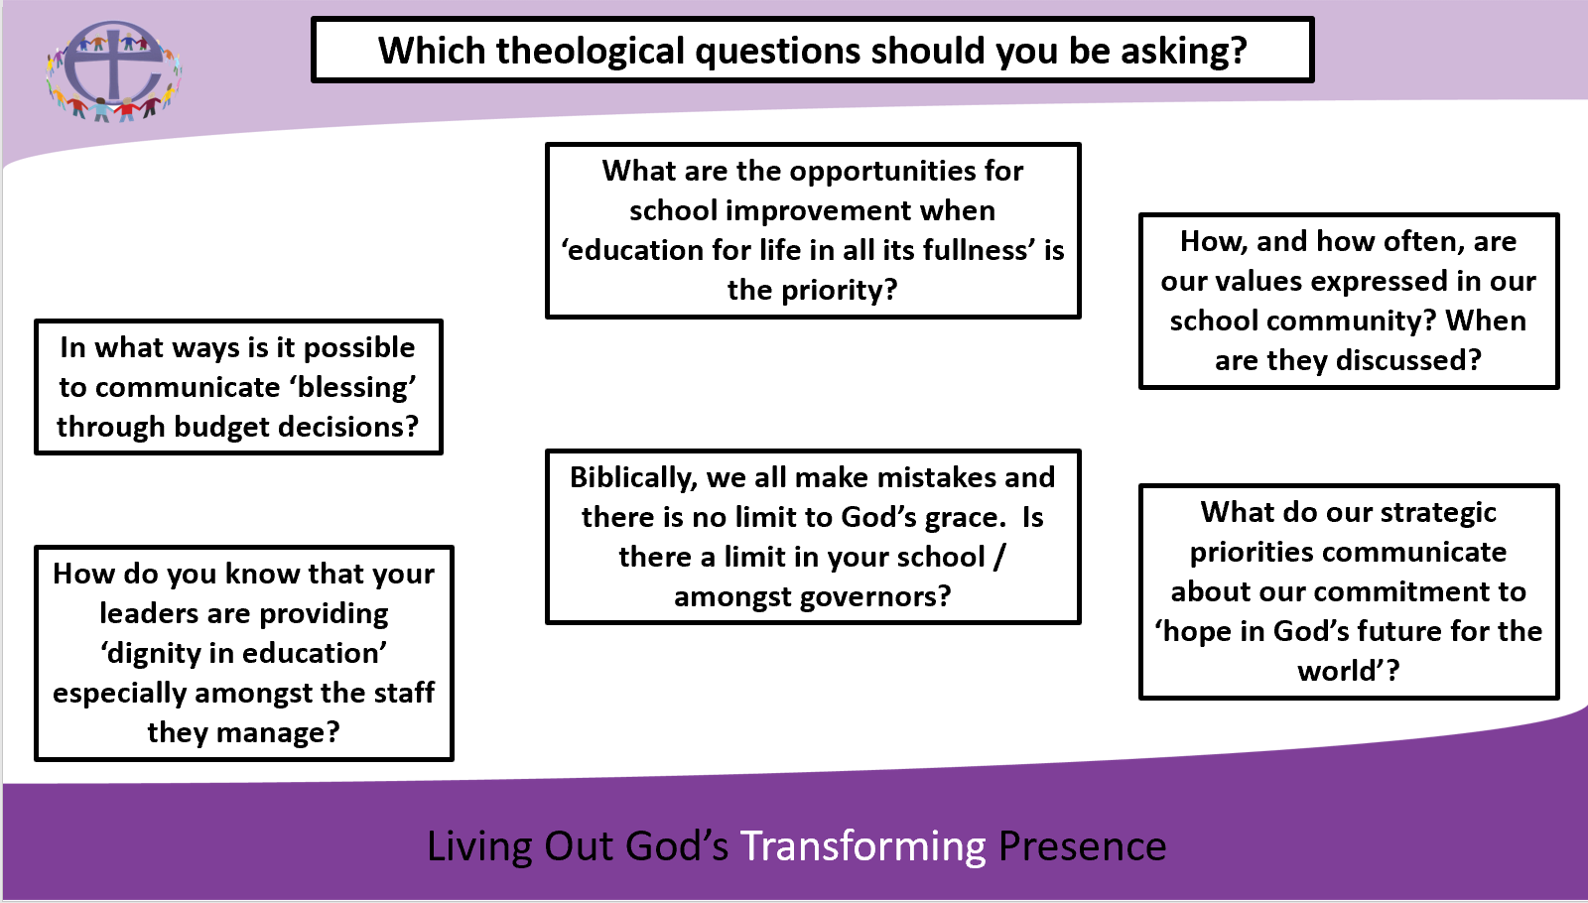
Find out more about and order the ‘Bringing the Vision Alive’ resources here.
Download the SIAMS evaluation schedule here.
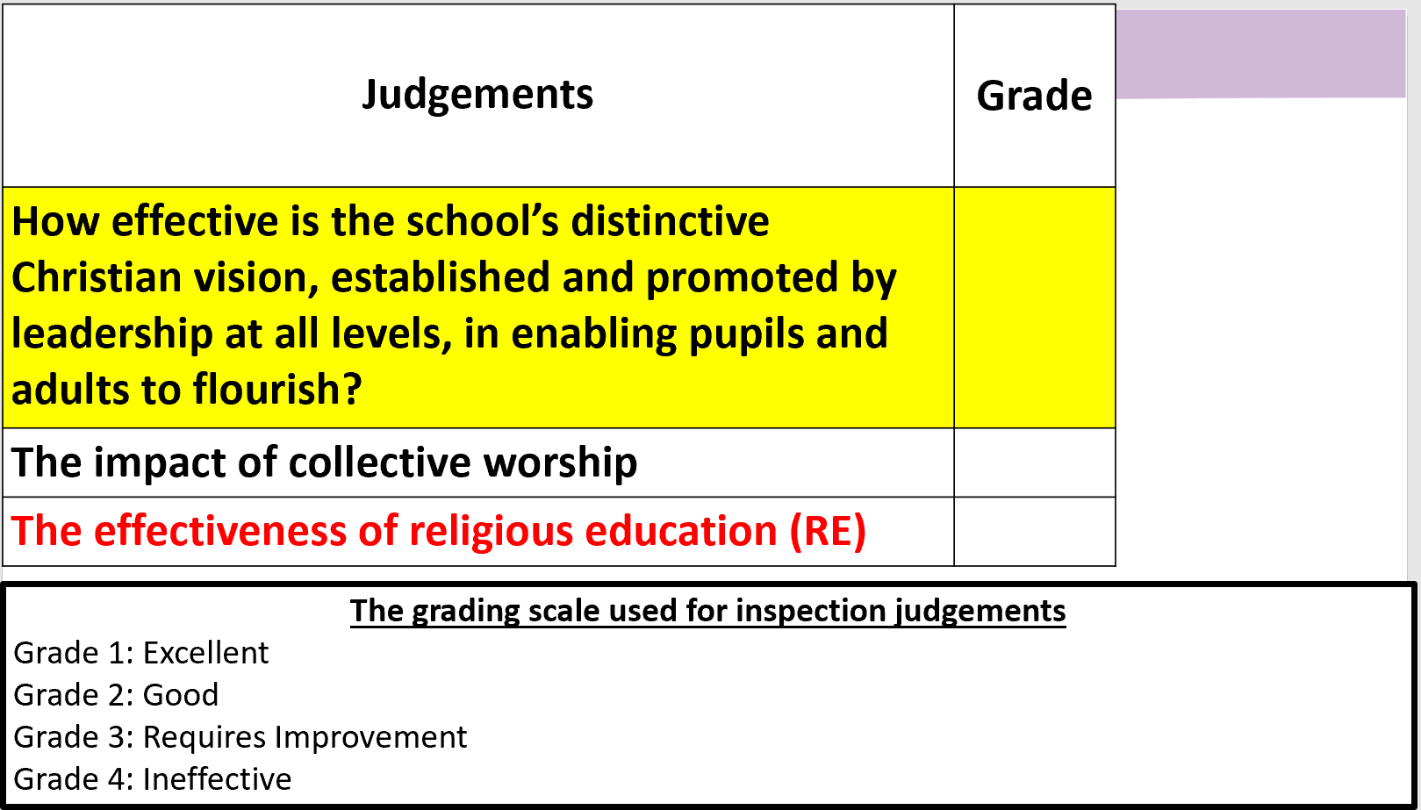

When was your school last inspected under SIAMS? What was the judgement? When is the next inspection due?

Has the current SIAMS self-evaluation form (SEF) for your school been shared and discussed with governors?

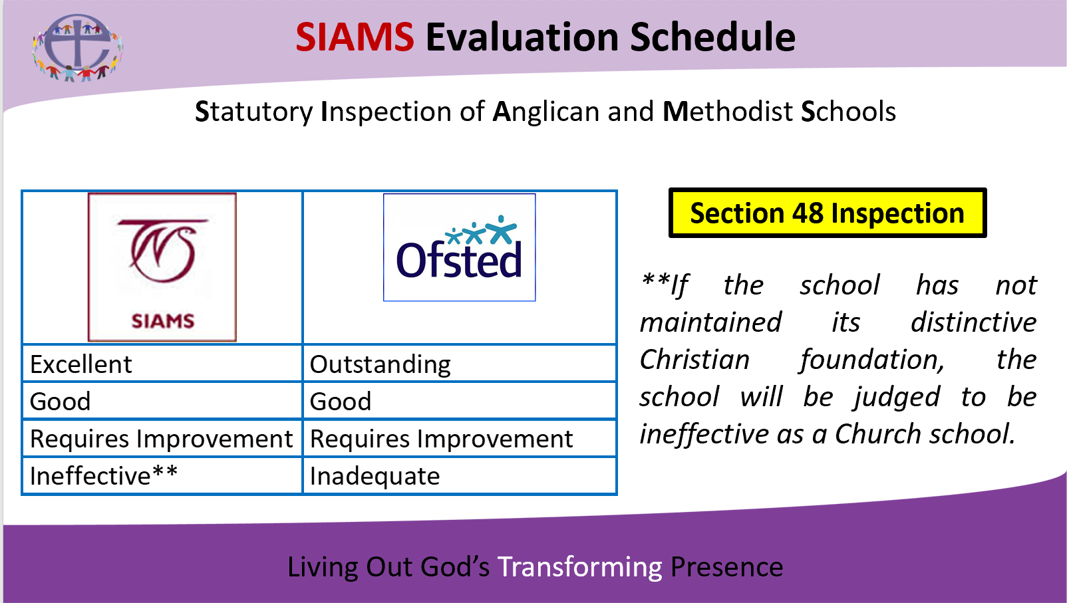
Additional notes:

