4. Governors and Governing Boards
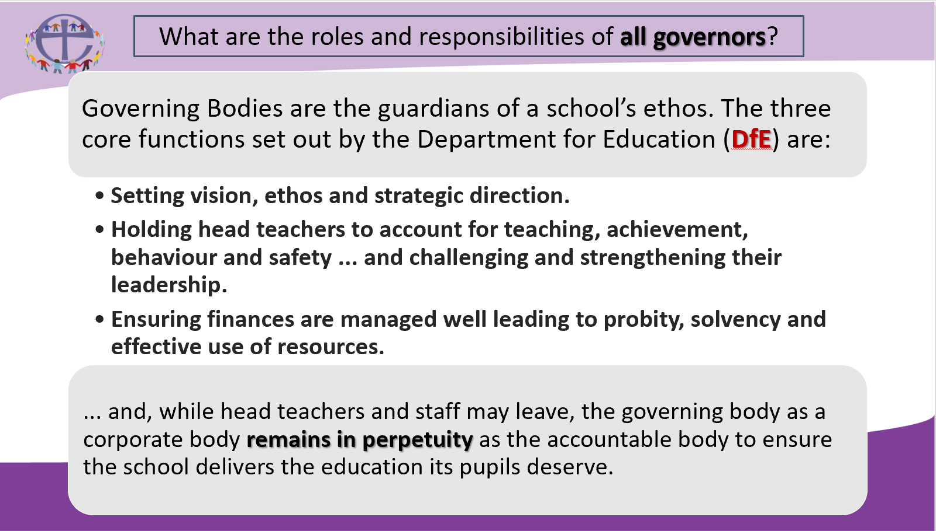
Academy Schools
Academy schools are state-funded schools in England which are directly funded by the Department for Education and independent of local authority control. The terms of the arrangements are set out in individual Academy Funding Agreements. They do not usually, unless stated in the documents below, have an ex-officio foundation governor described as a role.
Academy schools may either belong within a single academy Trust (SAT) or belong with other academy schools as part of a multi academy Trust (MAT). The structure of the Trust will be set out in the Articles of Association and the committees, including those at school level, operate under the terms set out in the Trust’s Scheme of Delegation
In an academy Trust, the governing body is the Trust Board, made up of ‘Trustees’ or ‘Directors’, and the ‘Members’. For a school within a MAT, the Trust Board will usually set up a committee for that school upon conversion to academy status. In a SAT or MAT that includes one or more church schools, the SDBE will usually become a ‘Corporate Member’ of the Trust, and will appoint a person to act as the SDBE Corporate Member representative inside the Member Group. The SDBE retains appointing authority for all foundation Members and Foundation Trustees (or Directors) and works alongside the Trust to appoint persons as ‘foundation local governors’.
SDBE Academy Policy and Small Schools Strategy
The SDBE Academy Policy can be found here. The policy states; “The SDBE believes the formal school collaboration offered by MATs is a key to mitigating risk and protecting and progressing church school education in the future”, and also “The SDBE is concerned that without belonging within an established and effective MAT, any church school’s long term future is potentially at risk.”
The Department for Education classify as a ‘small school’ any which has 210 or less pupils on roll i.e. for a Primary School, this would mean 7 classes (Year R to Year 6) of 30 pupils (i.e. 210 in total). 143 church schools of the 194 church schools in the Diocese of Salisbury fall within this category.
The SDBE Small Schools Strategy was agreed by the Board of SDBE in 2020. The strategy sets out the following;
“SDBE recommendation for church school leaders, including governors, is to:
- Engage with the SDBE in a risk and opportunities analysis to ensure that leadership decisions being made currently by the school governing body and the SDBE will protect and enable the school’s long term future.
- Explore how belonging within a MAT could contribute to protecting the school’s future and enable its further flourishing.
- Establish a plan that will secure the school’s long term future, whether or not this includes belonging within a MAT.”
VA and VC Schools
A voluntary aided school (VA school) is a state-funded school in England and Wales in which a foundation or trust (usually a religious organisation) appoints a majority of governors as ‘foundation’. The foundation or trust also contributes to building costs and is a substantial partner in the running of the school.
A voluntary controlled school (VC school) is a state-funded school in England and Wales in which a foundation or trust needs to have at least 2 / 25% of governors appointed as ‘foundation.
Both VA and VC schools have an Instrument of Government – this document sets out the constitution of the governing board. Examples;
INSTRUMENT OF GOVERNMENT: VOLUNTARY AIDED CE SCHOOLS
- The name of the school is …School.
- The school is a voluntary aided school.
- The name of the governing body is “The governing body of… School”.
- The Governing Body shall consist of:
- 2 parent governors
- 1 local authority governor
- 2 staff governors (including the head teacher)
- 7 foundation governors

- Total number of governors is 12.
- The foundation governors shall be appointed by the Salisbury Diocesan Board of Education in consultation with the Parochial Church Council of the parishes or ecclesiastical district in the area served by the school.
- a) The holder of the following office shall be a foundation governor ex-officio: the principal officiating minister.
INSTRUMENT OF GOVERNMENT: VOLUNTARY CONTROLLED CE SCHOOLS
- The name of the school is …School.
- The school is a voluntary controlled school.
- The name of the governing body is “The governing body of … School”.
- The governing body shall consist of:
- 4 parent governors
- 1 local authority governor
- 2 staff governors (including the head teacher)
- 1 co-opted governor
- 3 foundation governors
- The total number of governors is 11.
- The foundation governors shall be appointed by the Salisbury Diocesan Board of Education in consultation with the Parochial Church Council of the parishes or ecclesiastical district in the area served by the school.

  - The holder of the following office shall be a foundation governor ex-officio:
    - The principal officiating Anglican Minister of the parish
  - The Archdeacon of the Archdeaconry in which the school is situated shall appoint a foundation governor to act in the place of the ex-officio foundation governor whose governorship derives from the office named in 6 (a) above, in the event that the ex-officio governor is unable or unwilling to act as a foundation governor, or there is a vacancy in the office by virtue of which his/her governorship exists.
The Archdeacon of the Archdeaconry in which the school is situated shall be entitled to request the removal of any ex-officio governor whose governorship derives from the office named in 6 (a) above and to appoint a substitute governor.

The role of the governing body of a school
Establishing and securing the long term future of a school is fundamentally the role of the governing body of that school. As already stated, if the school is part of a SAT or a MAT, the governing body is the Trust Board and Members group of the Trust of which the school is a part.
For more detail, refer to the Governance Handbook which can be found here, and also the structures and roles guidance documents which can be found for Trusts here and for local authority maintained schools here.
This task incorporates all three of the ‘core functions of governance’ as described by the Department for Education, and as part of the governing body, foundation governors carry this responsibility alongside their fellow governors. As it says in the service of commissioning, this is a task to be carried out “diligently, faithfully and joyfully.”
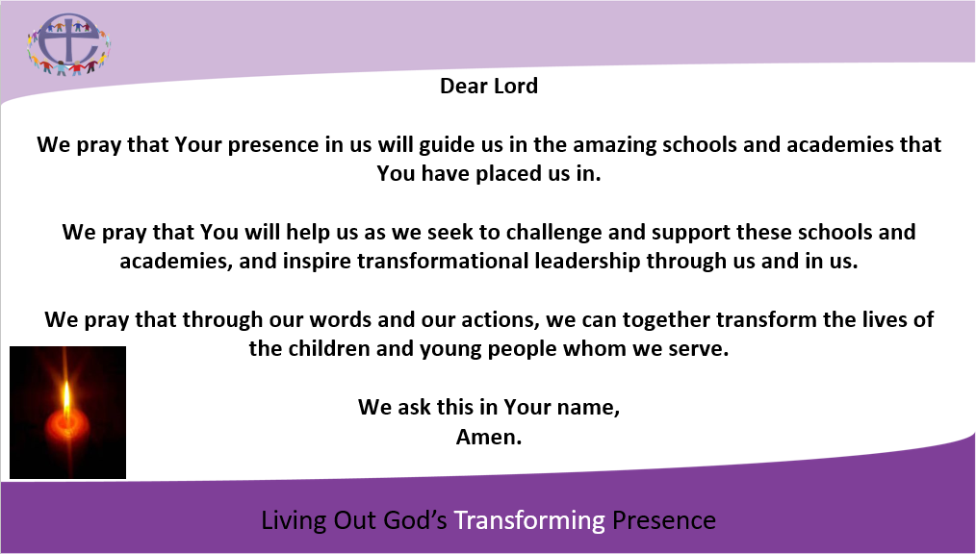
What does it mean to be a foundation governor?
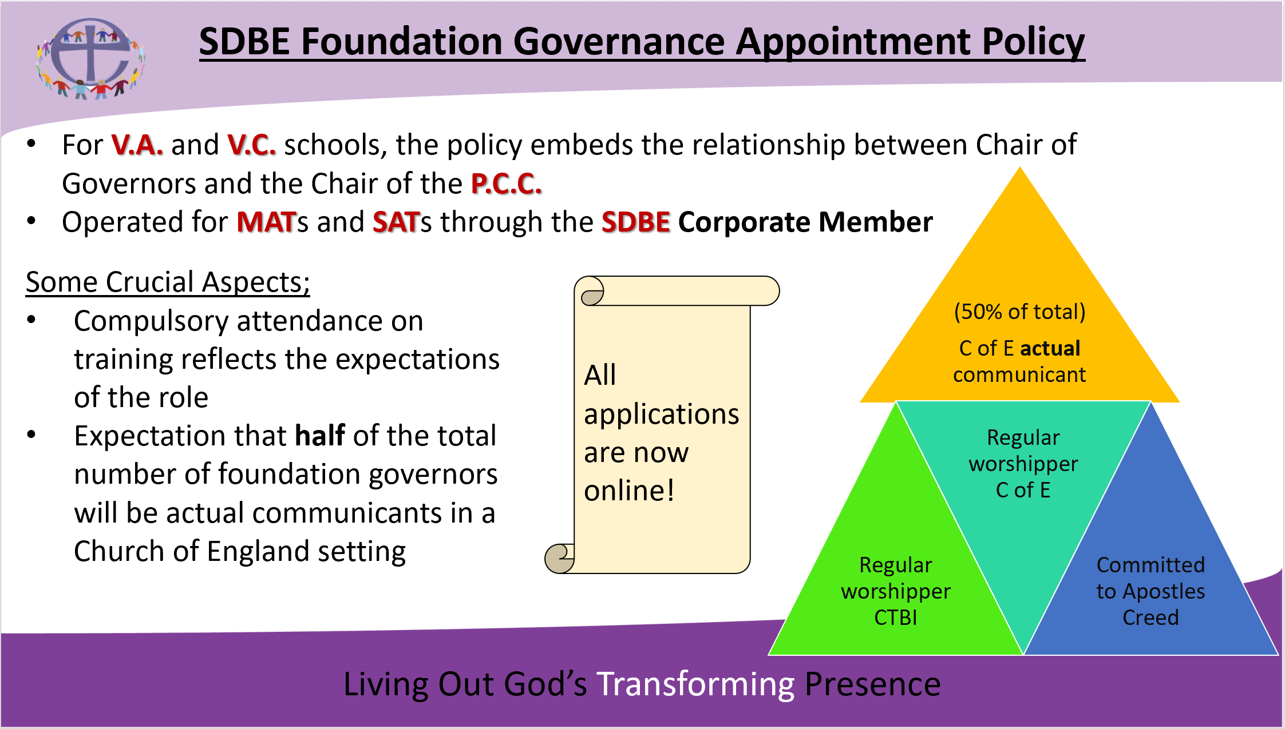
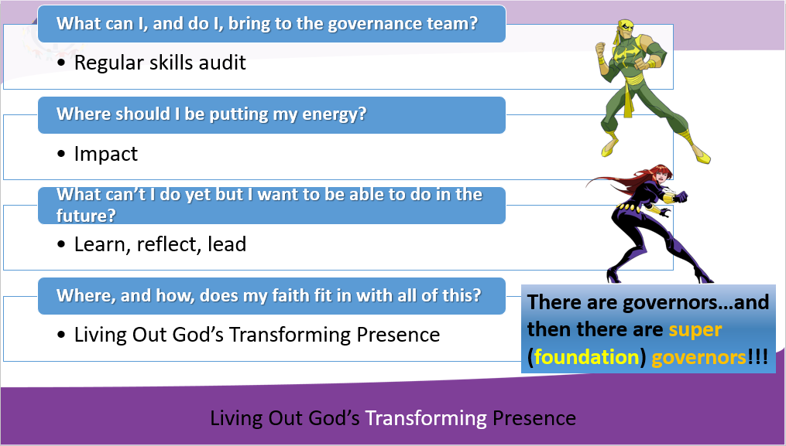
These 4 questions are crucial to enabling, understanding and developing our journey as a foundation governor, and they are questions that you are encouraged to keep returning to. Spend some time reflecting on each one – you can fill in the answers for yourself in module 10 of this journal.
      - What can I, and do I, bring to the governance team?

      - Where should I be putting my energy?

      - What can’t I do yet but I want to be able to do in the future?

      - Where, and how, does my faith fit in with all of this?

