3. Introducing the Salisbury Diocesan Board of Education (SDBE)
Who are they? What role do they have?

What support does the SDBE offer?

The Strategic Plan
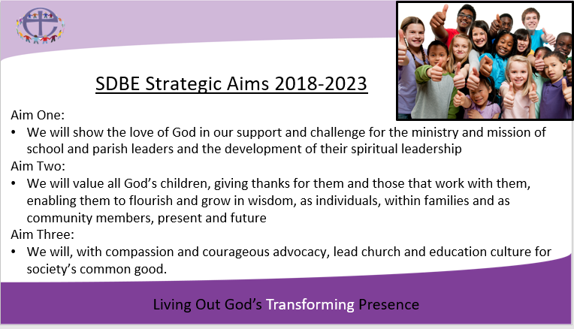

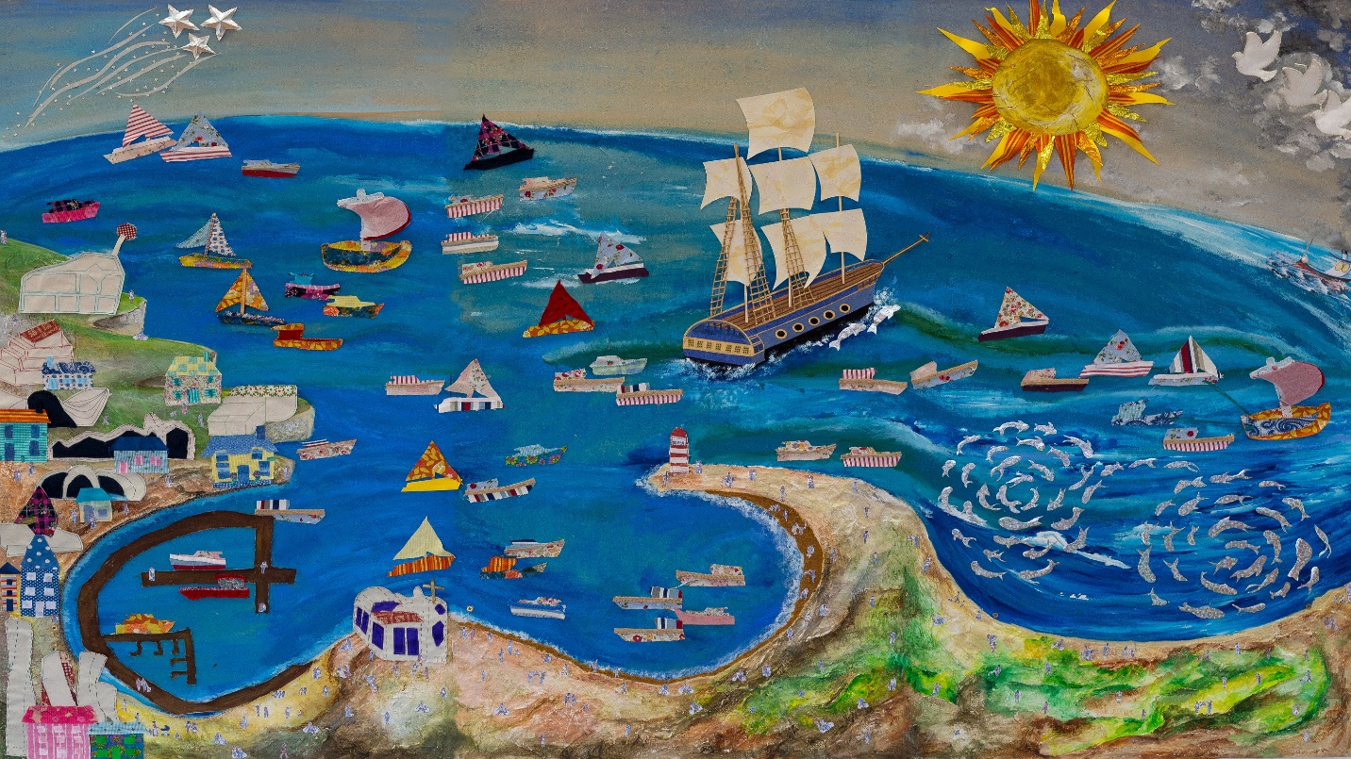
The Vision Vessel
This image represents the Diocesan Board of Education, the family of church schools, academies and their parish communities. Leaving the harbour, the vessel representing the DBE is powered by the wind, the power of God caught in the sails. If the wind does not blow our ship will go nowhere; our faith enables the sails to rise and catch the wind. The three masts represent God’s goodness, mercy and compassion, reminding us of God’s abundant Grace, and our vision of ‘living out God’s transforming presence’ in all we do. Sailing in our ship are all the staff and trustees - clear in their roles, working together to ensure the ship makes best use of the wind in its sails and the cargo of expertise, for the common good of all schools, academies and parishes.
The shoaling fish represent the beauty and the energy of the children and young people we all serve. The doves in the sky reflect God’s constant presence on the journey. The shooting stars demonstrate the brightness of the partnership work with the Diocesan Board of Finance and the Cathedral.
The ship sails in flotilla alongside many ships; they are schools, multi-academy trusts and the parishes, full of leaders, governors, clergy, staff, parents and children. Each is unique. We journey together, ropes and ladders symbolising our support for each other and our common purpose. The ships have chosen to join the flotilla - they have chosen an interdependent relationship. The DBE vessel provides support and challenge as servant leader. The dolphins swimming alongside symbolise this.
The flotilla is sailing out together from the harbour to navigate the seas of a changing educational landscape beyond. Some of the boats are travelling ahead. The speed of the waves breaking on the bows reflects the continual striving for improvement, both for the DBE and the schools and parishes.
The buildings on the quayside are all those with whom we work in partnership, including the teaching schools, local authorities and the Education Office of the Church of England. In the harbour, new boats are built representing new church schools of the future. The sun shines brightly, representing our shared hope.

