6. Vision, Provision and Impact
The Big Questions
If everything flows from / is impacted by your school’s distinctive Christian vision, can you think of some ways in which this would enable ‘pupils and adults to flourish’ in your school?

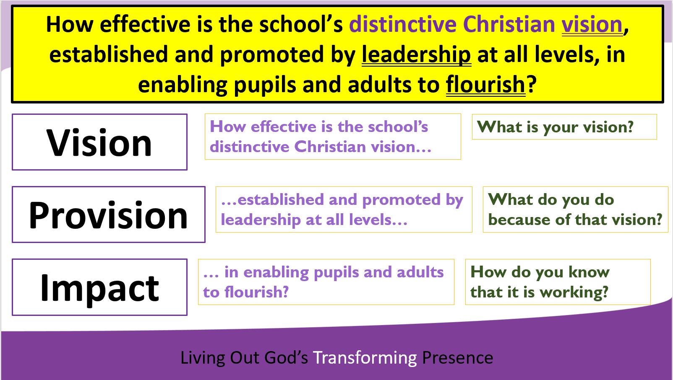

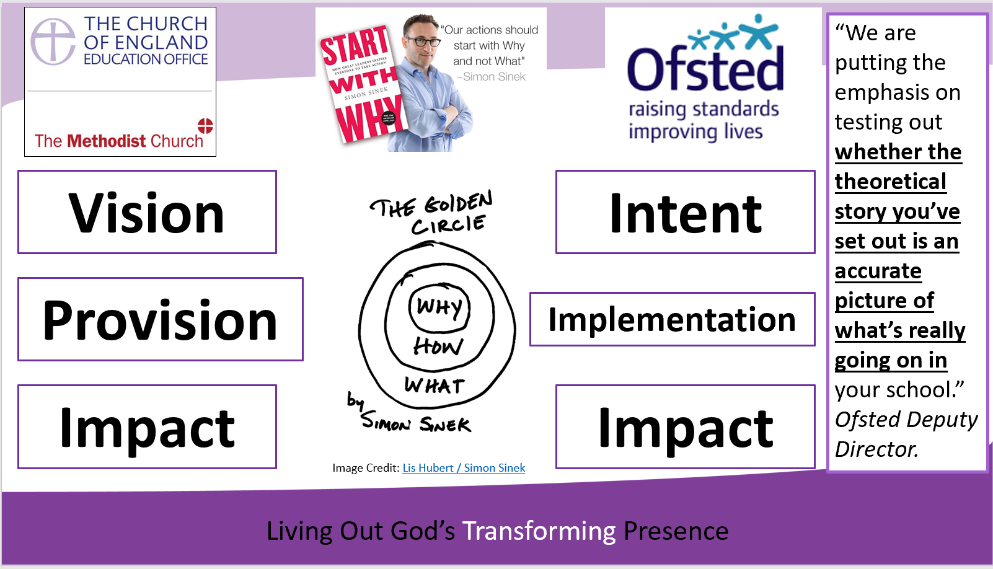

Are you familiar with the idea of ‘Why’ from Simon Sinek? (If not, his book ‘Start with Why’ is excellent)

Whether it is ‘Vision’ (SIAMS), ‘Why’ (Sinek) or ‘Intent’ (Ofsted), can you as a Foundation governor, see how the stated aim / ambition is being ‘fully lived out’ in your school?

It’s all about the big (yellow) question!
What are you going to do more of / differently in your role as a Foundation governor as a result?

Statutory Inspection of Anglican and Methodist Schools
Office for Standards in Education

