Week 37 Coping with losing

 | RRS |  | I can identify current limitations and try to overcome them

Reflection; watch this film trailer if you can http://www.youtube.com/watch?v=PhcBQp9NFJI
In the 1950 world cup held in Brazil the biggest shock came when an American team of part timers beat the English national side who were nicknamed the ‘Kings of football’. The USA won 1:0 and as a result England were eliminated in the group stage. England had rested their best players and they had underestimated their opponents. The shock led to changes in the way the English team were selected and organised. The England right back in this match was a man called Alf Ramsey, he never forgot the experience. He went on to be the manager of England when they won the world cup in 1966. The 1950 world cup was the only time England has played in a blue kit.
Music: ‘Pick yourself up’ by Frank Sinatra http://www.youtube.com/watch?v=3EFPJL1uQbs

Thinking: Think about something that you are ‘losing at’ today. What changes do you need to make to move forward? Show this on the football shirt

Some people think football is a matter of life and death. I can assure them it is much more serious than that. (Bill Shankley)

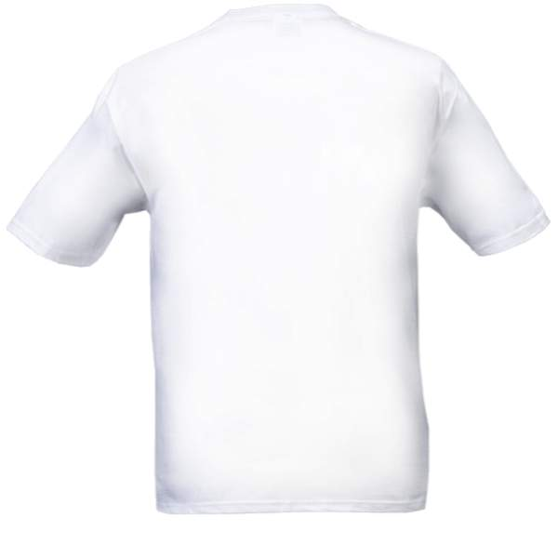
‘No, in all these things we are more than conquerors through him who loved us’. Romans 8

