 Olympic Value Inspiration

 | RRS | 

Reflection:
Finally, brothers and sisters, whatever is true, whatever is noble, whatever is right, whatever is pure, whatever is lovely, whatever is admirable—if anything is excellent or praiseworthy—think about such things.
Philippians 4v8

Thinking:
Think back over this year at school. Who has inspired you the most? Who gets your Gold Medal? Who gets your Silver who gets your bronze?

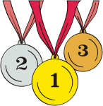

Celebrate what you want to see more of. (Thomas J. Peters)

