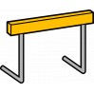Hurdles What Hurdles?

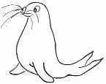 | RRS | 

Reflection
Wilma Rudolph was born prematurely at 4.5 lbs she had with 21 brothers and sisters, she had polio as a very young child. She recovered, but wore a brace on her left leg and foot which had become twisted as a result. By the time she was twelve years old, she had also survived scarlet fever, whooping cough, chickenpox, and measles. Her family drove her regularly from Clarksville, Tennessee to Nashville, Tennessee for treatments to straighten her twisted leg. In the 1960 Summer Olympics in Rome she became the first American woman to win three gold medals in track and field during a single Olympic Games
Suggested Music Stronger By Mandisa

Thinking: Remember the parable of the Mustard seeds?
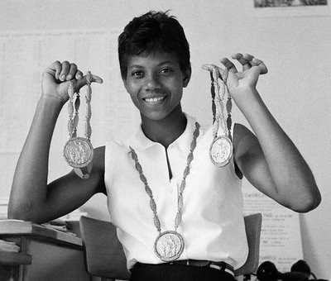
What are the hurdles you have to overcome?

Never underestimate the power of dreams and the influence of the human spirit. We are all the same in this notion. The potential for greatness lives within each of us
Wilma Rudolph

