 Olympic value Excellence

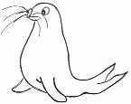 | RRS | 

Reflection:
‘Do you not know that in a race all the runners run, but only one gets the prize? Run in such a way as to get the prize” 1 Corinthians 9 v 24

Watch the Video Proud http://www.youtube.com/watch?v=LEoxGJ79PMs

Thinking: What things are you excellent at? What things that you do make you feel proud? Fill in the Scrolls of honour

What have you done today to make you feel proud
it’s never too late to try
what have you done today to make you feel proud
you could be so many people
if you make that break for freedom?

Everyone who competes in the games goes into strict training. They do it to get a prize that will not last; but we do it to get a prize that will last forever. 1 Corinthians 9 v 25

