Mustard Seeds

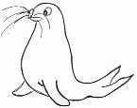 | RRS | 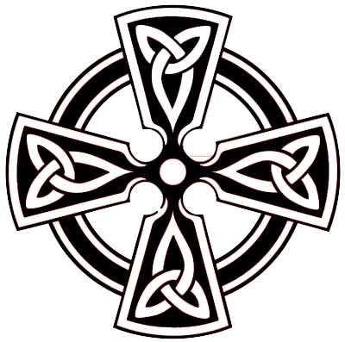 | Article 29  Teach us to read and write and teach us well so we grow up to be the best we can at whatever we wish to do

Reflection
He told them another parable: “The kingdom of heaven is like a mustard seed, which a man took and planted in his field. Though it is the smallest of all seeds, yet when it grows, it is the largest of garden plants and becomes a tree, so that the birds come and perch in its branches” Matthew 13 v31-32

Thinking: God can take the most unlikely people and help them achieve extra ordinary things. Go on dream a little What would you like to do that everybody tells you yon can’t achieve? Write your ideas in the leaves of the tree
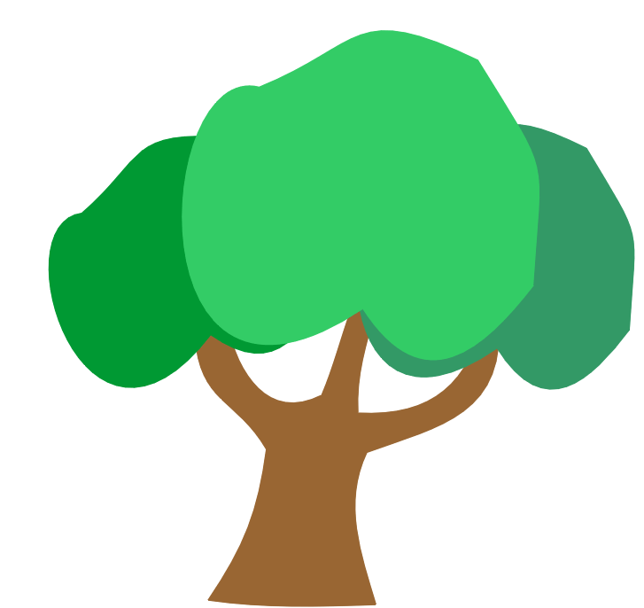

‘From small things, mama Big things one day come’ Bruce Springsteen from the song of the same name.

