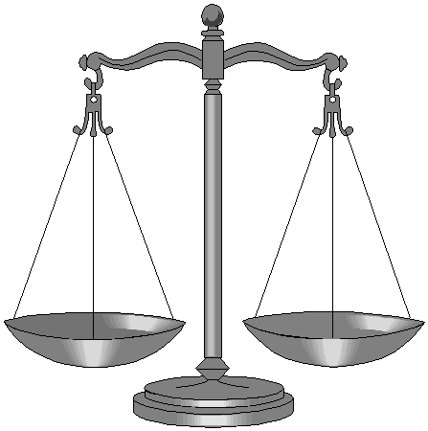 Justice

 | RRS |  | It is your responsibility to always do the right thing.

Reflection:
Watch the ‘Social Justice’ reflection once and then look at the thinking before you watch it again.

Thinking:
Is it just Christians that believe in justice for all?

What other religions do you now know also believe in justice for all?

If such a large proportion of our world wants justice for all, then why do you think so much injustice occurs in the world?

What can you do to prevent injustice occurring in your life?

The LORD loves righteousness and justice. (Psalm 33:5)

