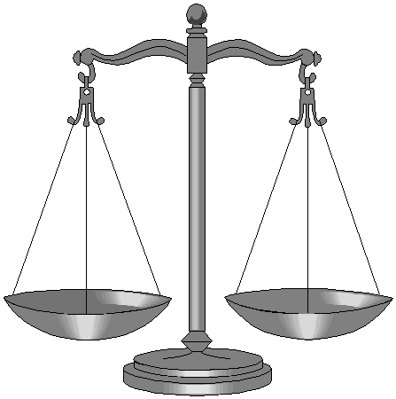 Justice

 | RRS |  | It is your responsibility to always do the right thing.

Reflection:
Listen to or watch the song ‘Where is the love?’ by the Black Eyed Peas.

Thinking:
People killin', people dyin'
Children hurt and you hear them cryin'
Can you practice what you preach
And would you turn the other cheek

Think about the line ‘practice what you preach’. What do we ‘preach’ about Justice?

Now think about the line ‘And would you turn the other cheek’. What does it mean to turn the other cheek?

Would you turn the other cheek if you saw some injustice in our school?

What might you do about it?

Follow justice and justice alone, so that you may live and possess the land the LORD your God is giving you. (Deuteronomy 16:20)

