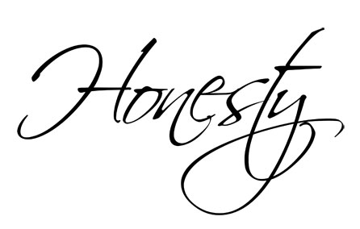 Honesty

 | RRS |  | It is your responsibility to always do the right thing.

Reflection:
Honesty is always the best policy!

Thinking:
Honestly, what would you do ...
...if you found a £20 note lying in the street?

...if you saw your friend doing wrong and then another child punished for it?

...if you were asked to keep a secret by a friend?

...if you knew that your friend had cheated in a test?

How do you feel about your answers? Are you proud of them or not?

Would you be pleased if you were the one who had lost the money or been the one to be wrongly punished?

Kings take pleasure in honest lips; they value a man who speaks the truth. (Proverbs 16:13)

