 Forgiveness

 | RRS | 

Reflection:
Jesus’ last words on Earth were “Father, forgive them, for they do not know what they are doing.” (Luke 23:34)

Thinking:
Who was Jesus talking to?

Who did he want to be forgiven?

What actions did he want them to be forgiven for?

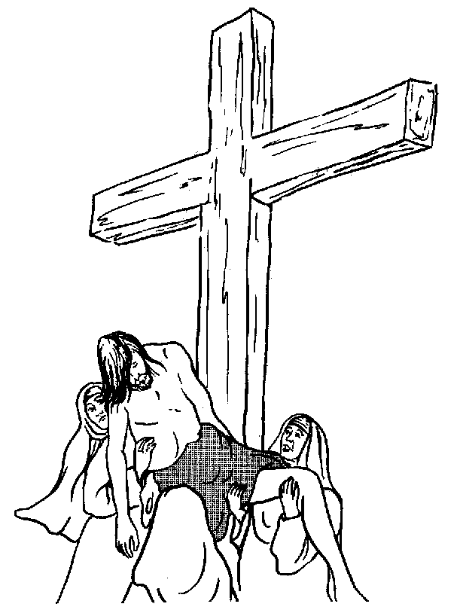

By asking for this forgiveness, Jesus showed us a bit of what God is like. What qualities was he showing us?

