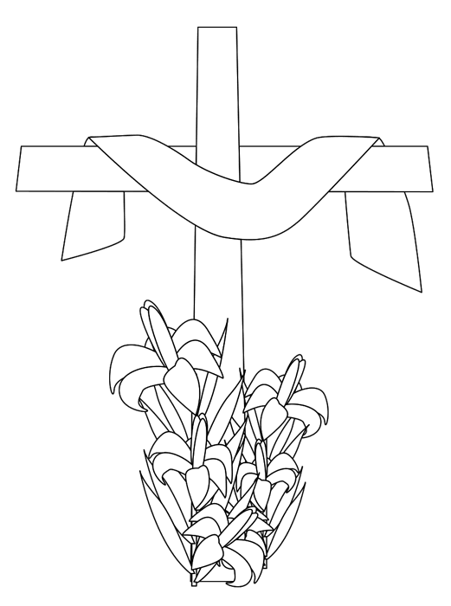 Easter 2
Sacrifice

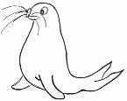 | RRS | 

Reflection:
Image: Christ on the Cross – Eugene Delacroix www.nationalgallery.org.uk
Music: Sacrifice – Elton John

Thinking:
Jesus made the ultimate sacrifice when He gave up his life on the cross, so that we might be forgiven our sins.

We can never beat Christ’s sacrifice but what sacrifices could we make that might help others or make the world a better place to live in? Make a list:

*

*

*

In your opinion what are the most precious sacrifices we can make? (Time? Money? Worldly goods?)

Why?

The Bible says: ‘Sacrifice without love has no value’ (Corinthians 13.3)

