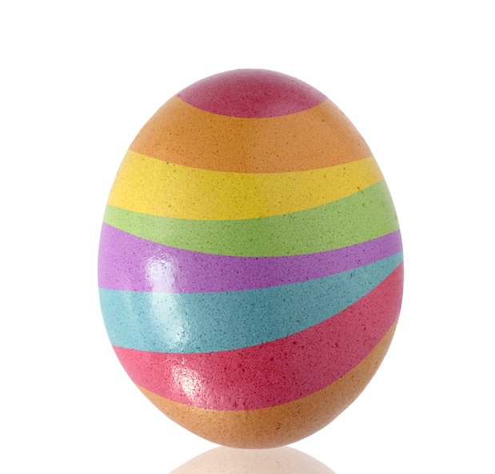 Easter 1
For eggsample ...

 | RRS | 

Reflection: The role of symbols in our lives.
Youtube clip: I wanna Easter Egg – Bugs Bunny
New vocabulary: ‘Symbol’ and ‘represent’

Thinking:
In the clip, the child has forgotten that Easter is a special time in the Christian calendar. He just wants a chocolate egg! But why do we give eggs at Easter? What do the eggs represent to Christians?

Easter is a time of many important symbols e.g. the cross and the bread and wine eaten at the last supper. If you were to invent a new symbol to represent something good – what would it be? E.g. a cake to represent sharing.
- Draw your new symbol and write what it represents underneath your picture.

- Remember the image you have chosen and the meaning you gave to it

Mark 16.6 He is risen; he is not here.

