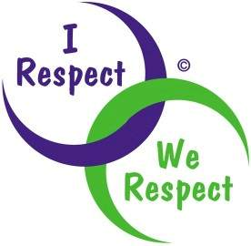 Respect

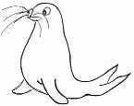 | RRS | 

Reflection:
Watch Michael Jackson’s ‘Earth Song on You Tube.
http://www.youtube.com/watch?v=K3vTBiOsSGY

Then God said, "Let us make man in our image, in our likeness, and let them look after the fish of the sea and the birds of the air, the livestock, over all the earth, and all the creatures that move along the ground." Genesis 1 v26

Thinking:
What have we done to the world?
Look what we've done.

What have we done to the world?

Have we respected our world?

What will happen if we don’t start showing our world respect?

How are YOU going to show the earth some respect? What are you going to DO?

