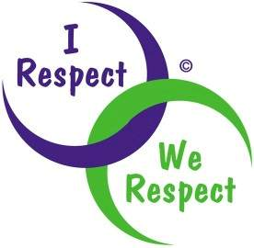 Respect

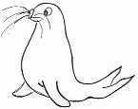 | RRS | 

Reflection:
When we show respect to others, they respond with respect for us. (Arapaho Proverb)

Thinking:
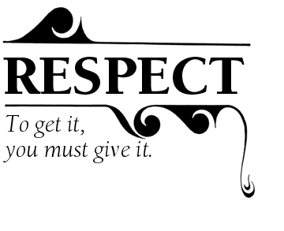
It is easy to show respect to people who are always kind and considerate to others, who are always right or who always know what to do in a crisis. But what about the rest of us? If we want to be shown respect then we must show respect for others.

If you do not want to be shouted at then what must you not do to others?

If you do not want to be excluded from a group then what must you not do to others?

If you do not want people to tease you because of your differences then what must you not do to others?

Why do you think this might gain you respect?

Show proper respect to everyone: Love the brotherhood of believers, fear God, and honour the king. 1 Peter 2. v17

