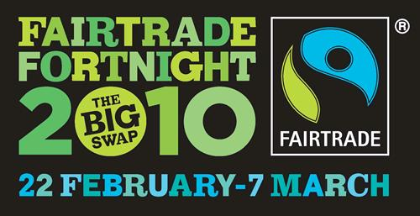 Fair-trade Fortnight

 | RRS | 

Reflection: He has showed you, O man, what the LORD requires of you? To act justly and to love mercy and to walk humbly with your God. Micah 6 v8

Thinking: If a jar of Coffee cost £2 to buy. How should that money be divided up among those that were involved in producing it?

Stage of Production | How much?
Coffee Farmer: Works all year to grow the coffee
Coffee Exporter : Buys coffee from farmer and puts it on a ship
Coffee Shipper: Owns the ship the coffee sails in
Coffee roaster: Roasts the coffee and puts it in jars
Coffee seller : maybe a supermarkets like Tesco’s

Your teacher will now tell you the answers. What do you think? is this fair?

For Teacher the answers!
Farmer =4p
Exporter = 7p
Shipper= 12p
Roaster = 120p
Seller = 57p

Figures approx and based on Oxfam

