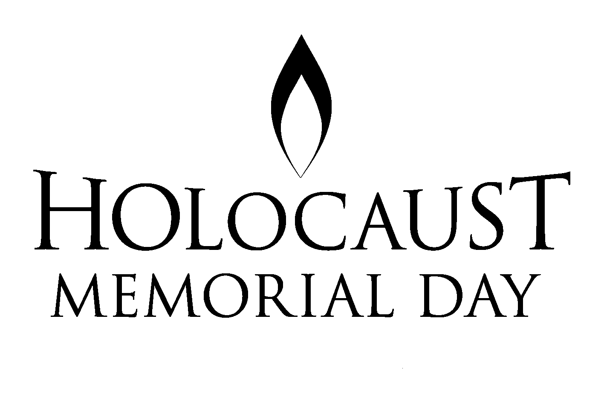 Never Again

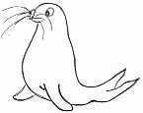 | RRS |  | Holocaust Memorial Day  UNCRC: Article 14

Reflection:
‘We carry on telling our stories because we were eye witnesses. The most important thing is to tell people so this can never happen again’
Ibi Ginsburg Holocaust Survivor

The Jewish tradition of leaving a pebble on top of a tombstone shows that someone has honoured the deceased person’s memory with a visit to the grave.

Thinking: Give each child a small polished stone. Ask them to hold the stone and look carefully at it.

Imagine : From all the stories you have heard try to begin to imagine what it would have been like to live at the time of the holocaust

Remember : all those that have died in all the holocausts that you have heard about

Reflect: Reflect on what you would or could or will do to stop this happening again.

React: When you are ready bring your stone and add it to the Cairn in the classroom to show your commitment to stand against prejudice and to respect the values rights beliefs of others.

Bible quote : For there is no difference between Jew and Gentile—the same Lord is Lord of all and richly blesses all who call on him, for, "Everyone who calls on the name of the Lord will be saved Romans 10v12

