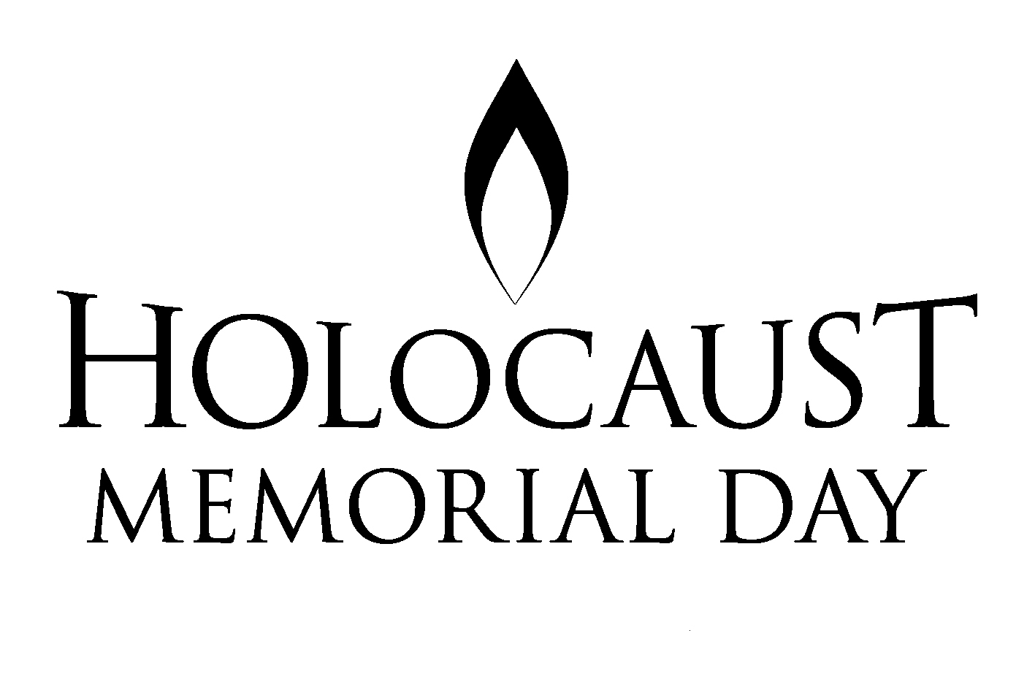 Never Again

 | RRS |  | Holocaust Memorial Day  UNCRC: Article 14

Reflection:  ‘We carry on telling our stories because we were eye witnesses. The most important thing is to tell people so this can never happen again’  Ibi Ginsburg Holocaust Survivor | For there is no difference between Jew and Gentile—the same Lord is Lord of all and richly blesses all who call on him, for, "Everyone who calls on the name of the Lord will be saved. Romans 10 v 12

Thinking:
The Jewish tradition of leaving a pebble on top of a tombstone shows that someone has honoured the deceased person’s memory with a visit to the grave.Why do you think people visit the graves of holocaust victims, even if they never knew them personally?

If you visited such a grave, would you want to see many pebbles placed on top of it or not?

Why?

If you would like to, use the space below to draw and then shade a pebble to show your commitment to standing against prejudice and to respect the values, rights and beliefs of others.

