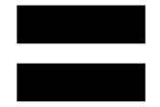 Equality

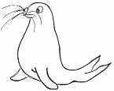 | RRS | 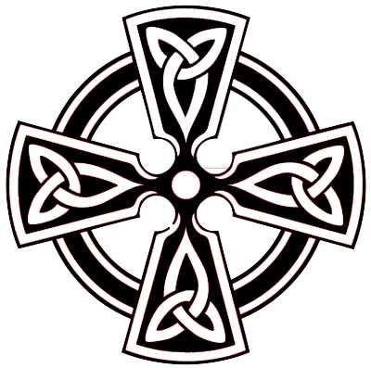

Reflection:
Equality is about making sure people are treated fairly and given fair chances. Equality is not about treating everyone in the same way, but it recognises that their needs are met in different ways. (North Devon Council)

Thinking:
There are lots of different symbols for equality. Have a look at the four examples below.
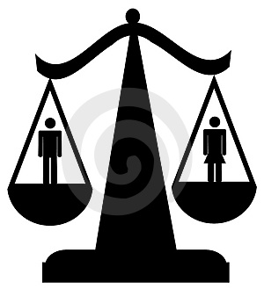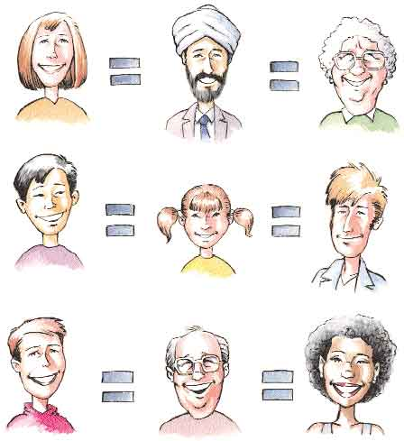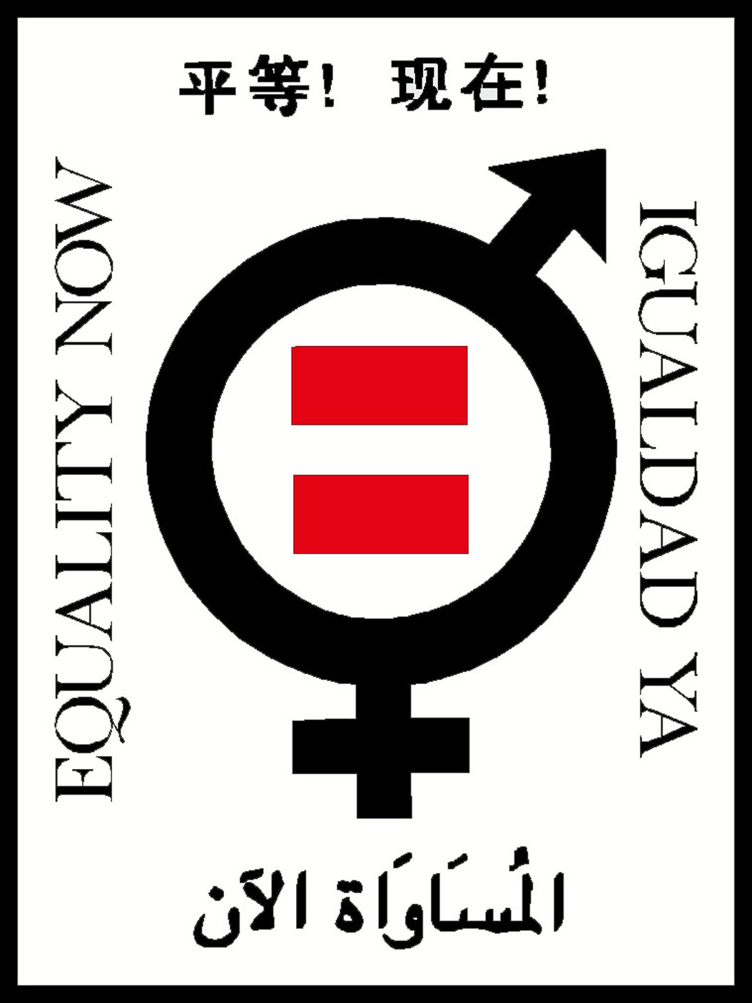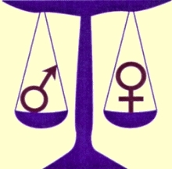

Do you think the equals sign or the scales is the best representation of what equality means?

Circle the symbol below that you think is the best.
Why have you chosen this one?

Have a go at designing a symbol that deals with more than just gender equality

So God created man in his own image, in the image of God he created him; male and female he created them. Genesis 1 v 27

