Self Control

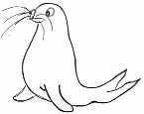 | RRS | 

Reflection ‘
But the fruit of the Spirit is love, joy, peace, patience, kindness, goodness, faithfulness, gentleness and self-control. Against such things there is no law. Galatians 5 v 23

Thinking
Think of a time when your emotions have been very strong……

How did you feel at the time?

’Emotions: They guide, they hide….they help you to decide…’
Did you manage to control your self/ your emotions? How?

Were you proud of yourself afterwards or disappointed?

Would you do anything different next time you felt this strength of emotion welling up from within?

