SO, YOU’VE BEEN
RECOMMENDED FOR TRAINING!

A Guide to What Happens Next

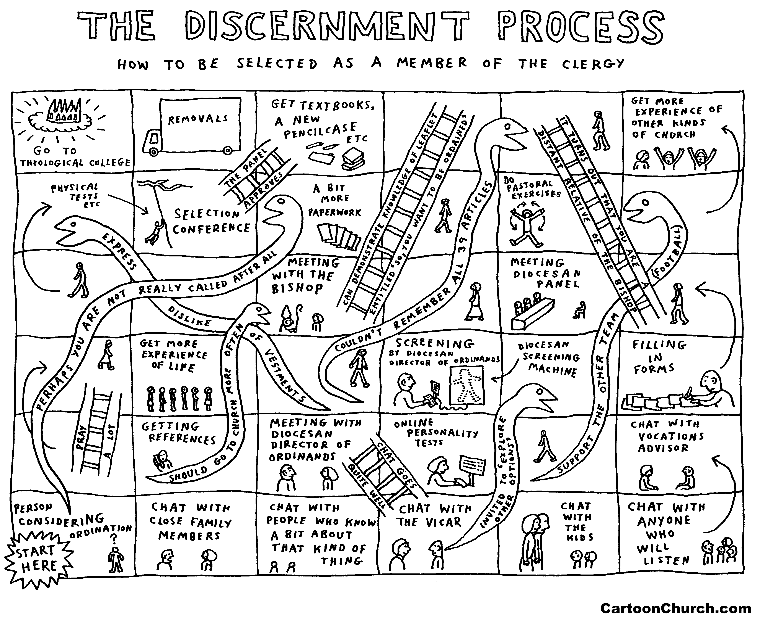

We are delighted that you have been recommended for training and look forward to working with you as you engage with the formational experience of Theological College. It is important to note that your BAP Report recommends you for training and that the discernment process continues whilst you are at College to lead to a potential recommendation for ordination. This continuing time of discernment and formation is both exciting and daunting and there will undoubtedly be many questions in your mind as you prepare for it - this leaflet aims to answer some of them, and your conversations with the DDO will provide the opportunity to explore others. The Diocesan Team are here to support you throughout, so don’t hesitate to be in touch if you have any queries - here are some useful contact details to keep close at hand:

DDO & Coordinator for Initial Ministerial Education - The Revd Nigel Done
Phone: 01722 411944 (Option 4) 07464547703
Email: nigel.done@salisbury.anglican.org
Address: Church House, Crane Street, Salisbury SP1 2QB

Team Administrator - Miss Andrea Dredge
Phone: 01722 411944 (Option 4)
Email: andrea.dredge@salisbury.anglican.org
Address: Church House, Crane Street, Salisbury SP1 2QB

DECIDING ON A COLLEGE OR COURSE

Exploring the Options

Once Bishop Nicholas has affirmed your recommendation for training, you will need to arrange a meeting with the DDO to begin to explore the variety of options available. Try not to listen to the advice of friends who have been through training before you - the landscape has changed significantly over the past few months and their wisdom, although generously offered, may be rather out of date! Every ordinand’s needs are different and training pathways are bespoke in reflection of that, taking into account personal circumstances, funding provision, the wisdom received in the BAP Report, and any particular formational needs. Whether you hope to train full time, part time, residentially, or non-residentially, your DDO will be able to discuss which are possible and assist you in exploring further. The agreed pathway will provide the opportunity for you to be stretched and challenged by new experiences and opportunities so that you can truly be ‘in formation’.

Involving the Family

If you have a spouse and/or children, the DDO will offer to visit you at home so that the whole family can be involved in the decision making process and have the opportunity to ask any questions they might have.
THE PRACTICALITIES OF TRAINING

The practicalities of training will vary according to the pathway you are following, and the DDO will be able to explain the details of your particular route to you. The following information will be a helpful guide, however, as you contemplate the journey ahead:

Full Time Residential and Non-Residential Training (with a maintenance grant)

- Finances - The financial arrangements for full time training are relatively straight forward – we will pay your course/tuition fees directly to your Theological College, and will also provide you with a grant to cover reasonable accommodation and living expenses. You will receive a small book grant too. Your grant will be paid in three equal termly instalments - on the first banking day of the month in September, January and April. In order to calculate your grant we will send you a form in May each year – please return these as soon as possible to ensure there isn’t a delay in your funding reaching your bank account.

If you own your own home, there are particular decisions to be made if you enter into residential training. Some people decide to keep their property and to rent it out to finance the mortgage, others decide to sell the property to be free from the commitment. There are no rights and wrongs here, and the decision is entirely up to you.

- Accommodation for those in Residential Training - If you are single you will usually be accommodated within the College itself; couples and those with children will often have the choice of a flat on site or a house within reasonable travelling distance of it. If it is agreed that accommodation outside of the College environs is most suitable, then we will work with you to ensure that a property can be found within the agreed budget provision.

Most colleges are skilled at helping you arrange accommodation as early as possible if you have school age children, as they are aware that a permanent address is usually needed to affirm a school place.
Once your accommodation is agreed we will ask you to obtain and send to us three quotations from removal firms so that we can pay the fee directly to the agreed company (please note that you are responsible for paying the transit insurance).

Part Time Non-Residential Training
(without a maintenance grant)

- Finances - The financial arrangements for part-time non-residential training aim to ensure that you do not have to fund any of your training yourself - this means that we pay your course/tuition fees directly to your Theological College.

This training route does not include a grant towards your accommodation or living expenses, so you will need to ensure that you can be financially self-sustaining from that perspective.

- Balancing Training and Work Commitments - Part-time training can sometimes be something of a juggling act, especially as those who embark on this pathway are often in full time employment also. This juggling act is perfectly viable, so don’t panic! We are happy to put you in touch with those who have recently trained part-time if it would be helpful as you explore ways to pattern your commitments.

KEEPING IN TOUCH

Belonging in the Diocese

Whilst you are training at Theological College you will find yourself part of a close knit community, and friendships will be formed that will last a life time. This experience of community is a great gift, but don’t forget that you are a valued part of the community in Salisbury Diocese too! This sense of community is expressed in a variety of ways, most significantly in our commitment as a Diocese to praying for you during your training and formation.

The reality is that your attention will need to be focused on your Theological College environment whilst you are in training, but we encourage you to keep in contact as you can and to make it a priority to attend Bishop Nicholas’ Ordinand’s Party each spring - this is a great opportunity to consolidate relationships with the Bishop’s Staff and with other ordinands, many of whom you will meet again during your Curacy.

The key point of contact during your time at Theological College will be the DDO, and she will visit you at least once a year (usually in January/February). These visits are an opportunity to reconnect, to reflect on the past few months, to engage with any questions you might have about the training pathway and, when the time is right, to explore a potential Curacy. We encourage you to be in contact at any time in between these visits, however - whether you have exciting experiences to share, family news, a practical question to ask, an issue to explore, or simply something you’d like us to remember in our prayers, we are always delighted to hear from you.

Embracing Opportunity

Your time in training will present you with a wealth of opportunities - and we encourage you to make the most of them! Whether you are invited to experience a placement in a new environment, to spend a term at a Theological College overseas, or to engage with an area of mission or ministry you never even believed existed, allow yourself to be stretched and challenged.

The DDO is always happy to have a conversation around any opportunity that may affect your training pathway, so don’t be afraid to be in touch if your Theological College has a suggestion you’d like us to consider.

FORMATION AND LEARNING

Being ‘in Formation’

There are many aspects to the training pathway you will engage with over the next few years - these include theological study and contextual placements, spiritual formation, practical skills in applied theology, and the experience of being part of a learning and worshipping community. The aim of all this is to enable you to become a reflective practitioner - a person who can engage deeply and creatively in ministry and mission as you live out your faith and vocation in the varying contexts in which you may find yourself in the future.

Your time in training will be an exciting adventure and you will find yourself shaped and formed by it in ways you never expected. For some, this leads to new discoveries that may affect the sort of context you might seek for your Curacy. The DDO will keep in conversation with you about all these things as you journey through your time at College so that we can be sure to find a Curacy that will build on your experience and enable you to continue in formation over the coming years.

Feedback and Reports

The content of your training pathway will be shaped by the recommendations within your BAP Report. Half way through your time at College the Principal will send a report to Bishop Nicholas and the DDO letting them know how your training is progressing, commenting on how any recommendations within the BAP Report have been engaged with, and highlighting that which is to be celebrated as well as challenges that are still to be addressed. During your last term at College, the staff will send a final report to Bishop Nicholas and the DDO providing an overall summary of your formational journey over the past few years. It is in this report that the College staff will decide whether to recommend that you should be ordained.

None of your College reports will come as a surprise to you and the process is very transparent - your tutors will discuss them with you as they are written, and in your regular tutorial meetings too. Generally people find these reports perceptive, helpful and affirming!

FROM COLLEGE TO CURACY

The process of finding a Title Parish (or Curacy as they are usually known) varies from diocese to diocese, so don’t worry if your experience seems different to that of others! The DDO will explain Salisbury Diocese’s approach to you closer to the time, but the following will help you gain an insight into that which is involved.

Exploring a Curacy in the Diocese of Salisbury

In Salisbury Diocese we run a ‘curate-led’ process, which means that we always have far more potential Curacies available than our allocation of Curates - this means that we are free to discern the best match for you, rather than feel constrained by the need to ‘shoe-horn’ you into an existing post. A Curacy is a significant and foundational experience and we take seriously the need to invest time and energy at the discernment stage to make sure we get it right. Those who apply to become Training Incumbents are carefully selected to ensure that they are skilled in nurturing others in the first few years of ordained ministry; they also have to demonstrate that their parish/benefice is a context in which a Curate can flourish and grow.

During your penultimate year at College the DDO will begin to explore with you what shape your Curacy might take, taking into account the needs of any family you might have also. The DDO and Bishop’s Staff will then work together to try to discern a suitable match for you, and we will contact you in June of your penultimate year in the hope of inviting you to explore a potential Curacy over the summer break so that it can all be settled before you return to College for your final year.

As part of this exploration, you will want to meet with the Incumbent to consider how you might work together and to gain an insight into their hopes and expectations for the Curacy. You will also wish to spend some time getting to know the context itself, perhaps visiting on a Sunday to join the Church community for worship. The DDO will be available to help you reflect on all of this as you discern whether this is the right Curacy for you.

If all parties are content that the match is a good one, an official ‘Offer of Title’ letter will be sent to you by the Bishop’s Office and, once accepted, we will send you a booklet that explains the process from then on in. This booklet will provide a wealth of practical information that will help you end well at College and arrive well in your new context. The DDO’s visit in your final year will be a key time to explore any other questions you might have and to find out details of the ordination itself - and, as always, we ask you not to be shy in contacting us in the meantime if we can help in any way.

As your time at Theological College draws to a close and your Curacy approaches, you will receive a grant to help you with the purchase of vestments and clerical shirts. This grant is usually paid to you in May. For those of you moving into a stipendiary Title Post, you will also be provided with a grant to assist with the expenses of moving into the house provided for your Curacy at around the same time (your removal expenses will be funded as before, although this time we pay the transit insurance too!).

Exploring a Curacy in another Diocese

Occasionally an ordinand wishes to be released from the Diocese of Salisbury to explore a Curacy elsewhere. If you find yourself in this position then it is helpful to let the DDO know your thoughts as soon as possible, as you are not able to apply for a Curacy within another diocese until you have received a letter of release from Bishop Nicholas. If you are released, we will still continue to support you financially and pastorally until you complete your time at Theological College. Although we would not be responsible for working with you to find a Curacy, the DDO will do all she can to support you in exploring possibilities within other dioceses nevertheless.

A FINAL WORD

It is a privilege to accompany you as you engage with the exciting experiences ahead. Don’t be afraid to contact us if we can help in any way and, most importantly, know you that you are very much in our thoughts and prayers. We wish you every blessing for the coming months and years.

