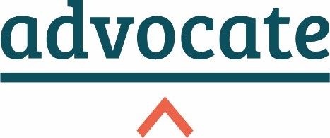

The Birmingham Litigant in Person   
Support Scheme (“B-CLIPS”)

**INFORMATION FOR COURT STAFF**

1. You may be approached by Litigants in Person (‘LiPs’) asking for the B-CLIPS list. This note explains what B-CLIPS is, and where you should direct people who ask for it. It also includes information for the usher who is dealing with the B-CLIPS list.

**What is B-CLIPS**

1. B-CLIPS provides advice and advocacy for unrepresented parties in the Business and Property Courts’ B-CLIPS List held on nominated Fridays at the Birmingham Civil and Family Justice Centre (Priory Courts, 33 Bull Street, Birmingham, B4 6DS). Cases listed onto the B-CLIPS List will include injunctions, Part 8 Claims, FDRs and any other case that is not a Final Hearing, Trial or CCMC.
2. The Scheme is a collaboration between Business and Property Courts (“BPC”) practitioners at the local Bar and Advocate.

**What you should do with a Litigant in Person for the B-CLIPS list**

1. The B-CLIPS list is limited in scope. It does not provide representation for every Litigant in Person who attends court. It is only for cases which have been listed into the B-CLIPS list.
2. You should continue to direct LiPs who attend the front desk to the court room or ushers’ desk relevant to the listing for their case.
3. If you cannot find a LiP’s case on the lists for the First Floor, it *may* be that they have been listed into the B-CLIPS list on the second floor. This list will take place on selected Fridays only.
4. If, therefore, you cannot find a LiPs case on the list **and** it is a Friday, then you should check the list for the second floor to see if the LiPs case appears there.
5. If so, please direct the LiP to the second floor and ask them to sign in with the usher.

**If you are the usher for the B-CLIPS list**

1. The B-CLIPS list should have one or two conference rooms reserved on the second floor for the B-CLIPS representatives to use. The conference rooms should be marked as reserved for B-CLIPS. If you cannot find the reserved conference rooms, please contact His Honour Judge Williams’ clerks who may be able to assist. Please direct the volunteer representatives and the LiPs to the conference rooms.
2. If you come across any issues on a B-CLIPS day, please contact Advocate at [birminghamprobono@weareadvocate.org.uk](mailto:birminghamprobono@weareadvocate.org.uk) and Alex Pritchard Jones at No.5 at [apj@no5.com](mailto:apj@no5.com).
3. The CJC, local practitioners, and Advocate are grateful for your help with the Scheme.